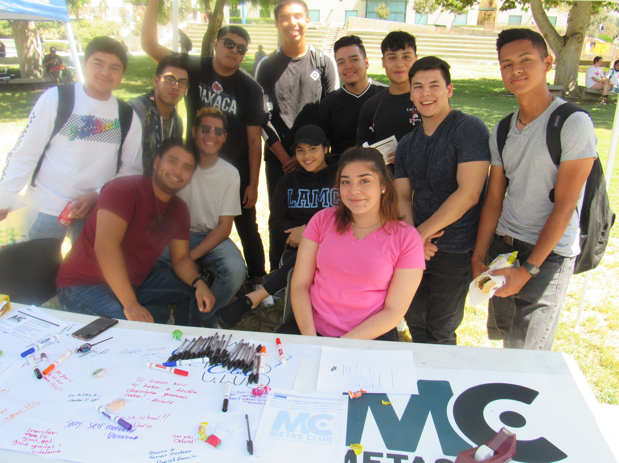
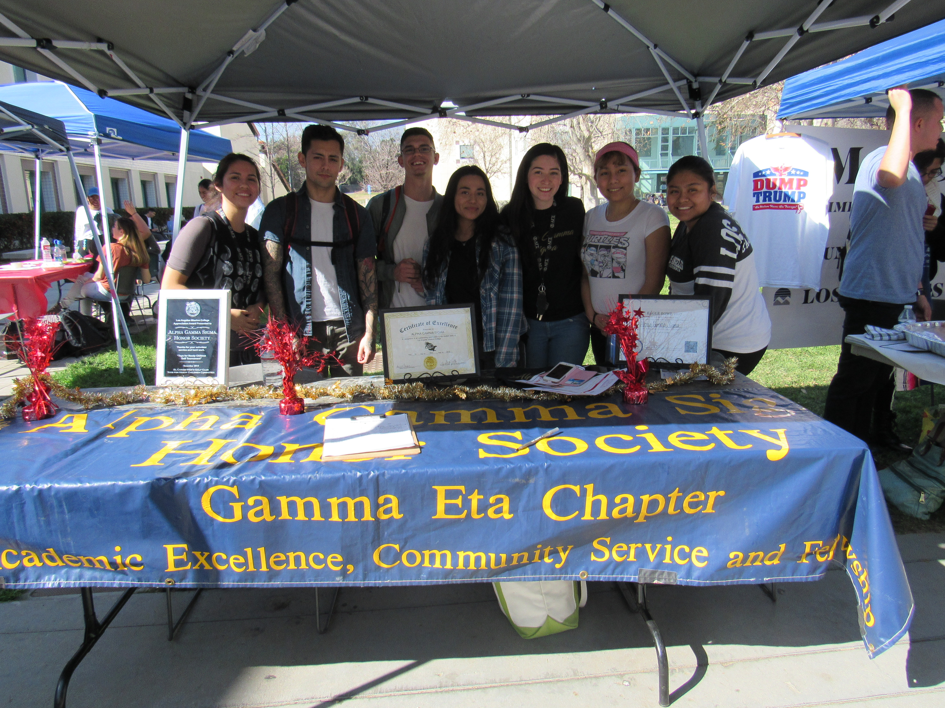
Los Angeles Mission College
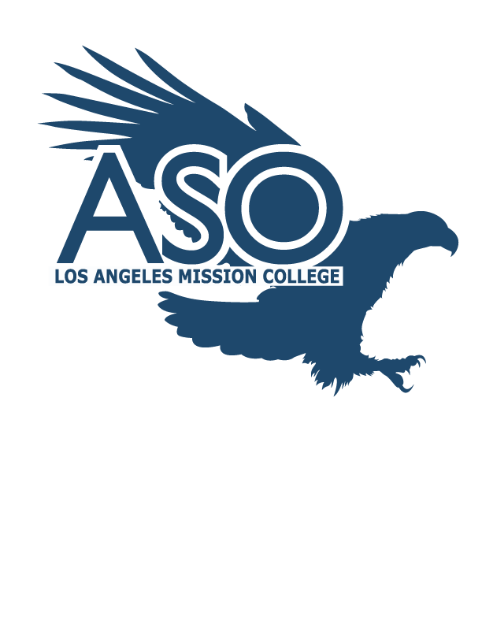

Los Angeles Mission College
13356 Eldridge Avenue
Sylmar, CA 91342
Phone: 818-367-7600

www.lamission.edu

Associated Student Organization (ASO)
President: Briana Garnica (2019-20)
Advisor: Robert Crossley
Contact: 818-364-7820

ASO meets on TBA in the ASO Conference Room located in the Lower Level Campus Center.
- ASO is an organization that was established to provide students the opportunity of participation in the development of student leadership skills.
- Assist in the promotion and development of individual student organizations.
- Provides students representation in all areas, including, but not limited to issues affecting students and the community.
- Works in cooperation with administration on all levels of student government, including, but not limited to, Academic Senate and community organization.
Who can join?
- Registered students of Los Angeles Mission College who pay the $10 A.S.O. fee
- Faculty and Staff Members

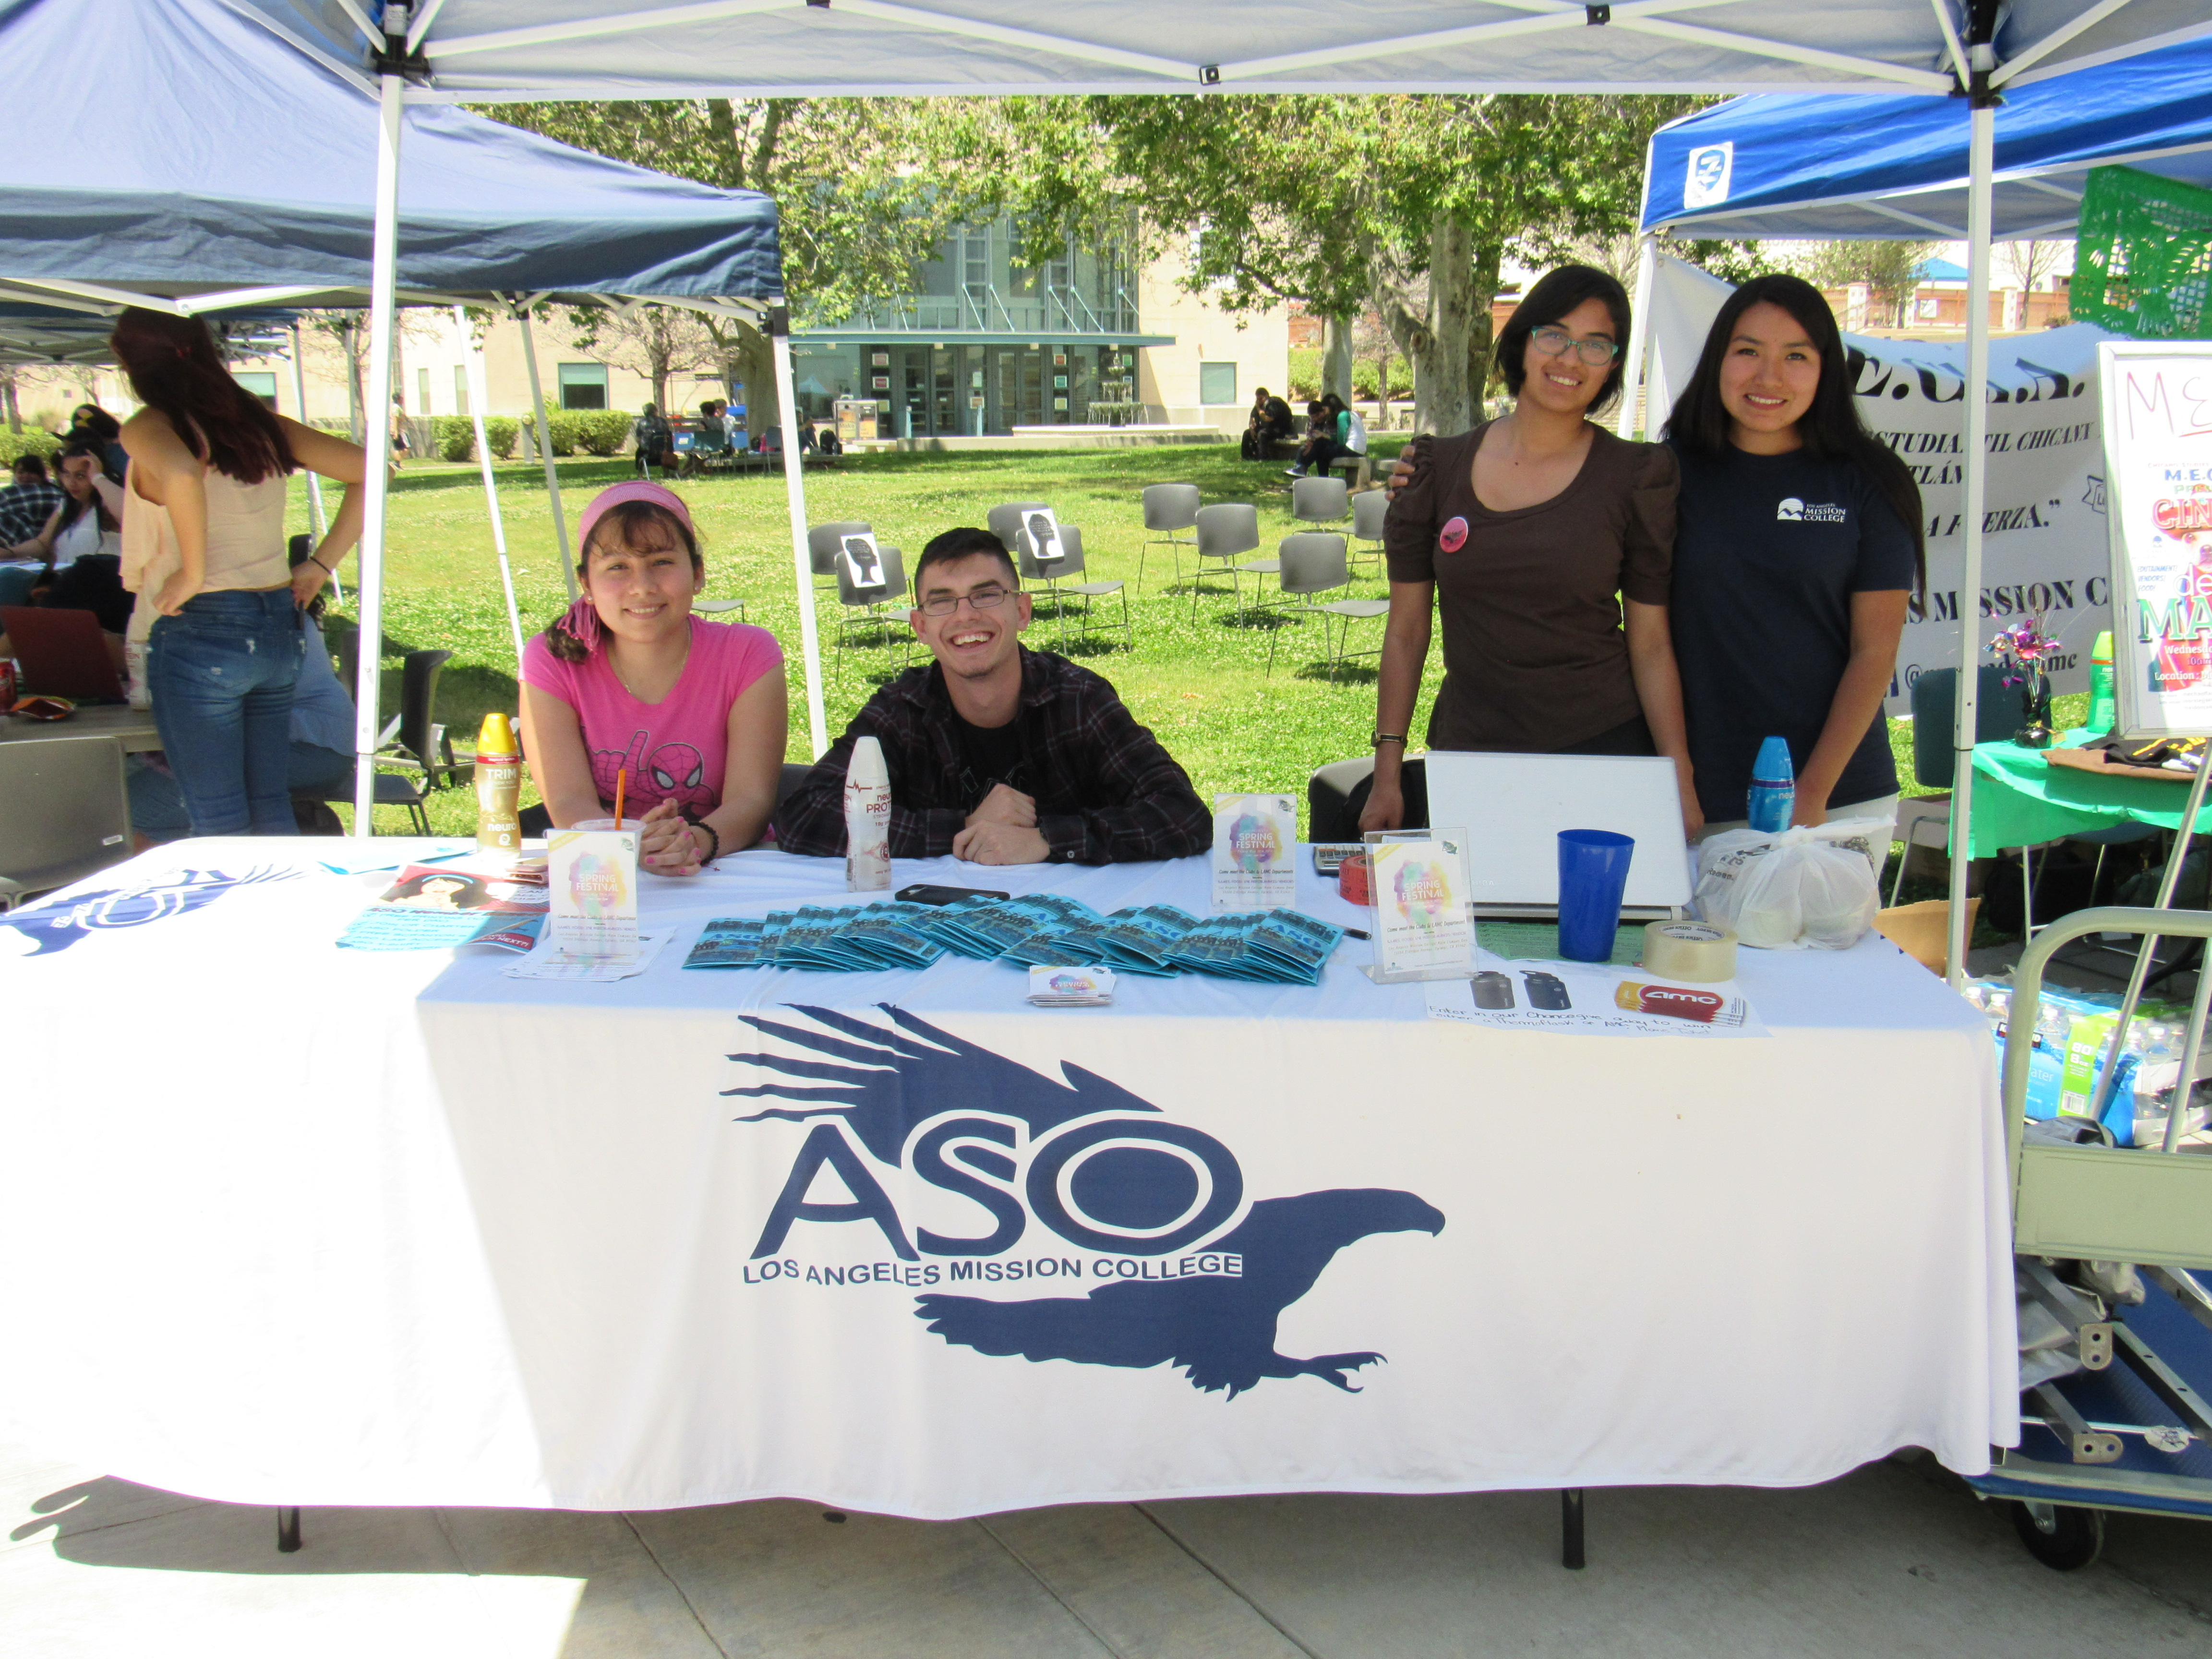
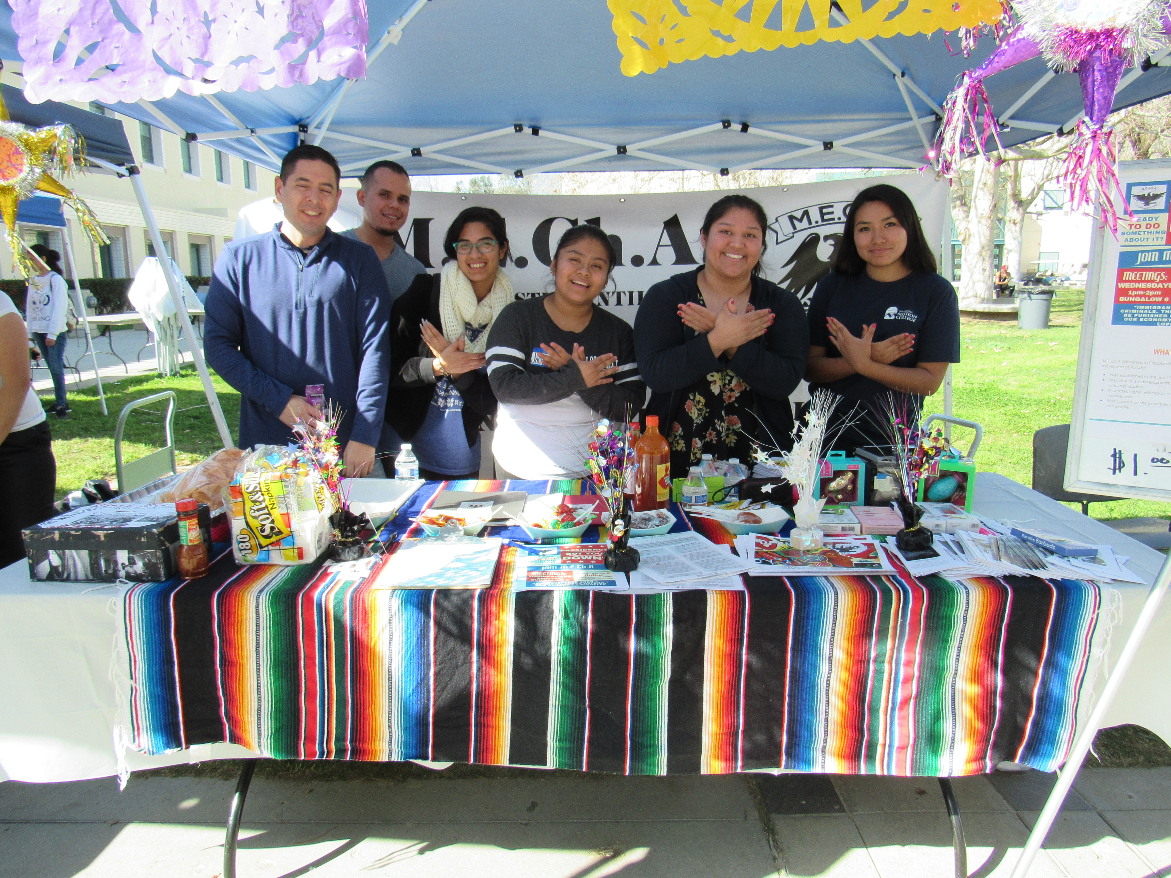
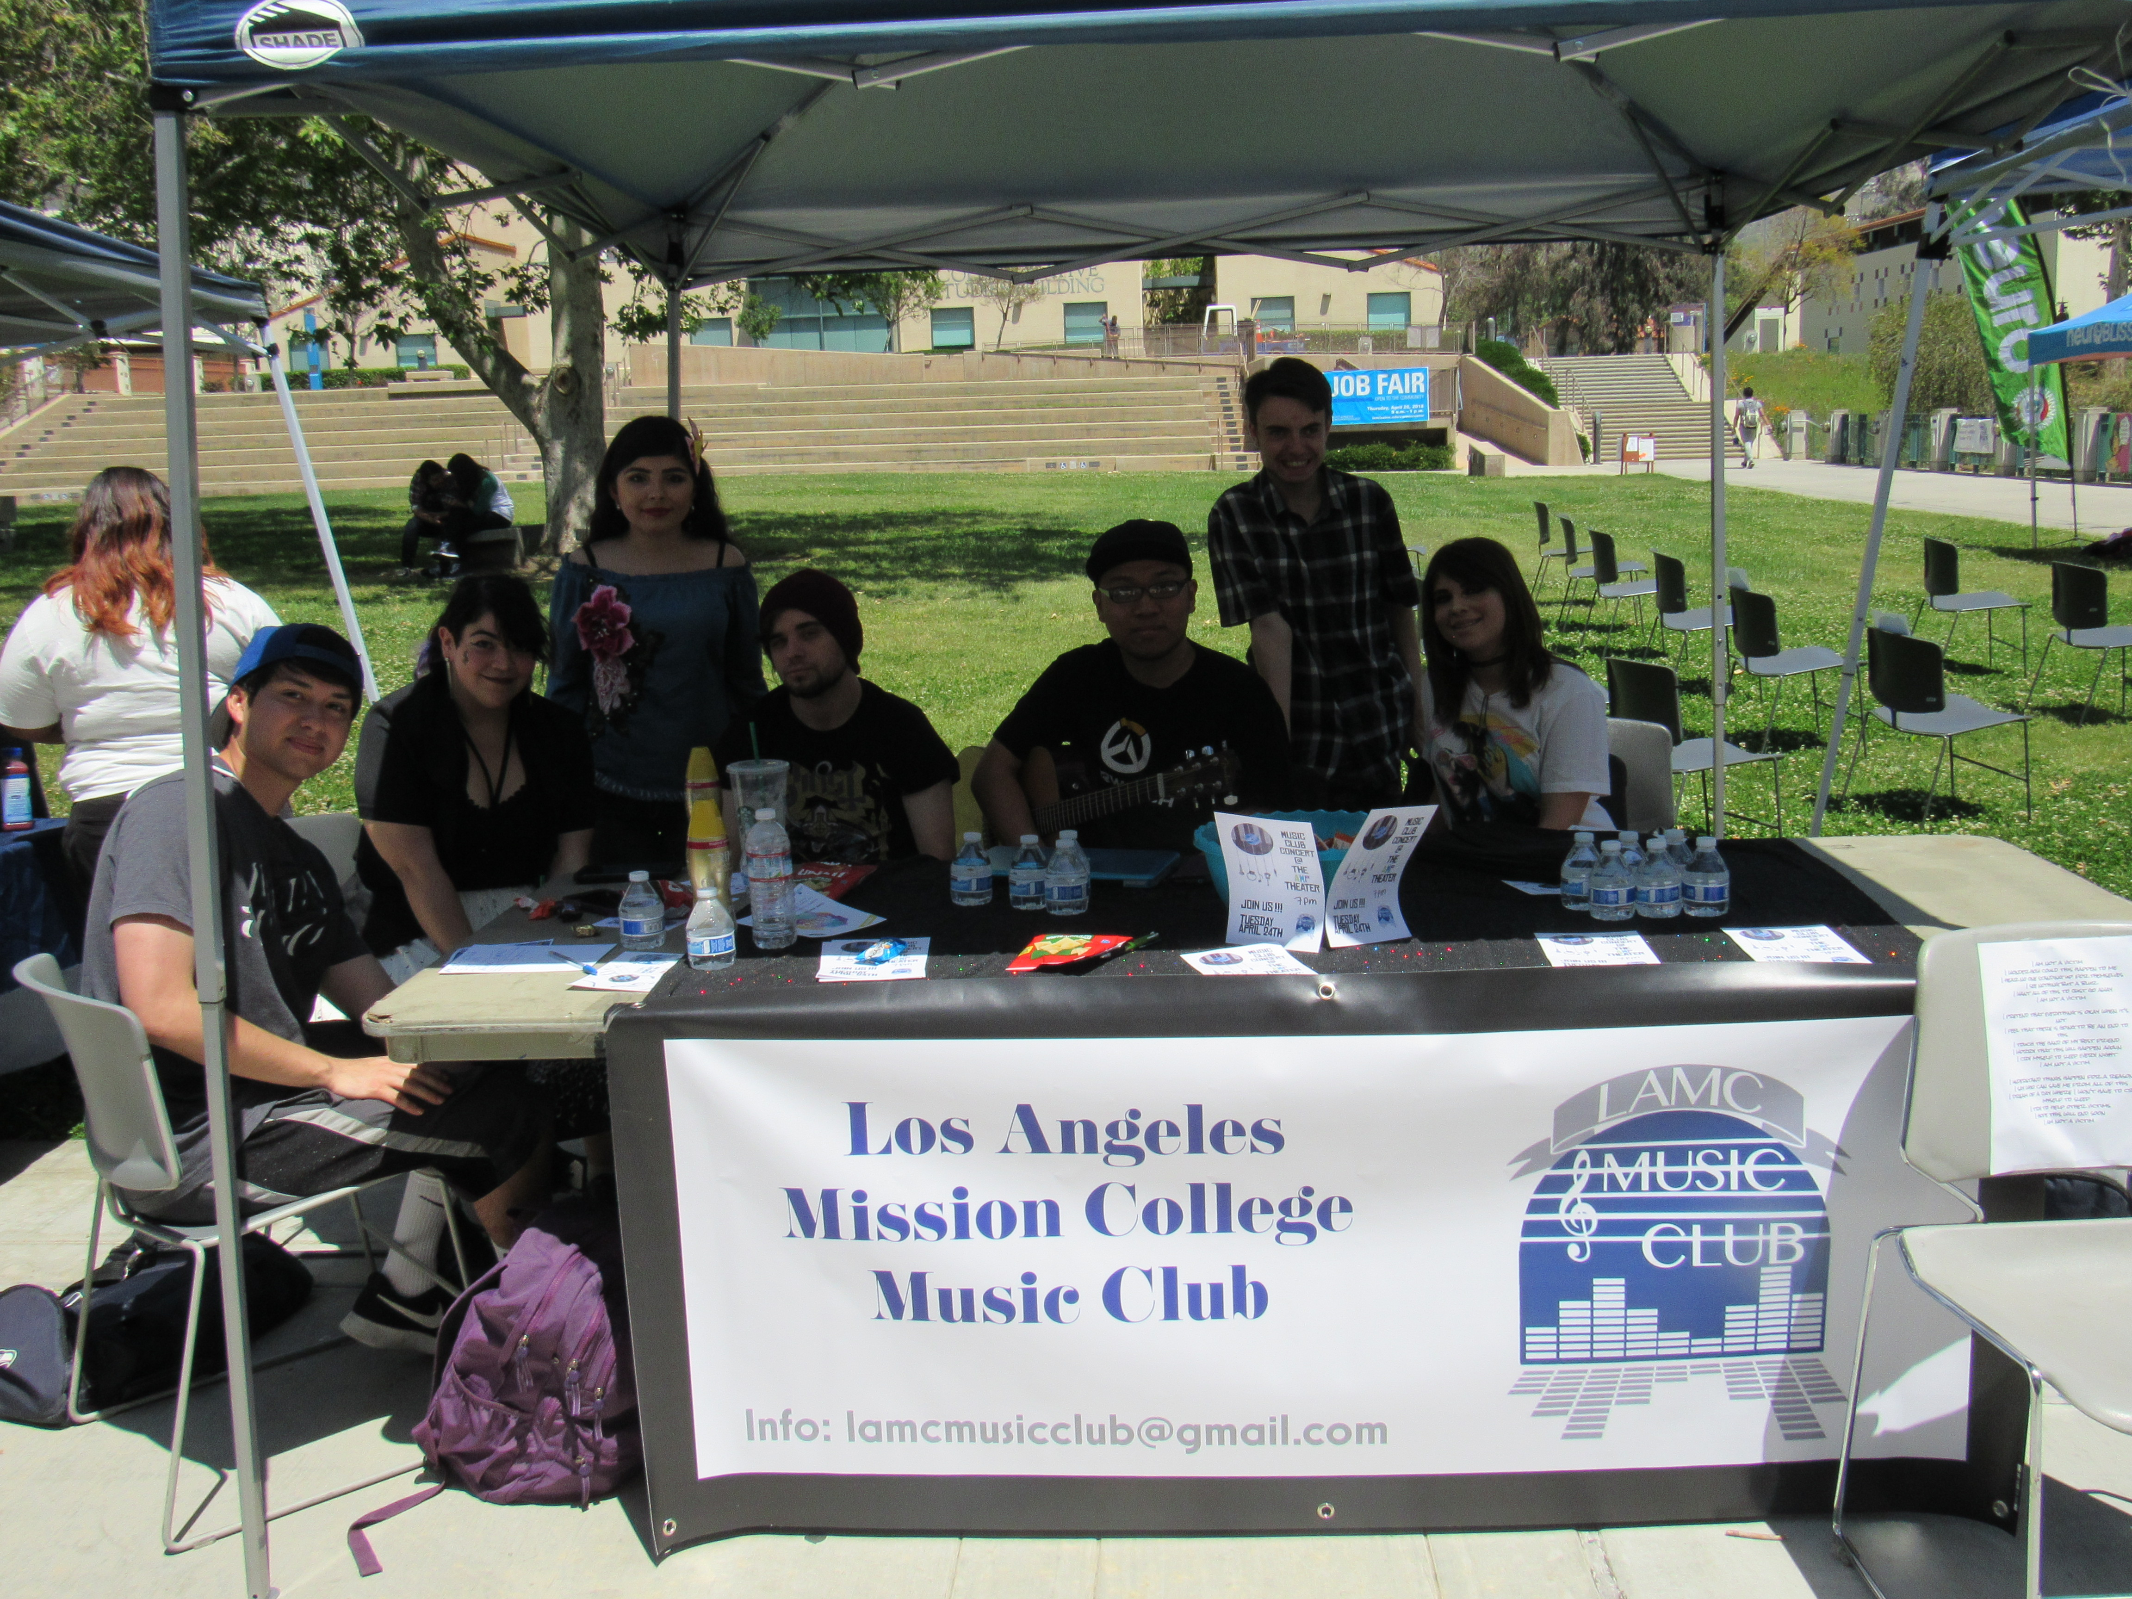

Campus Clubs & Organizations:

Alpha Gamma Sigma (AGS)
Club Advisor: Mark Pursley
Alpha Gamma Sigma Purpose - To promote academic excellence and community service.

AMP E-Sports

Club Advisor: Johnny Phung

Club Purpose: Provide an equal opportunity for all campus students to enjoy a recreational and competitive activity of videogames, both console and PC.

Child Development
Club Advisor: Patricia Rodriguez
Child Development Purpose - To provide students with the opportunity to gain skills, experience and the tools necessary in the field of child development.

Culinary Arts
Club Advisor: Trinidad Silva
Culinary Arts Purpose – To advance in culinary experience.

Dance Club
Club Advisor: Carla Lubow
Club Purpose – To incorporate and learn the many difference dance styles know to us and to give opportunity to those not part of the dance class and want a creative output to learn or have a way to expand their creativity.

Drama Club
Club Advisor: Robert Cucuzza
Drama Club Purpose - To learn about different dance styles and to dance socially with peers.

Girl Up
Club Advisor: Myriam Levy
Girl up Purpose: Aims to empower others to get involved, teach their communities that girls matter, and make sure that girls in developing countries are educated, healthy, and safe, counted, and positioned to be the next generation of leader

Interior Design
Club Advisor: James Lemmon
Interior Design Purpose – To add value to academic life through design innovation and collaboration.

LGBTQ

Advisor: James Lemmon/ Joshua Wentz

Association Purpose – To allow a safe atmosphere for students, faculty, and staff of any sexual or gender preference or gender congregate and discuss gay, lesbian, bisexual or transgender issues.

Math Club

Club Advisor: Nora Trow-Shaw

Math Club Purpose: To promote awareness and appreciation of mathematics on campus and provide a fulfilling and creative approach to the studies.

Mecha
Club Advisor: Jose Maldonado

Mecha Purpose - Is a student organization that promotes higher, education, culture and history.

Mental Health Awareness Club

Club Advisor: Araksya Arutyunyan/Larry Resendez

Mental Health Purpose: Create a greater awareness and interest in the field of mental health. To strengthen the presence of mental health on our campus by sponsoring guest lectures and mental health related films.

METAS

Club Advisor: Carlos Gonzalez/Kristine Gonzalez

METAS Purpose: empower the campus by uniting METAS Club members and LAMC students to create partnership with various student lead clubs and local community organization.

Multicultural Club

Club Advisor: Riye Park

Club Purpose: For Students to share and learn about the diverse cultures represented on campus, through interpersonal interaction and communication.

Music
Club Advisor: Joshua Wentz
Classical Music Purpose - To expand the musical exposure of students, the college, and the community as a whole.

Robotecas

Club Advisor: Mari Rettke

Robotics Purpose – To provide computer repair services to students, faculty and community.

STEM Health & Science

Club Advisor: Angela Pan

STEM Purpose: Inform students about health sciences programs and help undergraduate’s student become aware of the activities in the community and professional job available for this major.

Student Veterans Club

Club Advisor: Katie Kirst

Veterans Purpose: Serve as a medium for veterans to establish the comradery in LAMC as they did while serving, support and relate to one another through their prior military experience.

