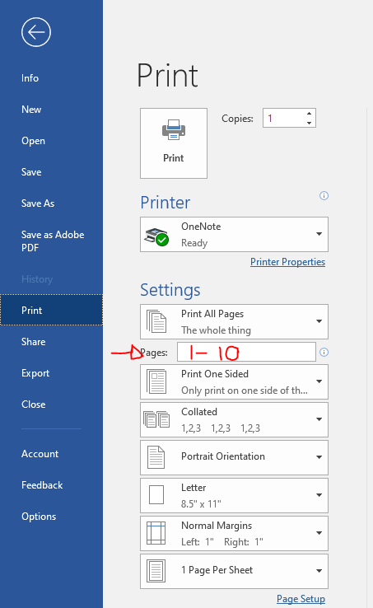
How to Print
Step 1. Print you documents as you normally would. (Number of pages printing cannot exceed 10 or it won’t print. If it does exceed 10 pages in the print menu input 1-10 in the pages box. see image for reference.)----->

Step 2. Click on the windows icon in the lower left and type Web client, then double click it. (if it doesn’t open right click on the Blue Z icon in the lower right corner and click open.)

Step 3. Once the program opens, log in using your student ID and the month/day born as your pin.

Step 4. Click the check box to select the documents you want to print and then click “pay and print”

