College Algebra Supplemental Material
for Biology Majors

This manual is the result of collaborative efforts between faculty from the Dept. of Mathematics and Life Sciences at Los Angeles Mission College and Mathematics faculty at University of California, Los Angeles

This manual is best used in conjunction with Academic Excellence Workshop manual. Website: https://bit.ly/2QCe0ld

January 2020

Funding for this publication was provided by NSF HSI Award number 1832348

College Algebra Academic Success Workshops Table of Contents
Content Worksheets 1
Factoring Review 2
Modeling with Linear Equations 3
Functions and Graphs 4
Polynomial Functions 6
Rational Functions 7
Exponential Functions 9
Systems of Equations 11
Sequences 12
Test Reviews 14
Cartesian Coordinate System and Functions Review 15
Solving Equations Review 21
Polynomial and Rational Functions Review 24
Logarithm and Exponential Functions Review 28
Systems of Equations Review 31
Conic Sections Review 34
Sequences and Series Review 37
Cumulative Review 39
Articles 44
Brainology and Mindset 45
When Biology Gets "Quirky", Scientists Turn to Math 52
Scientists use Math Modeling to Predict Unknown Biological Mechanism Regulation 55
Math Modeling Integral to Synthetic Biology 57
A Mathematical Approach to Understanding Intra-Plant Communication 59
Acknowledgements & Credits 62

Content Worksheets

Factoring Review

One of the challenges students face in College Algebra is the difficulty to recognize complicated looking problems as needing the same skills as those in earlier classes. To be able to do that, you must first make sure that you understand the reasons behind all the choices in methods we use. Here are some exercises to practice this:

- Factor x⁵ y⁵ + x⁷ y

Why did you choose the method that you used? Think about all the steps that you took and choices that you made in the factoring this problem. Some of these may have been completely subconscious. Try to apply those same steps to the following problems.
  - Factor x−4 y−3 + x−5 y−1
1 − 1 1 1
  - Factor x 4 y 2 + x3 y 2
1 − 1 1 3
c) Factor ( x + 2)5 ( y −1) ⁴ + ( x + 2)2 ( y −1) ⁴

- Factor both x² − 64 and x³ − 64
Now once again think about all the necessary steps and the choices you had to make. And try these problems:

  - Factor (x + 5)² − 64
  - Factor x⁶ − 8
  - Factor x⁶ − 4
  - Factor x⁶ − 64

- Factor x² − 2x − 24
Once you have thought about how you recognized the process needed for these problems, see if you would have recognized that the same process would have been needed for the following, and why?

a) Factor (x + 2 y)² − 3(x + 2 y) −10
2 1
b) Factor x 3 − 2x3 − 48

- Simplify :
4 2

x 3 + x 3 −12

5
x3 + 4x

Modeling with Linear Equations
For textbook reference you can use the free opnestax Precalculus text: https://openstax.org/details/ books/precalculus Sections 2.1-2.3

A biologist is studying the effects of pollutants such as mercury in stormwater run-off on a local species of frogs. She notices that the relationship between the number of frogs and the amount of mercury present in the water can be modeled linearly. Each sampling site is 1 square kilometer area. In the first site, the water has 0.002 mg of mercury per liter, and there are 5200 frogs present. In the second sampling site further up the river, the water has 0.003 mg of mercury per liter, and there are 4600 frogs presents.
- Write a Linear model that can predict the number of Frogs per square kilometer, F, based on the amount of Mercury per Liter of Water, M.
- Graph the line (Make sure that you only graph the appropriate of the domain and range).
- Find the slope. What does this number tell us about the frogs?
- Find the x-intercept. What does this number tell us about the frogs?
- Find the y-intercept. What does this number tell us about the frogs?
- If there are less than 7000 frogs in the one square kilometer area, the mosquito population will grow unchecked. Mosquitoes carry the plasmodium parasite, which causes malaria in infected humans. What would be the maximum allowable amount of mercury in one liter of water, if we want to prevent the spread of malaria?

- Crickets chirp by vibrating their wings. Since Crickets are ectotherms (cold-blooded) the rate of their physiological processes and their overall metabolism are influenced by temperature. The relation between the number chirps per second, C, and the temperature in degrees of Fahrenheit, F, can be modeled using a linear equation. Given that crickets chirp 20 times per second when the temperature is 88.6º and 16 times per second when the temperature is 80.6º.
  - Write a linear equation for calculating the number of chirps based on the temperature)
  - Graph the equation
  - Find the slope. What does this number tell us about the crickets?
  - Find the x-intercept. What does this number tell us about the crickets?
  - Find the y-intercept. What does this number tell us about the crickets?
  - At what temperature would the crickets chirp 17 times per second?

Functions and Graphs

- When a medicine is taken orally, the amount of drug in the bloodstream after t hours is measured and
64
48
32
16

modeled by the function y =
the graph.
f (t) , as shown in

  - Find
f (3) .

  - Phrase your answer to part a as a sentence in the context of the medicine.
Units
  - When does the level of the drug reach its maximum value and how many units are in the blood stream?
  - Write in interval notation, the time interval during
which the amount of the drug in the blood stream is 0 increasing.
  - When the drug reaches its maximum level in the bloodstream, how many additional hours are required for the level to drop to 20 units?
  - Use the graph to describe in words the 9 hour period.

3 6 9
Hours

- Let t represent time measured in hours after 6 AM. The physical activity level of an office worker may be modeled by the following function:

⎧
f (t) = ⎪
⎨
t ² + 5 if 0 ≤ t ≤ 3
14 if 3 < t ≤ 9

⎪−2t + 32 if 9 < t ≤ 16
⎩

  - Graph the function above.
  - What are the peak activity hours for this person?
  - Is the person more active at 8 AM or 8 PM?
  - Find an AM time when the person is equally active as they are at the same PM time.
  - In what ways would you expect the activity level of a construction worker to be different? How could you alter the office worker function to reflect this difference?

- Once a species is introduced in a region, its population’s size after t years can be modeled using the function f (t) = −t ² +16t + 40 . The average rate of growth for populations over a period of

time, h, depends on the number of years that has elapsed and can be calculated using the
f (t + h) − f (t)
difference quotient .
h

  - Use the difference quotient to come up with a general formula for the rate of change.
  - Use your answer in part a) to calculate the average rate of change for the population size over a 3 year period starting year 4.

  - Using
f (t) , calculate the population size at year 3 and then again at year 7. What was the

average change per year over the 4 years? Does your answer match part b0?

- When a thermal inversion layer is over a city (as it happens in San Fernando Valley), air pollutants get trapped and cannot rise and therefore must disperse horizontally. Assume that a factory in Sylmar begins emitting a pollutant at 8:00 AM and the pollutant dispersed horizontally over a circular area. If t represents the time, in hours since the factory began emitting pollutants, assume that the radius of the circle of pollutants is r(t) = 2t . Recall that the area of

a circle is a function of its radius and can be represented using
  - Find ( A □ r)(t)
  - Interpret ( A □ r)(t) in terms of the pollution.
A(r) = π r ² .

  - What is the area of the circular region covered by the layer at noon?
  - Under what conditions would the circular model of pollution dispersion not be realistic? How could you alter the model to make it more realistic in the scenario you identified?

Polynomial Functions

- Copper in high doses can be lethal to aquatic life. The following table lists the measurements of copper concentration in freshwater, C taken at various distances x kilometers downstream taken by a biologist team studying the pollution impact on freshwater mussels..

x (km) | 5 | 21 | 37 | 53 | 59
C (ppm) | 20 | 13 | 9 | 6 | 5

Statistical software programs can be used to fit various equations to gathered data. Biologists have used such a regression program and have found that the quadratic equation

C = .00345x2 − .4933x + 22.23
graph of the equation).
fits the data very closely (the data points are very close to the

  - Concentrations above 10 ppm are lethal to mussels. According to the model how far downstream does the toxic water extend?
  - Find the vertex for the quadratic model generated by the computer.
  - Sketch the proposed parabola using its vertex and y-intercept.
  - Discuss the validity of the model for both short and long distances.
  - How would a realistic graph of the water pollution really look?

- Based on gathered dates, the quadratic function
f (x) = 0.0058x2 − .038x + 2.660 models the

worldwide atmospheric concentration of carbon dioxide (CO₂) in parts per million (ppm) over the period 1960 – 2013, were x = 0 represents the year 1960. If the model continues to apply, answer the following questions:
  - What will the concentration of CO₂ be in 2020?
  - What year had the lowest concentration of CO₂? What is the lowest concentration of the CO₂ measured?
  - When will the concentration reach 47 ppm?
- Sketch the proposed parabola using its vertex and y-intercept.
- Discuss the validity of the model both short term and long term.
- How are the concerns about the model different in problems 1 and 2?
- How would a realistic graph of the water pollution really look?

- As you have noticed in the above problems, quadratic equations are not always the best models for gathered data. To familiarize ourselves with other types of polynomials that can be used we

will examine a cubic function
f (x) = 14x3 + 4x2 − 8x −10

  - List all possible rational roots.
  - Test the roots to see if any work.
  - Find all the roots (real or imaginary)
  - Sketch a graph for the above equation using its intercepts and the sign for y value.

Rational Functions
- Ecologists and evolutionary biologists often use the size of the population, N (census population size) to assess population health and to identify processes that shape evolution. For example, genetic drift plays a larger role in smaller populations. Population size, however, may not always be a good measure. For example, a population may consist of 95% sexually immature and 5% sexually mature individuals. In such cases, effective population size (Ne) may be computed based on the number of individuals that actually take part in reproduction. Effective population size and census population size may be drastically different when the number of breeding males and breeding females in a population are not close (e.g. polygamous species and social insects). In this case, we can express effective population size using a rational function as,

N = 4N f Nm ,
e

N f + Nm

Where Nf and Nm are the number of breeding females and breeding males, respectively. We will also assume that, Nf + Nm = N.

  - If the number of breeding males and females are equal, how does the effective population size compare to the census size?

  - If the effective size of a given population is 1000 and the number of breeding females is a 400, what is the number of breeding males?

  - In most insect colonies, the number of breeding females is fixed, while the number of breeding males may fluctuate based on ecological factors. As the number of breeding males increases, the supply of food and competition will eventually limit the effective size of the population. Suppose that an insect colony has 500 breeding females. Find the limit on the effective size of the population as the number of males gets bigger.

  - Would this function have any vertical asymptotes? Explain.

- To further examine rational functions, we will use your calculator to study the function’s behavior for very large values. For each of the following functions complete the table for each function, and in your words describe what happens to the function.

1
x | f(x)
10
100
1000
10,000

  - f (x) =
x

  - f (x) =

5

x + 2
x | f(x)
10
100
1000
10,000

  - f (x) =
5x x + 2

d) f (x) = 6x − 4
x | f(x)
10
100
1000
10,000

2x +1
x | f(x)
10
100
1000
10,000

e) f (x) = 6x − 4
x | f(x)
10
100
1000
10,000

2x² +1

6x² − 4
x | f(x)
10
100
1000
10,000

- f (x) =
2x +1

2x² − 4
x | f(x)
10
100
1000
10,000

- f (x) =
6x² +1

- Look back at each of the functions and the see if you can form a hypothesis on the effects of the exponents, coefficients, and the constant terms on the end behavior of each function.

- The activity of an immune system invaded by a parasite can be modeled by the function
an²

f (n) =
b + n²
, where n measures the number of larvae in a host, a is a constants that

depends on the type of parasite and b is a measure of the sensitivity of the immune system. The immune system’s activity increases as the number of larvae increase. If for a certain parasite a = 0.2 and the hosts immune system’s sensitivity is given by b = 17, find the maximum activity for the host’s immune system.

Exponential Functions

- Exponential functions can be used to model the concentration of a drug in a patient's body. Suppose the concentration of Drug X in a patient's bloodstream is modeled by

C(t) = C e^{−rt}
0
where C (t) represents the concentration at time t (in hours), C0 is the

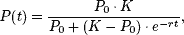
concentration of the drug in the blood immediately after injection, and r > 0 is a constant indicating the removal of the drug by the body through metabolism and/or excretion. The rate constant r has units of 1/time (1/hr). It is important to note that this model assumes that the blood concentration of the drug (C0) peaks immediately when the drug is injected. (Source: Biology Project, University of Arizona)

  - Suppose that a drug has a removal rate constant of r = 0.080 1/hr and an initial concentration (C0 ) of 5.0 mg/L. Find the drug concentration after 4.0 hours to the nearest tenth
  - If the initial concentration of a drug is 10 mg/L, and after 2 hours the concentration reduces to 8.5 mg/L , find the constant r to the nearest hundredth.
  - If for Drug X, r = 0.20 1/hr, how long after injection does the concentration of a Drug X decrease to 35% of its initial level? Round your answer to the nearest tenth.
  - Suppose Drug X is ineffective when the concentration drops below 0.50 mg/L. If
r = 0.14 1/hr, what concentration must be initiated if the concentration is to be
0.50 mg/L after 6.0 hours? Round your answer to the nearest tenth.
  - Suppose a drug is administered with an initial concentration of 2.60 mg/L. If
r = 0.120 for this drug, and the drug is ineffective when the concentration falls below 0.650 mg/L, what is the approximate maximum time a nurse can wait to administer another dose?
  - If r = 0.22 1/ hr for a particular drug, how long does it take for the concentration to be half the initial concentration?
  - The data below correspond to a particular drug. Using the data, find the value of the constant r.

Time (hours) | Concentration (mg/L)
2.00 | 3.63
5.00 | 2.47

3) A fundamental population growth model in ecology is the logistic model. This model is more realistic than exponential growth in that logistic growth is not unbounded: the logistic model assumes that in the long run, due to competition for resources, the environment can only support some finite number of animals, called the carrying capacity. We can write the logistic model as
where P(t) is the population size at time t (assume that time is measured in days), P0 is the initial population size, K is the carrying capacity of the environment, and r is a constant representing the rate of population growth or decay independent of
competition for resources. (Source: Biology Project, University of Arizona)

- Given an initial population of 100 individuals, a carrying capacity of 250 individuals, and r = 0.4, compute the expected population size 4 days later.
- Repeat the calculation in part a with an initial population of 400. Was there a change?
- How long will it take a population of 13 with a carrying capacity of 80 to double given r = 0.2?
- Let r = 0.34, K = 100, and P0 = 12. Given these value compute the population size when t = 5, t = 10, t = 25, t = 100, and t = 1000 days. What do you notice? What do you suggest happens to the population size farther into the future (as t → ∞) ?

Systems of Equations

- A chemist has two different alcohol solutions available. One solution contains 5% alcohol and the other 12% alcohol. How much of each should be mixed to obtain 1250 gal of a solution containing 10% alcohol?

- The following table shows the number of bacteria present, in millions, measured on a surface during 5 hours. Find a function of the form f(x) = ax² + bx + c that fits this data. Using this function, what would you predict the number of bacteria present at hour 10?

Hour | Bacteria present (in millions)
0 | 20
3 | 29
5 | 85

- A zoologist wishes to plan a meal for a new zoo animal around three available foods. The percentage of the daily requirements of proteins, carbohydrates, and iron contained in each ounce of the three foods is summarized in the following table: Determine how many ounces of each food the zoologist should include in the meal to meet exactly the daily requirement of proteins, carbohydrates, and iron (100% of each) for the animal.

 | Food I | Food II | Food III
Protein (%) | 10 | 6 | 8
Carbohydrates (%) | 10 | 12 | 6
Iron (%) | 5 | 4 | 12

- Animals tend to migrate around their habitat based on the availability of resources and migration patterns of other animals. The annual migration paths of different species can be plotted on map grids, and biologists can find equations for the paths. These paths are then monitored to protect various populations from coming across new and more aggressive species or the effects of new human interaction. Suppose that for practical purposed the migration pattern for a population of antelope in an animal sanctuary can be
approximately modeled to have equation x² + y² = 16 while the path of lions in the same
sanctuary can be approximated by the equation 4x² + 25 y² = 100 .

  - Find all the places on the grid where their paths cross. Do you think that the antelope are necessarily in danger? Why or why not?

  - To avoid tunneling through a mountain, a new proposed road would cut through the sanctuary. If the road’s path in the park has equation y − x² = 3 . Will the road cross the migration path for the Antelope? How about the Lions?

Sequences

- Frequently the populations of animals grow rapidly at first and then level off because of competition for limited resources. In one study, the population of winter moth was modeled with the sequence
given below, where a_{n} represent the population density per acre during year n :
a1 = 1
a = 2.71a − 0.17(a ) 2 , for n ≥ 2
n n−1 n−1

Write the sequence for n = 1, 2, 3,...,10

n
a_{n}

Describe what happens to the population density.

- If certain bacteria are cultured in a medium with sufficient nutrients, they will double in size and then divide every 30 minutes. Let N₁ be the initial number of bacteria cells, N₂ be the number after 30 minutes, N₃ be the number after 60 minutes, and N _{j} the number after 30( j −1) minute,
  - Write N _{j+1} in terms of N _{j} for j ≥ 1.
  - If N₁ = 410 find the number of bacteria after 3 hours.
  - Describe the growth of these bacteria.

- If the bacteria are not cultured in a medium with sufficient nutrients, competition will slow the growth. According to Verhulst’s model, the number of bacteria N _{j} after 30( j −1) minutes can be modeled using
⎡ ⎤

⎢
=
N j +1 ⎢
2 ⎥
N ⎥ N j , where K is a constant and j ≥ 1

⎢1+ j ⎥
⎢⎣ K ⎥⎦
- N₁ = 410 and K = 3000 calculate the population for the first 10 hours.(Round to the nearest integer).
- Describe the growth of the bacteria with limited nutrients and compare it with the bacteria in
problem 3.
- K is called the saturation constant. Why do you think that is the name given to K? Try the above problems with different values of K.

- Male honeybees hatch from eggs that have not been fertilized, so a male bee only has one parent (a female). On the other hand, female honeybees hatch from fertilized eggs, so a female has two parents (one male and one female).

  - Following the description above, make a diagram showing the number of ancestors for in each generation for a male bee for 5 generations.
  - Write the numbers as a sequence. What kind of a sequence is this?
  - Write a formula for the sequence.
  - Using F_{n} , M_{n} and P_{n} for female, male and total population for each generation, try to find a relation between the current population and the previous generations of males and females.

Test Reviews

Cartesian Coordinate Systems and Functions Review

Graph the equation.
1) 5x + y = -1

2) y = x2 + 2

3) The points (-2, -3) and (-2, 6) are the endpoints of the diameter of a circle. Find the length of the radius of the circle.

Find the midpoint of the segment having the given endpoints.
4) (-3, 7) and (-4, 4)

Find an equation for the circle.
5) Endpoints of a diameter (3, -4), (3, 4)

Find the center and radius of the circle.
6) (x + 6)2 + (y + 9)2 = 1

Evaluate as requested.
- Given that f(x) = x , find f - 2 .
11 - x 5
- Given that g(x) = 5x3, find g(5 + h).
Graph the function.
9) f(x) = + 4
x
10) f(x) =
x + 3
11) A graph of a function f is shown below. Find f( 0).
y
3

2 (0, 2)

1
-3 -2 -1
(1, 0)
1 2 3 x
-1

-2
(2, -2)
-3

Find the domain of the function.
12) f(x) =
1 - x

13) f(x) = 1
x2 + 5x - 14

Find the domain and range of the function represented in the graph.
14)
6
5
4
3
2
1
y
-6 -5 -4 -3 -2 -1
-1
-2
-3
-4
-5
-6
1 2 3 4 5 6 x

- Suppose the sales of a particular brand of appliance satisfy the relationship S(x) = 130x + 5200, where S(x) represents the number of sales in year x, with x = 0 corresponding to 1982. In what year would the sales be 6110?

- Martyʹs Tee Shirt & Jacket Company is to produce a new line of jackets with an embroidery of a Great Pyrenees dog on the front. There are fixed costs of $670 to set up for production, and variable costs of $44 per jacket. Write an equation that can be used to determine the total cost, C(x), encountered by Martyʹs Company in producing x jackets.

- Find a linear function, h, given h(-8) = -17 and h(8) = 15.

Determine whether the pair of lines is parallel, perpendicular, or neither.
18) 3x - 4y = 6
8x + 6y = 6

Solve the problem.
19) In triangle ABC, angle A is three times as large as angle C. The measure of angle B is 15° less than that of angle
C. Find the measure of the angles.

Solve and write interval notation for the solution set. Then graph the solution set.
20) 4 < 1 - 4x ≤ 12

Solve and give interval notation for the solution set. Then graph the solution set.
21) -7x + 1 ≥ 15 or 3x + 3 ≥ -9

Determine the intervals on which the function is increasing, decreasing, and constant.
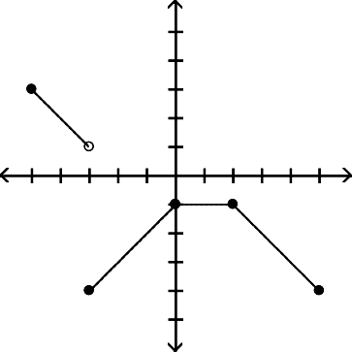
22)
5
4
3
2
1
y
-5 -4 -3 -2 -1-1
-2
-3
-4
-5
1 2 3 4
5 x

- Elissa wants to set up a rectangular dog run in her backyard. She has 36 feet of fencing to work with and wants to use it all. If the dog run is to be x feet long, express the area of the dog run as a function of x.

Solve.

- From a 15-inch by 15-inch piece of metal, squares are cut out of the four corners so that the sides can then be folded up to make a box. Let x represent the length of the sides of the squares, in inches, that are cut out. Express the volume of the box as a function of x. Graph the function and from the graph determine the value of x, to the nearest tenth of an inch, that will yield the maximum volume.

Graph the function.
25) f(x) = 3 - x, for x ≤ 2,
1 + 2x, for x > 2

Solve.

- At Allied Electronics, production has begun on the X-15 Computer Chip. The total revenue function is given by R(x) = 47x - 0.3x2 and the total cost function is given by C(x) = 6x + 13, where x represents the number of boxes of computer chips produced. The total profit function, P(x), is such that P(x) = R(x) - C(x). Find P(x).

For the function f, construct and simplify the difference quotient 27) f(x) = 6x2 + 3x
Find f(x) and g(x) such that h(x) = (f ∘ g)(x).
x + 2
x - 1
28) h(x) =
f(x + h) - f(x)
.
h

Answer the question.
  - How can the graph of f(x) = 1 (x + 2)2 - 5 be obtained from the graph of y = x2?
2

  - The resistance of a wire varies directly as the length of the wire and inversely as the square of the diameter of the wire. A 20 foot length of wire with a diameter of 0.1 inch has a resistance of 3 ohms. What would the resistance be for a 37 foot length, with diameter 0. 01 inch, of the same kind of wire ?

A graph of y = f(x) follows. No formula for f is given. Graph the given equation.
31) y = f(2x)
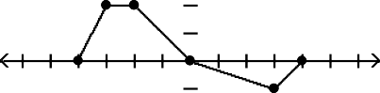
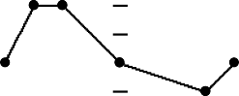
6
5
4
3
2
1
y
-6 -5 -4 -3 -2 -1-1
-2
-3
-4
-5
-6
1 2 3 4 5
6 x
6
5
4
3
2
1
y
-6 -5 -4 -3 -2 -1-1
-2
-3
-4
-5
-6
1 2 3 4 5
6 x

Answer Key

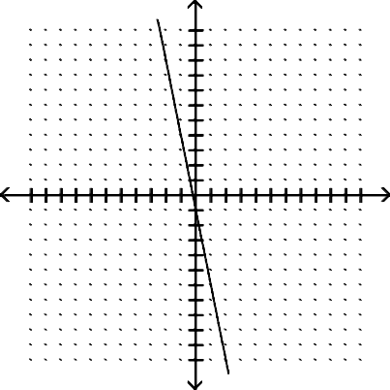
1) 10)
y
10
5
-10
-5
5
10 x
-5
-10
2)
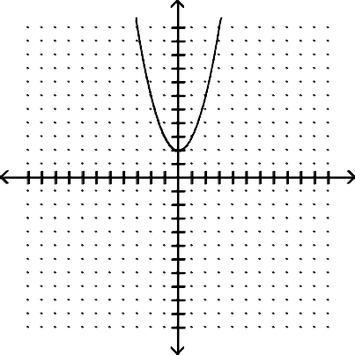
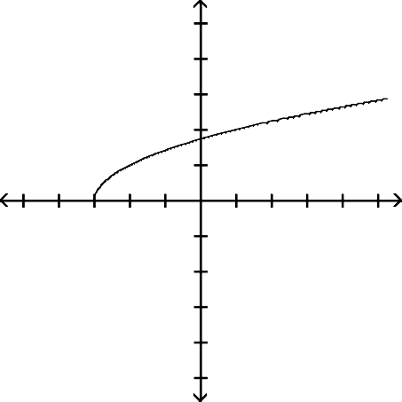
11) 2
y
10
5
-10
-5
5
10 x
-5
-10
5
4
3
2
1
y
-5 -4 -3 -2 -1
1 2 3 4 5 x
-1
-2
-3
-4
-5
12) {x|x ≤ 1}, or (-∞, 1]
13) {x|x ≠ -7 and x ≠ 2}, or (-∞, -7) ∪ (-7, 2) ∪ (2, ∞)
14) Domain: [-3, 0]; Range: [-0, 4]
15) 1989
16) C(x) = 670 + 44x
17) h(x) = 2x - 1
18) Perpendicular
19) 117°, 24° and 39°

20)
- 11 , - 3

4 4
3) 4.5

4) - 7 ,
2
11 2
-5 -4 -3 -2 -1 0 1 2 3 4 5

21) (-∞,∞)

5) (x - 3)2 + y2 = 16
6) (-6, -9); 1
7) - 2
57
8) 625 + 375h + 75h2 + 5h3
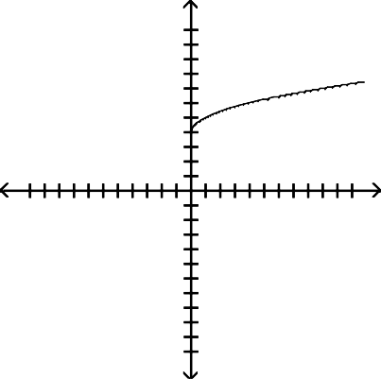
9)
y
10
5
-10
-5
5
10 x
-5
-10

-7 -6 -5 -4 -3 -2 -1 0 1 2 3 4 5 6 7

22) Increasing on (-3, 0); Decreasing on (-5, -3) and (2, 5); Constant on (0, 2)
23) A(x) = 18x - x2
24) 2.5 inches
25)

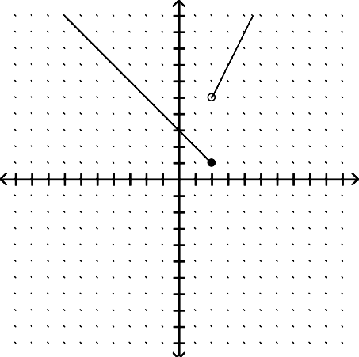
10 y
5
-10
-5
5
x
-5
-10

Answer Key
Testname: CARTESIAN COORDIANTE SYSTEMS AND FUNCTIONS

26) P(x) = -0.3x2 + 41x - 13
27) 12x + 6h + 3

28) f(x) = x, g(x) =
x + 2
x - 1

- Shift it horizontally 2 units to the left. Shrink it vertically by a factor of 1 . Shift it 5 units down.
2
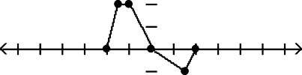
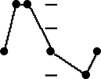
- 555 ohms 31)
6
5
4
3
2
1
y
-6 -5 -4 -3 -2 -1-1
-2
-3
-4
-5
-6
1 2 3 4 5
6 x

Solving Equations Review

  - Express the number in terms of i:
-20

2) Simplify: (9 - 5i)(2 + 4i)

3) Simplify: (7 - -64) + (4 + -9)

- Simplify: (7 - 3i)2

- Simplify:
8 + 3i
4 - 2i

- Simplify: i
5 + i

- Simplify: i17

- Simplify: i10

9) Solve:: x2 + 12x + 36 = 17

10) Find the zeros of the function. Give exact answers: f(x) = x2 - 5x + 1

11) Solve: (2p - 4)2 = 5(2p - 4) + 6

12) Solve: x2/3 - 7x1/3 + 10 = 0

- A grasshopper is perched on a reed 5 inches above the ground. It hops off the reed and lands on the ground about 5.9 inches away. During its hop, its height is given by the equation h = -0.4x2 + 1.50x + 5, where x is the distance in inches from the base of the reed, and h is in inches. How far was the grasshopper from the base of the reed when it was 3.75 inches above the ground? Round to the nearest tenth.

- The area of a square is 81 square centimeters. If the same amount is added to one dimension and removed from the other, the resulting rectangle has an area 9 square centimeters less than the area of the square. How much is added and subtracted?

- Find the vertex of the parabola: f(x) = -3x2 + 24x - 51

16) Graph: f(x) = -x2 - 2x - 1

- Find the range of the given function: f(x) = -2x2 - 12x - 14

- Find the intervals on which f(x) is increasing and the intervals where it is decreasing. f(x) = -3x2 + 18x + 81

- A projectile is thrown upward so that its distance above the ground after t seconds is h(t) = -16t2 + 420t. After how many seconds does it reach its maximum height?

- The number of mosquitoes M(x), in millions, in a certain area depends on the June rainfall x, in inches, according to the function M(x) = 3x - x2. What rainfall produces the maximum number of mosquitoes?

21) Solve: 1 + 1 + 1 = 9
t 3t 5t

22) Solve:
4
m + 3
+ 5 m
= 3m + 3 m2 + 3m

23) Solve: 1 - 1 = 6

x - 6 x
x2 - 6x

- Solve:
3
2x - 5

+ 9 = 5

- Solve:
3x + 14
= x + 3

26) Solve: 2x + 3 - = 1
x + 1

27) Solve: x1/3 = -5

28) Solve 1 = 1 + 1 , for T2
Q T1 T2

29) Solve: Z = A(1 + x)1/3, for x 30) Solve: 8 - 4x + 3 = 5
31) Solve: ∣3x + 5∣ = 6

- Solve and write interval notation for the solution set: ∣7x + 5∣ < 15

- Solve and write interval notation for the solution set: |11x + 7| < 0

- Solve and write interval notation for the solution set:
4x - 1 > 4
5

- Solve and write interval notation for the solution set: |3x - 7| > -6

Answer Key

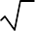
1) 2 5 i
2) 38 + 26i
3) 11 - 5i
4) 40 - 42i
29) x =
30) - 3
2
Z 3
1
-
A
, 0

32 - 2
3
5)
+ 16 + 4 i
31) - 11 , 1

20 20 3 3
3

6) 1 + 5 i

32)
- 20 , 10

26 26 7 7

7) i 8) -1
17
33) No solution
19

21

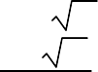
9) -6 + 17, -6 -
34)
-∞, -
∪ , ∞
4 4

5 ± 21
10)
2
11) 3 , 5
2
12) 8, 125
13) 4.5 in.
14) 3 cm 15) (4, -3) 16)
35) (-∞, ∞)

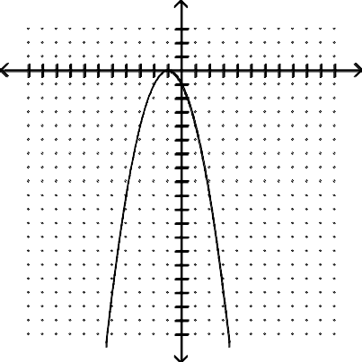
y
-10
-5
5
10 x
-5
-10
-15
17) (-∞, 4]
- Increasing on (-∞, 3); decreasing on (3, -∞)
- 13 sec
20) 1.5 in.
21) 23
135
22) - 2
- {x|x is a real number and x ≠ 0 and x ≠ 6} 24) - 59
2
-3 +
29
25)
2
26) 3, -1
27) -125
QT1
28) T2 = T1 - Q

Polynomials and Rational Functions Review

  - Is -3 a zero of the function f(x) = x4 - 3x2 - 54 ?

  - Find the zeros of the polynomial function f(x) = -6x2(x - 9)(x + 1)3 and state the mutliplicity.

  - Find the zeros of the polynomial function f(x) = x3 + x2 - 3x - 3 and state the mutliplicity.

  - Assume that a person's threshold weight W, defined as the weight above which the risk of death rises dramatically, is given 3
h 12.3
by W(h) = , where W is in pounds and h is the person's height in inches. Find the threshold weight for a person

who is 6 ft 1 in. tall. Round your answer to the nearest pound.

  - A(x) = -0.015x3 + 1.05x gives the alcohol level in an average personʹs bloodstream x hours after drinking 8 oz of 100-proof whiskey. If the level exceeds 1.5 units, a person is legally drunk. Would a person be drunk after 4 hours?

  - Graph the function: f(x) = 2x(x + 1)(x - 2)

  - Graph the function: f(x) = -x4 - 3x2

  - Graph the function: f(x) = x4 - 5x3 + 6x2

  - Graph the function: f(x) = x3 + 3x2 - x - 3

  - Graph the piecewise function: f(x) =
-x + 6, for x < -2,
9, for -2 ≤ x < 0, x2 - 5, for x ≥ 0

  - Divide x3 - x2 + 4 by x + 2 using long division.

  - Divide using synthetic division: (2x4 - x3 - 15x2 + 3x) ÷ (x + 3)

  - Find a polynomial function of degree 3 with -2, 3, 5 as zeros.

  - Find a polynomial function of degree 3 with 5, 2i, -2i as zeros.

  - Suppose that a polynomial function of degree 4 with rational coefficients has 6, 4, 3i as zeros. Find the other zero.

  - Given that 2 is a zero of the given polynomial, find the other zeros. f(x) = x3 - 4x2 + 9x - 10; 2

  - List all possible rational zeros for the polynomial. f(x) = -2x4 + 4x3 + 3x2 + 18

  - Find the rational zeros. f(x) = x3 - 8x2 + 4x + 48

  - Use Descartes' Rule of Signs to determine the possible number of positive real zeros and the possible number of negative real zeros for the function. F(x) = 9x5 - 5x4 + 3x3 - 3

x - 4
  - State the domain of the rational function. f(x) = x2 + 5x

x2 - 100
  - Find the vertical asymptote(s) of the graph: h(x) = (x - 2)(x + 4)

  - Find the horizontal asymptote, if any: f(x) =
x2 + 3x + 2 9 - x2

  - Find the horizontal asymptote, if any: f(x) = x2 + 5x - 7
x - 7

x - 4
  - Graph: f(x) = x + 5

  - Graph: f(x) =
x2 - 16

x - 4

  - The function N(t) =
0.6t + 1000
6t + 5 , t ≥ 8 gives the body concentration N(t), in parts per million, of a certain dosage of

medication after time t, in hours.

  - Find a rational function that satisfies the given conditions: Vertical asymptotes x = -3, x = 6; horizontal asymptote y = 2; x-intercept (2, 0)

x - 1
  - For the function g(x) = x + 8 , solve g(x) > 0.

  - Solve. x5 - 4x3 ≥ 0

Solve: x < 3 x - 4
30)

31) Suppose that the temperature T, in degrees Fahrenheit, of a person during an illness is given by the function

4t T(t) = t2 + 1
+ 98.6 , where t is the time, in hours. Find the interval on which the temperature is over 100∘.

Answer Key
Testname: POLYNOMIAL AND RATIONAL FUNCTIONS TEST REVIEW

- Yes 9)
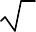
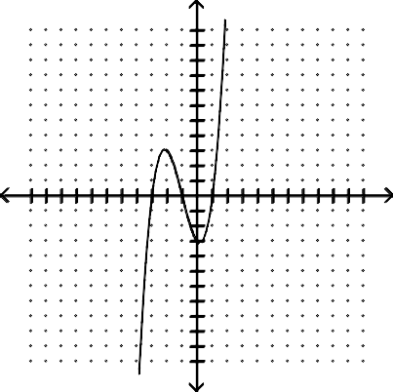
- -1, multiplicity 3; 0, multiplicity 2; 9, multiplicity 1
y
10
8
6
4
2
-10 -8 -6 -4 -2-2
-4
-6
-8
-10
2 4 6 8 10
x
- -1, multiplicity 1; 3, multiplicity 1; - 3, multiplicity 1
4) 209.1 lb
5) Yes 6)

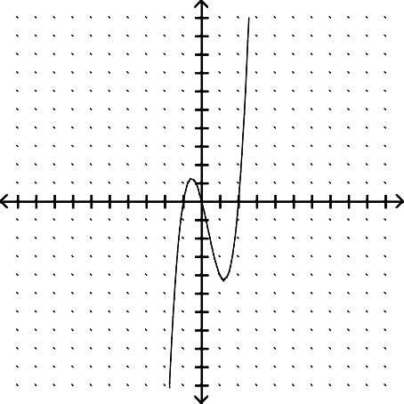
10)
10 y
5
-10
-5
5
x
-5
-10

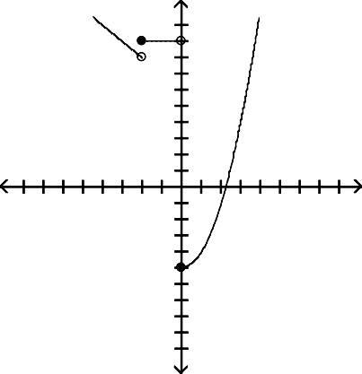
7)
10
y
5
-5
5
x
-5
-10

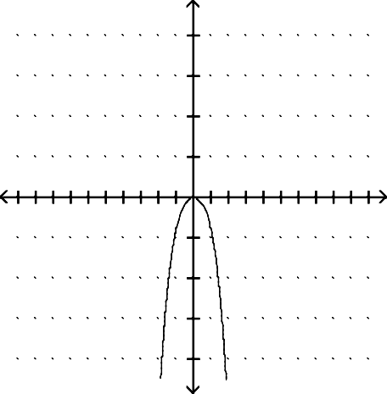
11) (x + 2)(x2 - 3x + 6) - 8
y
20

15

10

5
-10
-5
5
10x
-5

-10

-15

-20
12) Q(x) = (2x3 - 7x2 + 6x - 15); R(x) = 45
13) f(x) = x3 - 6x2 - 1x + 30
14) f(x) = x3 - 5x2 + 4x - 20
15) - 3i
16) 1 + 2i, 1 - 2i
17) ±1, ± 1 , ±2, ±3, ± 3 , ±6, ±9, ± 9 , ±18
2 2 2
8) 18) 4, 6, -2
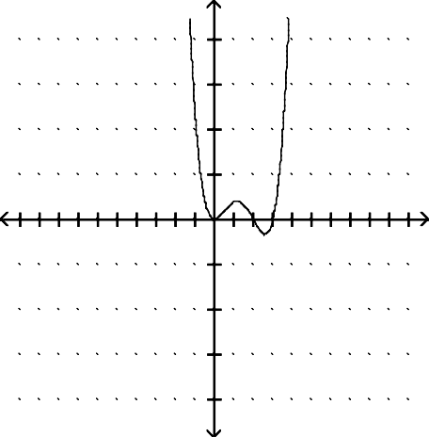
19) 1 or 3 positive; 0 negative
y
20

15

10

5
-10
-5
5
10x
-5

-10

-15

-20
20) (-∞, -5) ∪ (-5, 0) ∪ (0, ∞)
21) x = 2, x = -4
22) y = -1
- None

Answer Key
Testname: POLYNOMIAL AND RATIONAL FUNCTIONS TEST REVIEW

- x-intercept: 4, 0 ; y-intercept:
0, - 4 ;
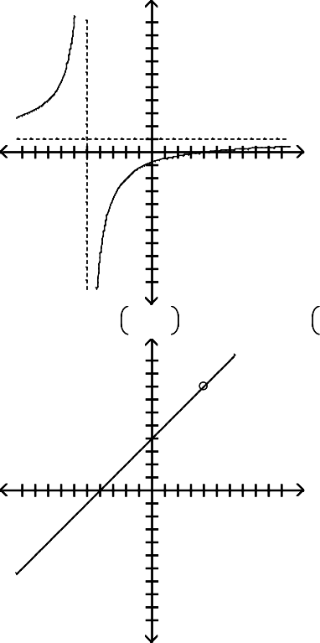
5

10
8
6
4
2

-10 -8 -6 -4 -2-2
-4
-6
-8

2 4 6 8 10

-10  25) x-intercept: -4, 0 , y-intercept: | 0, 4 | ;
10
8
6
4
2

26)
-10 -8 -6 -4 -2-2
-4
-6
-8
-10
2 4 6 8 10

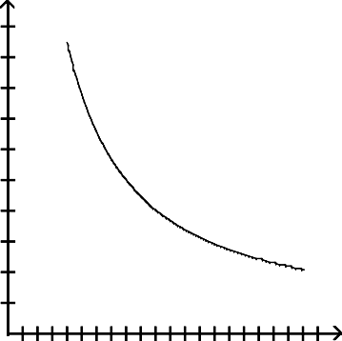
20
N

16

12

8

4

4 8 12 16 20 24 28 32 36 40 t
N(t) → 0.1 as t → ∞.
2x2 - 4x

27) f(x) =
x2 - 3x - 18

28) (-∞, -8) ∪ (1, ∞)
29) [-2, 0] ∪ [2, ∞)
30) 4, 6; (-∞, 4) ∪ 6, ∞
31) (0.408, 2.449)

Logarithm and Exponential Functions Review
Determine whether or not the function is one- to- one.
1)
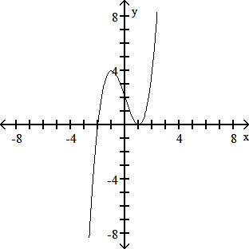

2) f(x) = x2 + 7
3) f(x) = 5x3 + 6
If the function is one- to- one, find its inverse. If not, write "not one- to- one."
4) f(x) = 3
x - 8
5) f(x) =
6) f(x) = (x + 5)2
3 x + 3
Solve the equation.

7) (
)x + 1 = 25x

8) e4x - 1 = (e3)- x
5
Find the future value.
  - $1972 invested for 12 years at 4% compounded quarterly
Solve the problem.
  - Find the required annual interest rate, to the nearest tenth of a percent, for $1100 to grow to $1400 if interest is compounded monthly for 7 years.
  - The decay of 938 mg of an isotope is given by A(t)= 938e- 0.022t, where t is time in years since the initial amount of 938 mg was present. Find the amount (to the nearest milligram) left after 96 years.
Solve the equation.
  - logx 9 = - 2

13) log(x - 5) 10 = 1
Use the properties of logarithms to rewrite the expression. Simplify the result if possible. Assume all variables represent positive real numbers.
14)
log16
9 m n

Write the expression as a single logarithm with coefficient 1. Assume all variables represent positive real numbers.
15) (loga t - loga s) + 4 loga u
Use the change of base rule to find the logarithm to four decimal places.
16) log 9 62.74
Solve the equation. Round to the nearest thousandth.
17) 4(x - 1) = 22
18) 5e(4x - 1) = 25
Solve the equation and express the solution in exact form.
19) log(x + 10) = 1 + log(4x - 3)
20) log9 (x - 4) + log9 (x - 4) = 1
Solve for the indicated variable.
- f = i - k ln t, for t
Solve the problem.
- How long must $5300 be in a bank at 5% compounded annually to become $9993.94? (Round to the nearest year.)
- The growth in population of a city can be seen using the formula p(t) = 10,124e0.004t, where t is the number of years. According to this formula, in how many years will the population reach 15,186? Round to the nearest tenth of a year.
- Suppose f(x) = 34.0 + 1.3log (x + 1) models salinity of ocean water to depths of 1000 meters at a certain latitude. x is the depth in meters and f(x) is in grams of salt per kilogram of seawater. Approximate the depth (to the nearest tenth of a meter) where the salinity equals 37.
Suppose that y 2 - log (100 - x) can be used to calculate the number of years y for x percent of a population of 0.29
499 web- footed sparrows to die. Approximate the percentage (to the nearest whole per cent) of web- footed sparrows that died after 3 yr.
25) =

Answer Key
Testname: Logarithm and Exponential Functions Review

- No
- No
- Yes
4) f- 1(x) = 8x + 3
x
5) f- 1(x) = x3 - 3
6) not a one- to- one
7) 1 3
8) 1 7
9) $3179.31
10) 3.5%
11) 113
12) 1 3
13) {15}
- log16 9 + 1 log16 m - log16 n
2

- loga
tu4 s

16) 1.8837
17) {3.230}
18) {0.652}
19) 40 39
20) {7}
- t = e(i - f)/k
- 13 yr 23) 101.4 yr 24) 202.1 m 25) 87%

Systems of Equations Review

Solve the following Systems using any method: 1) 8x + 36 = -4y
-5x - 2y = 20

2) -3x + 4y = 24
-6x = 22 - 8y

3) 3 x - 1 y = -18
2 3
3 x + 2 y = -9
4 9

4) x + 2y = 18
4x + 8y = 72

  - Jim wants to plan a meal with 82 grams of carbohydrates and 1260 calories. If green beans have 7 grams of carbohydrates and 30 calories per half cup serving and if french fried shrimp have 9 grams of carbohydrates and 190 calories per three-ounce serving, how many servings of green beans and shrimp should he use?

  - A student takes out two loans totaling $11,000 to help pay for college expenses. One loan is at 7% simple interest, and the other is at 10% simple interest. The first-year interest is $890. Find the amount of the loan at 10%.

  - In a chemistry class, 5 liters of a 4% silver iodide solution must be mixed with a 10% solution to get a 6% solution. How many liters of the 10% solution are needed?

Solve the system.
8) 2x + 4y + 10z = 105 x + 2y + 5z = -21
x + y + z = -5

9) x - y - 5z = -4
y + 3z = 6 x + y + z = 8

Let u represent 1 , v represent 1 , and w represent 1 . Solve first for u, v, and w. Then solve the system of equations.
x y z
10) 1 + 1 + 1 = - 1
x y z 5
1 - 1 - 9 = 37
x y z 15
2 + 1 + 1 = - 2
x y z 5
Find the product, if possible.

11)
-1 3
1 4
0 -2 6
1 -3 2

Evaluate the determinant.
2 0 0
12) 7 -9 0
-9 5 7

Solve using Cramerʹs rule.
13) 4x + 3y - z = 2
x - 9y + 6z = 31 7x + y + z = 17

Decompose into partial fractions.
9x - 31

14)
x2 - 7x + 12

15)
26x2 - 76x + 54 (x - 5)(2x - 1)2

Graph

16) y ≤ 4x - 5, y ≥ -x

17) 4y - x > -28, y + 4x < 23,
4x > y, y < 0

Answer Key

1) (-2, -5)
2) No solution 3) (-12, 0)
- Infinitely many solutions
- 4 half cups of beans and 6 three-ounce helpings of shrimp
6) $4000
7) 2.5 L
- No solution
9) (2z + 2, -3z + 6, z)
10) (-5, 3, -3)
11)
3 -7 0
4 -14 14
12) -126
13) (1, 2, 8)

14) 5
x - 4
+ 4
x - 3

15) - 5 + 5 + 4

16)
(2x - 1)2
2x - 1
x - 5

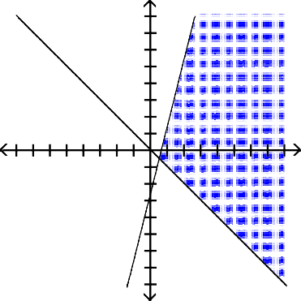
16 y
-16
x
-16
17)
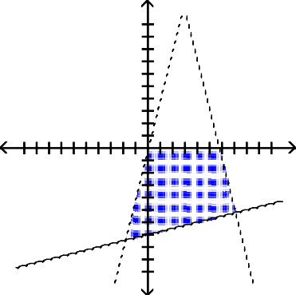
10
y
-10
10 x
-10

  - Graph: y2 - 5x = 0

Conic Sections Review

  - Find the focus and directrix: y2 = - 28x
  - Find the equation of a parabola given: Focus (0, - 6), directrix y = 6
  - Find the equation of a parabola given: Focus (- 3, - 5), directrix y = 9
  - Find the vertex, the focus, and the directrix of the parabola: (y + 2)2 = 12(x + 4)
  - Find the vertex, the focus, and the directrix of the parabola: y2 + 8x + 2y + 25 = 0
  - A searchlight is shaped like a paraboloid of revolution. If the light source is located 2 feet from the base along the axis of symmetry and the opening is 14 feet across, how deep should the searchlight be?
  - Find the equation of a paraboala with the following: Vertex: (2, 3); horizontal axis of symmetry; containing the point (18, 1)
  - Find the center and radius for the circle: x2 + y2 - 16x - 2y = - 16
  - Find the vertices and foci of the ellipse: x2 + y2 = 1
25 4

  - Find the vertices and foci of the ellipse: 36x2 + 49y2 = 1764
  - Find the equation of an ellipse with the following: Vertices: (- 15, 0) and (15, 0); length of minor axis: 14
  - Find the equation of an ellipse with the following: Foci: (- 1,1) and(- 1,- 5); length of major axis: 10
  - Find the equation of an ellipse with the following:: Vertices: (- 2, - 10) and (- 2,2); endpoints of minor axis: (- 4, - 4) and (0, - 4)

Find the equation of the hyperbola: Center at (0, 0); focus at (0, 2 5); vertex at (0, 4)
  - Find the equation of the hyperbola: : Asymptotes y = 2 x, y = - 2 x; one vertex (9, 0)
9 9

  - Find the equation of the hyperbola: Vertices at (0, 7) and (0, - 7); foci at (0, 11) and (0, - 11)
  - Find the vertices of the hyperbola: 36x2 - 4y2 = 144
  - Graph: 4x2 - y2 = 4

20) Graph: 9x2 + 36y2 = 324
21) (x - 2)2 + (y + 1)2 = 1

9 4

Answer Key
CONIC SECTIONS REVIEW

1)

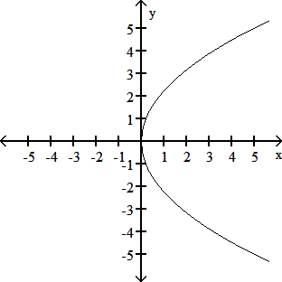
2) F: (- 7, 0); D: x = 7
3) x2 = - 24y
4) (x + 3)2 = - 28(y - 2)
5) V: (- 4, - 2); F: (- 1, - 2) ; D: x = - 7
6) V: (- 3, - 1); F: (- 5, - 1); D: x = - 1
7) 6.1 ft
8) 1 (x - 2) =(y - 3)2
4
9) (8, 1); r = 7
10) V: (- 5, 0), (5, 0);
F:(- 21, 0), ( 21, 0)
11) V: (- 7,0), (7, 0);
F: (- 13, 0), ( 13, 0)
19)

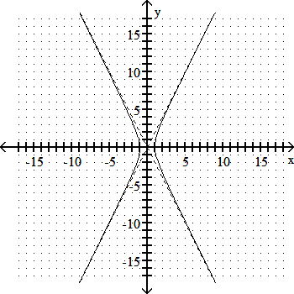
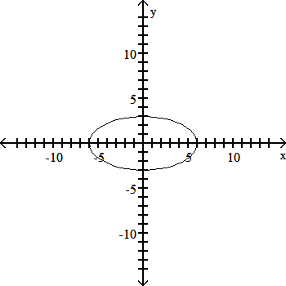

- x2 225
+ y2 = 1 49

21)

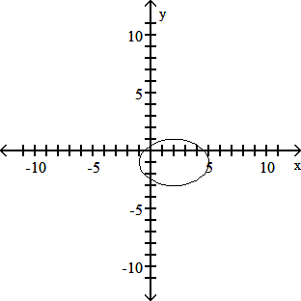
13) (y + 2)2 + (x + 1)2 = 1
25 16
14) x + 2 2 + y + 4 2 = 1
4 36
15) y2 - x2 = 1
16 4
16) x2 - y2 = 1
81 4
17) y2 - x2 = 1
49 72
18) (- 2, 0), (2, 0)

Sequences and Series Review
  - Find the first 5 terms of the sequence: an = 4n - 9

5n - 1
=
  - Find the first 5 terms of the sequence: an n2 + 5n

  - Find the first 5 terms of the given sequence: a1 = 4, a2 = 5, an + 1 = an + an - 1

  - Find the first 5 terms of the given sequence: a 1 = -7, an + 1 = an + 3

5) Find a7; an = (5n - 7)(6n - 5)

- Write an equation for the sequence: 2 , 3 , 4 , 5 , 6 , . . .
3 4 5 6 7

- Evaluate:
4
∑ (i2 - 5)
i=1

- Evaluate:
5
∑
k=2
1
4k(k + 1)

- Find the 12th term of the arithmetic sequence: 6.1, 5.6, 5.1, . . .

- Find a37, given a1 = 3 and d = -5

- Write a formula for Sn given: a1 = 21, d = -3, and n = 19

- The population of a species at the beginning of 1989 was 27,900 . If the population decreased 250 per year, how many exisated at the beginning of 2001?

13) Find the common reatio: 3, -9, 27, -81, 243, . . .

- Find the 10th term of the geometric sequence: 2 , -6 , 18 , . . .

- Write the general formula for the geometric sequence: 49, 7, 1, . . .

- Find the sum of the first 10 terms in the geometric series 1 + 1 + 1 . . .
45 15 5

∞ 1 i-1

- Find the sum, if it exists:
∑ 23 5
i=1

- Find the infinite sum if it exists: 0.42 + 0.0042 + 0.000042 + . . .

Answer Key:

1) -5, -1, 3, 7
2) 2 , 9 , 7 , 19
3 14 12 36
3) 4, 5, 9, 14
4) -7, -4, -1, 2
5) 3551
n + 1
6) n + 2
7) 10
8) 1
12
9) 2.1
10) -177
11) -114
- 24,150 people 13) -3
14) -486
15) 73-n
16) 1093
45
17) 115
4
18) 14
33

1) Factor. 8m7/4 - 9m- 1/2

2) Simplify: (x- 5 y9)(x- 2 y7)- 1

3) Solve: x - 5 = 50

Cumulative Review

x - 5
x + 5
x2 - 25

4)

Solve: 2x + 3 - x + 1 = 1
4 + 2
x
  - Simplify: x 1
4 + 8

  - Simplify: i42

  - Solve: V = 1
m

2Vem, for m

  - Solve: x3 + 8 = 0
  - Solve the equation: 2x- 2 - 12x- 1 + 10 = 0
Solve and graph the inequality. Give answer in interval notation.
10) - 1 ::C x + 1 ::C 3
2
Solve the rational inequality. Write the solution set in interval notation.
11) x + 13 < 5
x + 8
Solve the inequality. Write the solution set in interval notation.
12) (x + 10)(x - 8)(x + 2) > 0
13) |5x - 6| - 1 ? 7
- Find the center- radius form of the equation of the circle having a diameter with endpoints (- 5, 1) and (3, 7).
- A biologist recorded 6 snakes on 20 acres in one area and 9 snakes on 45 acres in another area. Find a linear equation that models the number of snakes in x acres.
For the polynomial, one zero is given. Find all others.
16) P(x) = x3 - 3x2 - 5x + 39; - 3

Find a polynomial of degree 3 with real coefficients that satisfies the given conditions.
17) Zeros of - 3, - 1, 4 and P(2) = 15
Give all possible rational zeros for the following polynomial.
18) P(x) = - 2x4 + 5x3 + 2x2 + 18
Graph the function.: f(x) =
3x - 2, if x < 2 3x + 1 if x ? 2

19)

20)

Graph the function.: g(x) = - x + 2 + 1
21) Compute and simplify the difference quotient f(x + h) - f(x) , for f(x) = 8x2 + 9x
h

22) Divide. -16x3 + 8x2 + 23x + 6
- 4x - 3
23) Graph: f(x) = x3 + 4x2 - x - 4
- A $128,000 trust is to be invested in bonds paying 9%, CDs paying 6%, and mortgages paying 10%. The bond and CD investment together must equal the mortgage investment. To earn a $11,170 annual income from the investments, how much should the bank invest in bonds?
- Find the number of years for $6600 to grow to $14,300 at 6% compounded quarterly. Round to the nearest tenth of a year.
If the function is one- to- one, find its inverse. If not, write "not one- to- one."
26) f(x) = 3
x - 8
27) Find the partial fractions for: 4x - 20
+ -
(x 5)(x 3)
Solve the equation and express the solution in exact form.
28) log9 (x - 7) + log9 (x - 7) = 1
Solve the equation.
29) 3(6 - 3x) = 1
27

30)
ex - 3 = 1 x + 2
e6

Solve the equation. Round to the nearest thousandth.
31) 166(1.28)x/4 = 332
Solve the equation. Give the answer in exact form.
32) 52x + 3(5x) = 28
Solve the equation.
33) log(x + 7) 11 = 1
Solve the system.
34) 4x + 5y + z = - 18 5x - 4y - z = 31 2x + y + 4z = - 5
Give all solutions:
35) x2 + y2 = 41
x + y = - 9

Answer Key
Testname: CUMULATIVE REVIEW

1) m- 1/2(8m9/4 - 9)
2) y2 x3
3) 0
4) {3, - 1}
5) 16
x
6) - 1
7) m = 2e
V
8) {- 2, 1 ± i 3}
9) 1, 1
5
10) [- 3, 5]

11) (- 00, -8) u - 27 , 00
4
12) (- 10, - 2) u (8, 00)
2
5

13) 00, -
u 14 , 00
5

14) (x + 1)2 + (y - 4)2 = 25
15) y = 3 x + 18
25 5
16) 3 + 2i, 3 - 2i
17) P(x) = - x3 + 13x + 6
2 2
18) ±1, ± 1 , ±2, ±3, ± 3 , ±6, ±9, ± 9 , ±18
2 2 2
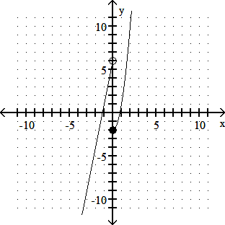
19)

Answer Key
Testname: CUMULATIVE REVIEW

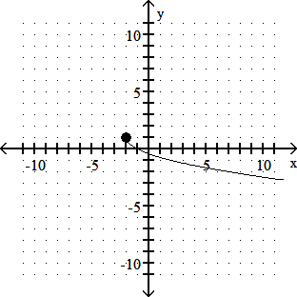
20)
21) 16x + 8h + 9
22) 4x2 - 5x - 2
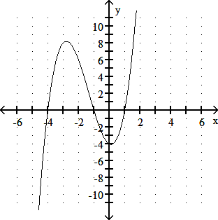
23)
24) $31,000
25) 13.0 yr
26) f- 1(x) = 8x + 3
x
27) 5 + - 1

x + 5
28) {10}
29) {3}
30) - 9 7
31) {11.231}
32) {log54}
33) {4}
x - 3

34) {(2, - 5, - 1)}
35) {(- 4, - 5), (- 5, - 4)}

Articles

Brainology and Mindset
Transforming Students’ Motivation to Learn - Carol S. Dweck - Winter 2008

PART A: This is an exciting time for our brains. More and more research is showing that our brains change constantly with learning and experience and that this takes place throughout our lives.

Does this have implications for students' motivation and learning? It certainly does. In my research in collaboration with my graduate students, we have shown that what students believe about their brains
— whether they see their intelligence as something that's fixed or something that can grow and change — has profound effects on their motivation, learning, and school achievement (Dweck, 2006). These different beliefs, or mindsets, create different psychological worlds: one in which students are afraid of challenges and devastated by setbacks, and one in which students relish challenges and are resilient in the face of setbacks.

How do these mindsets work? How are the mindsets communicated to students? And, most important, can they be changed? As we answer these questions, you will understand why so many students do not achieve to their potential, why so many bright students stop working when school becomes challenging, and why stereotypes have such profound effects on students' achievement. You will also learn how praise can have a negative effect on students' mindsets, harming their motivation to learn.

Mindsets and Achievement
Many students believe that intelligence is fixed, that each person has a certain amount and that's that. We call this a fixed mindset, and, as you will see, students with this mindset worry about how much of this fixed intelligence they possess. A fixed mindset makes challenges threatening for students (because they believe that their fixed ability may not be up to the task) and it makes mistakes and failures demoralizing (because they believe that such setbacks reflect badly on their level of fixed intelligence).

Other students believe that intelligence is something that can be cultivated through effort and education. They don't necessarily believe that everyone has the same abilities or that anyone can be as smart as Einstein, but they do believe that everyone can improve their abilities. And they understand that even Einstein wasn't Einstein until he put in years of focused hard work. In short, students with this growth mindset believe that intelligence is a potential that can be realized through learning. As a result, confronting challenges, profiting from mistakes, and persevering in the face of setbacks become ways of getting smarter.

To understand the different worlds these mindsets create, we followed several hundred students across a difficult school transition — the transition to seventh grade. This is when the academic work often gets much harder, the grading gets stricter, and the school environment gets less personalized with students moving from class to class. As the students entered seventh grade, we measured their mindsets (along with a number of other things) and then we monitored their grades over the next two years.

The first thing we found was that students with different mindsets cared about different things in school. Those with a growth mindset were much more interested in learning than in just looking smart in school. This was not the case for students with a fixed mindset. In fact, in many of our studies with students from preschool age to college age, we find that students with a fixed mindset care so much about how smart they will appear that they often reject learning opportunities — even ones that are critical to their success (Cimpian, et al., 2007; Hong, et al., 1999; Nussbaum and Dweck, 2008; Mangels, et al., 2006).

Next, we found that students with the two mindsets had radically different beliefs about effort. Those with a growth mindset had a very straightforward (and correct) idea of effort — the idea that the harder you work, the more your ability will grow and that even geniuses have had to work hard for their accomplishments. In contrast, the students with the fixed mindset believed that if you worked hard it meant that you didn't have ability, and that things would just come naturally to you if you did. This means that every time something is hard for them and requires effort, it's both a threat and a bind. If they work hard at it that means that they aren't good at it, but if they don't work hard they won't do well. Clearly, since just about every worthwhile pursuit involves effort over a long period of time, this is a potentially crippling belief, not only in school but also in life.

Students with different mindsets also had very different reactions to setbacks. Those with growth mindsets reported that, after a setback in school, they would simply study more or study differently the next time. But those with fixed mindsets were more likely to say that they would feel dumb, study less the next time, and seriously consider cheating. If you feel dumb — permanently dumb — in an academic area, there is no good way to bounce back and be successful in the future. In a growth mindset, however, you can make a plan of positive action that can remedy a deficiency. (Hong. et al., 1999; Nussbaum and Dweck, 2008; Heyman, et al., 1992)

Finally, when we looked at the math grades they went on to earn, we found that the students with a growth mindset had pulled ahead. Although both groups had started seventh grade with equivalent achievement test scores, a growth mindset quickly propelled students ahead of their fixed-mindset peers, and this gap only increased over the two years of the study.

In short, the belief that intelligence is fixed dampened students' motivation to learn, made them afraid of effort, and made them want to quit after a setback. This is why so many bright students stop working when school becomes hard. Many bright students find grade school easy and coast to success early on. But later on, when they are challenged, they struggle. They don't want to make mistakes and feel dumb — and, most of all, they don't want to work hard and feel dumb. So they simply retire.

It is the belief that intelligence can be developed that opens students to a love of learning, a belief in the power of effort and constructive, determined reactions to setbacks.

PART B: How Do Students Learn These Mindsets?
In the 1990s, parents and schools decided that the most important thing for kids to have was self- esteem. If children felt good about themselves, people believed, they would be set for life. In some quarters, self-esteem in math seemed to become more important than knowing math, and self- esteem in English seemed to become more important than reading and writing. But the biggest mistake was the belief that you could simply hand children self-esteem by telling them how smart and talented they are. Even though this is such an intuitively appealing idea, and even though it was exceedingly well-intentioned, I believe it has had disastrous effects.

In the 1990s, we took a poll among parents and found that almost 85 percent endorsed the notion that it was necessary to praise their children's abilities to give them confidence and help them achieve. Their children are now in the workforce and we are told that young workers cannot last through the day without being propped up by praise, rewards, and recognition. Coaches are asking me where all the coachable athletes have gone. Parents ask me why their children won't work hard in school.

Could all of this come from well-meant praise? Well, we were suspicious of the praise movement at the time. We had already seen in our research that it was the most vulnerable children who were already obsessed with their intelligence and chronically worried about how smart they were. What if praising intelligence made all children concerned about their intelligence? This kind of praise might tell them that having high intelligence and talent is the most important thing and is what makes you valuable. It might tell them that intelligence is just something you have and not something you develop. It might deny the role of effort and dedication in achievement. In short, it might promote a fixed mindset with all of its vulnerabilities.

The wonderful thing about research is that you can put questions like this to the test — and we did (Kamins and Dweck, 1999; Mueller and Dweck, 1998). We gave two groups of children problems from an IQ test, and we praised them. We praised the children in one group for their intelligence, telling them, "Wow, that's a really good score. You must be smart at this." We praised the children in another group for their effort: "Wow, that's a really good score. You must have worked really hard." That's all we did, but the results were dramatic. We did studies like this with children of different ages and ethnicities from around the country, and the results were the same.

Here is what happened with fifth graders. The children praised for their intelligence did not want to learn. When we offered them a challenging task that they could learn from, the majority opted for an easier one, one on which they could avoid making mistakes. The children praised for their effort wanted the task they could learn from.

The children praised for their intelligence lost their confidence as soon as the problems got more difficult. Now, as a group, they thought they weren't smart. They also lost their enjoyment, and, as a result, their performance plummeted. On the other hand, those praised for effort maintained their confidence, their motivation, and their performance. Actually, their performance improved over time such that, by the end, they were performing substantially better than the intelligence-praised children on this IQ test.

Finally, the children who were praised for their intelligence lied about their scores more often than the children who were praised for their effort. We asked children to write something (anonymously) about their experience to a child in another school and we left a little space for them to report their scores. Almost 40 percent of the intelligence-praised children elevated their scores, whereas only 12 or 13 percent of children in the other group did so. To me this suggests that, after students are praised for their intelligence, it's too humiliating for them to admit mistakes.

The results were so striking that we repeated the study five times just to be sure, and each time roughly the same things happened. Intelligence praise, compared to effort (or "process") praise, put children into a fixed mindset. Instead of giving them confidence, it made them fragile, so much so that a brush with difficulty erased their confidence, their enjoyment, and their good performance, and made them ashamed of their work. This can hardly be the self-esteem that parents and educators have been aiming for.

Often, when children stop working in school, parents deal with this by reassuring their children how smart they are. We can now see that this simply fans the flames. It confirms the fixed mindset and makes kids all the more certain that they don't want to try something difficult — something that could lose them their parents' high regard.

How should we praise our students? How should we reassure them? By focusing them on the process they engaged in — their effort, their strategies, their concentration, their perseverance, or their improvement.

"You really stuck to that until you got it. That's wonderful!"

"It was a hard project, but you did it one step at a time and it turned out great!"

"I like how you chose the tough problems to solve. You're really going to stretch yourself and learn new things."

"I know that school used to be a snap for you. What a waste that was. Now you really have an opportunity to develop your abilities."

PART C: Brainology
Can a growth mindset be taught directly to kids? If it can be taught, will it enhance their motivation and grades? We set out to answer this question by creating a growth mindset workshop (Blackwell, et al., 2007). We took seventh graders and divided them into two groups. Both groups got an eight- session workshop full of great study skills, but the "growth mindset group" also got lessons in the growth mindset — what it was and how to apply it to their schoolwork. Those lessons began with an article called "You Can Grow Your Intelligence: New Research Shows the Brain Can Be Developed Like a Muscle." Students were mesmerized by this article and its message. They loved the idea that the growth of their brains was in their hands.

This article and the lessons that followed changed the terms of engagement for students. Many students had seen school as a place where they performed and were judged, but now they understood that they had an active role to play in the development of their minds. They got to work, and by the end of the semester the growth-mindset group showed a significant increase in their math grades. The control group — the group that had gotten eight sessions of study skills — showed no improvement and continued to decline. Even though they had learned many useful study skills, they did not have the motivation to put them into practice.

The teachers, who didn't even know there were two different groups, singled out students in the growth-mindset group as showing clear changes in their motivation. They reported that these students were now far more engaged with their schoolwork and were putting considerably more effort into their classroom learning, homework, and studying.

Joshua Aronson, Catherine Good, and their colleagues had similar findings (Aronson, Fried, and Good, 2002; Good, Aronson, and Inzlicht, 2003). Their studies and ours also found that negatively stereotyped students (such as girls in math, or African-American and Hispanic students in math and verbal areas) showed substantial benefits from being in a growth-mindset workshop. Stereotypes are typically fixed-mindset labels. They imply that the trait or ability in question is fixed and that some groups have it and others don't. Much of the harm that stereotypes do comes from the fixed-mindset message they send. The growth mindset, while not denying that performance differences might exist, portrays abilities as acquirable and sends a particularly encouraging message to students who have been negatively stereotyped — one that they respond to with renewed motivation and engagement.

Inspired by these positive findings, we started to think about how we could make a growth mindset workshop more widely available. To do this, we have begun to develop a computer-based program called "Brainology." In six computer modules, students learn about the brain and how to make it work better. They follow two hip teens through their school day, learn how to confront and solve schoolwork problems, and create study plans. They visit a state-of-the-art virtual brain lab, do brain experiments, and find out such things as how the brain changes with learning — how it grows new connections every time students learn something new. They also learn how to use this idea in their schoolwork by putting their study skills to work to make themselves smarter.

We pilot-tested Brainology in 20 New York City schools. Virtually all of the students loved it and reported (anonymously) the ways in which they changed their ideas about learning and changed their learning and study habits. Here are some things they said in response to the question, "Did you change your mind about anything?"

I did change my mind about how the brain works…I will try harder because I know that the more you try, the more your brain works.

Yes... I imagine neurons making connections in my brain and I feel like I am learning something.

My favorite thing from Brainology is the neurons part where when u learn something, there are connections and they keep growing. I always picture them when I'm in school.

Teachers also reported changes in their students, saying that they had become more active and eager learners: "They offer to practice, study, take notes, or pay attention to ensure that connections will be made."

What Do We Value?
In our society, we seem to worship talent — and we often portray it as a gift. Now we can see that this is not motivating to our students. Those who think they have this gift expect to sit there with it and be successful. When they aren't successful, they get defensive and demoralized, and often opt out.
Those who don't think they have the gift also become defensive and demoralized, and often opt out as well.

We need to correct the harmful idea that people simply have gifts that transport them to success, and to teach our students that no matter how smart or talented someone is — be it Einstein, Mozart, or Michael Jordan — no one succeeds in a big way without enormous amounts of dedication and effort. It is through effort that people build their abilities and realize their potential. More and more research is showing there is one thing that sets the great successes apart from their equally talented peers — how hard they've worked (Ericsson, et al., 2006).

Next time you're tempted to praise your students' intelligence or talent, restrain yourself. Instead, teach them how much fun a challenging task is, how interesting and informative errors are, and how great it is to struggle with something and make progress. Most of all, teach them that by taking on challenges, making mistakes, and putting forth effort, they are making themselves smarter.

Carol S. Dweck is the Lewis and Virginia Eaton Professor of Psychology at Stanford University and the author of Mindset: The New Psychology of Success (Random House, 2006).

References

Aronson, J., Fried, C., & Good, C. (2002). Reducing the effects of stereotype threat on African American college students by shaping theories of intelligence. Journal of Experimental Social Psychology, 38, 113–125.

Binet, A. (1909/1973). Les idées modernes sur les enfants [Modern ideas on children]. Paris: Flamarion.

Blackwell, L., Trzesniewski, K., & Dweck, C.S. (2007). Implicit Theories of Intelligence Predict Achievement Across an Adolescent Transition: A Longitudinal Study and an Intervention. Child Development, 78, 246–263.

Cimpian, A., Arce, H., Markman, E.M., & Dweck, C.S. (2007). Subtle linguistic cues impact children's motivation. Psychological Science, 18, 314-316.

Dweck, C.S. (2006). Mindset. New York: Random House.

Ericsson, K.A., Charness, N., Feltovich, P.J., & Hoffman, R.R. (Eds.) (2006). The Cambridge Handbook of Expertise and Expert Performance. New York: Cambridge University Press.

Good, C. Aronson, J., & Inzlicht, M. (2003). Improving adolescents' standardized test performance: An Intervention to reduce the effects of stereotype threat. Journal of Applied Developmental Psychology, 24, 645-662.

Hong, Y.Y., Chiu, C., Dweck, C.S., Lin, D., & Wan, W. (1999) Implicit theories, attributions, and coping: A meaning system approach. Journal of Personality and Social Psychology, 77, 588–599.

Kamins, M., & Dweck, C.S. (1999). Person vs. process praise and criticism: Implications for contingent self-worth and coping. Developmental Psychology, 35, 835–847.

Mangels, J. A., Butterfield, B., Lamb, J., Good, C.D., & Dweck, C.S. (2006). Why do beliefs about intelligence influence learning success? A social-cognitive-neuroscience model. Social, Cognitive, and Affective Neuroscience, 1, 75–86.

Mueller, C. M., & Dweck, C. S. (1998). Intelligence praise can undermine motivation and performance. Journal of Personality and Social Psychology, 75, 33–52.

Nussbaum, A.D., & Dweck, C.S. (2007, in press). Defensiveness vs. Remediation: Self-Theories and Modes of Self-Esteem Maintenance. Personality and Social Psychology Bulletin.

When biology gets 'Quirky', scientists turn to math
24 July 2006

Ohio State University researchers who are trying to that lays out mathematical rules that researchers

solve a longstanding mystery in chemistry and biology are getting answers from a seemingly unusual source: mathematics. Ultimately, the project could provide a tool for clinical research, because it could explain why cells sometimes react to medicines in unexpected ways.

A chemical such as a drug could function very well inside a cell most of the time, and then suddenly not work well at all, as if a switch had been flipped. For researchers who are trying to develop new biochemical agents, this means that results can vary widely from experiment to experiment.

Martin Feinberg and his colleagues wanted to know why.

Through computer simulations, they discovered that the answer -- mathematically, at least -- could come down to the rate at which chemicals enter a cell. The results of their simulations appear in a recent issue of the Proceedings of the National Academy of Sciences (PNAS).

Feinberg, the Richard M. Morrow Professor of chemical engineering and professor of mathematics at Ohio State, and Gheorghe Craciun, formerly of Ohio State's Mathematical Biosciences Institute, created visualizations of chemical reactions called species-reaction graphs ("species" are the different chemicals in a reaction). The graphs are maps of a sort, where lines and curves connect chemicals like roads connect destinations. Craciun is now an assistant professor of mathematics and biomolecular chemistry at the University of Wisconsin.

Based on the number of connections and how they overlap, Feinberg and Craciun can tell with a glance whether a reaction is predictable, or whether it might be what they call "quirky" -- prone to the switching behavior that occasionally produces strange results. They created a theorem
can use to make the same judgment.

As it turns out, many of the graphs that describe biological reactions are quirky.

"Some of the graphs that come from classical biological reactions -- even simple ones -- indicate that these reactions might behave in very quirky ways," Feinberg said.

"This behavior may be essential to biology itself."

To test the theorem, he and his colleagues simulated a very simple chemical system on a computer: the behavior of a simplified biological cell containing an enzyme, DHFR (dihydrofolate reductase). DHFR is important in cell division because it helps provide an essential building block of DNA.

In fact, a classical chemotherapy agent, methotrexate, is used to thwart the operation of DHFR so that the out-of-control cell proliferation characteristic of cancer cannot take place.

Student Yangzhong Tang created the simulation software as part of her doctoral work. She described it as a simple computational tool which shows how rapidly DHFR converts reactants to products, depending on the rate at which reactants enter the cell. In particular, the software helps determine circumstances under which DHFR can operate in two very different conversion modes -- a rapid one and a slower one.

For the simulation, the researchers started with a low supply rate of reactants and then gradually increased the supply rate. At first, the DHFR converted reactants to products at 95 percent efficiency. Then, it abruptly dropped to 65 percent. When they decreased the flow rate, it just as abruptly returned to 95 percent.

"It was like a switch had been flipped, and the trigger was an increase or decrease of only 0.02 milliliters of reactant solution per minute," Feinberg said. "We were surprised to see that we could create such a dramatic switch just by changing the reactant supply rate a tiny amount.

"Keep in mind that this is in the absence of any methotrexate at all," he continued. "To understand what happens in the presence of the anti-cancer drug, one should be aware of the quirky phenomena that might be exhibited even when no methotrexate is present."

Seeing an unexpectedly low conversion efficiency of an enzyme during a laboratory experiment, scientists might erroneously conclude that there's something wrong with the enzyme or that the gene responsible for manufacturing the enzyme had gone awry. In fact, the real culprit might be a chemical switch, intrinsic to the mathematics, that is triggered by the reactant supply rate, Feinberg said.

The next step for the researchers is to try to observe this behavior in the laboratory. They are designing a plastic model cell with specialized filters so that they can carefully measure chemicals that enter and exit.

Several Ohio State professors have been assisting with development of that stage of the project, including Jeffrey Chalmers and S.T. Yang in the Department of Chemical and Biomolecular Engineering and Irina Artsimovitch of the Department of Microbiology.

Even after they do their laboratory experiments, Feinberg says he and his colleagues will be a long way from making any claims about what happens inside real biological cells. Their work implies that scientists should be cautious when interpreting the results of biochemical experiments, nothing more.

Still, he acknowledged that the theorem in the PNAS paper could ultimately help answer fundamental questions in chemistry, biochemistry, and evolution.

"Cells probably need a mechanism to switch readily between states in response to external signals," he
ventured. "It could be an evolutionary advantage. So I think biology wants this to happen."

Source: Ohio State University

APA citation: When biology gets 'Quirky', scientists turn to math (2006, July 24) retrieved 8 January 2019 from https://phys.org/news/2006-07-biology-quirky-scientists-math.html

This document is subject to copyright. Apart from any fair dealing for the purpose of private study or research, no part may be reproduced without the written permission. The content is provided for information purposes only.

Scientists use math modeling to predict unknown biological mechanism of regulation
14 October 2009

Orly Alter and her students worked with John F. X. Diffley, deputy director of the London Research Institute of Cancer Research UK, and members of his Chromosome Replication Lab, on experiments that were designed to test mathematical modeling to predict a previously unknown biological mechanism of regulation. The results, published online in the journal Nature Molecular Systems Biology on Oct. 13, 2009, verify the computationally predicted mechanism. Credit: University of Texas Cockrell School of Engineering

A team of scientists, led by a biomedical engineer at The University of Texas at Austin, have demonstrated - for the first time - that mathematical models created from data obtained by DNA microarrays, can be used to correctly predict previously unknown cellular mechanisms. This brings biologists a step closer to one day being able to understand and control the inner workings of the cell as readily as NASA engineers plot the trajectories of spacecraft today.

"Thanks to the Human Genome Project, biology and medicine today may be at a point similar to where physics was after the advent of the telescope," said Orly Alter, assistant professor of biomedical engineering at the university. "The rapidly growing number of large-scale DNA
microarray data sets hold the key to the discovery of cellular mechanisms, just as the astronomical tables compiled by Galileo and Tycho after the invention of the telescope enabled accurate predictions of planetary motions and, later, the discovery of universal gravitation. And just as Kepler and Newton made these predictions and discoveries by using mathematical frameworks to describe trends in astronomical data, so future discovery and control in biology and medicine will come from the mathematical modeling of large- scale molecular biological data."

In a 2004 paper published in the Proceedings of the National Academy of Sciences in collaboration with the late professor Gene H. Golub of Stanford University, Alter, who holds a Ph.D. in applied physics, used mathematical techniques inspired by those used in quantum mechanics to predict a previously unknown mechanism of regulation that correlates the beginning of DNA replication with RNA transcription, the process by which the information in DNA is transferred to RNA. This is the first mechanism to be predicted from mathematical modeling of microarray data.

For the past four years, Alter and her students worked with John F. X. Diffley, deputy director of the London Research Institute of Cancer Research UK, and members of his Chromosome Replication Lab, on experiments that were designed to test this prediction. The results, published online in the journal Nature Molecular Systems Biology on October 13, 2009, verify the computationally predicted mechanism.

A DNA microarray is a glass slide that holds an array of thousands of specific DNA sequences acting as probes for different genes, making it possible to record the activity of thousands of genes at once. Making sense of the massive

amount of data DNA microarrays generate is a major challenge. In her Genomic Signal Processing Lab, Alter creates mathematical models by arranging the data in multi-dimensional tables known as tensors. She then develops algorithms to uncover patterns in these data structures, and is able to relate these patterns to mechanisms that govern the activity of DNA and RNA in the cell.

Source: University of Texas at Austin (news : web)

APA citation: Scientists use math modeling to predict unknown biological mechanism of regulation (2009, October 14) retrieved 7 January 2019 from https://phys.org/news/2009-10-scientists-math- unknown-biological-mechanism.html

This document is subject to copyright. Apart from any fair dealing for the purpose of private study or research, no part may be reproduced without the written permission. The content is provided for information purposes only.

Math modeling integral to synthetic biology research
4 April 2014, by Kathy Major

A long-standing challenge in synthetic biology has been to create gene circuits that behave in predictable and robust ways. Mathematical modeling experts from the University of Houston (UH) collaborated with experimental biologists at Rice University to create a synthetic genetic clock that keeps accurate time across a range of temperatures. The findings were published in a recent issue of the Proceedings of the National Academy of Sciences.

"Synthetic gene circuits are often fragile, and environmental changes frequently alter their behavior," said Krešimir Josi?, professor of mathematics in UH's College of Natural Sciences and Mathematics. "Our work focused on engineering a gene circuit not affected by temperature change."

Synthetic biology is a field in which naturally occurring biological systems are redesigned for various purposes, such as producing biofuel. The UH and Rice research targeted the bacterium E. coli.

"In E. coli and other bacteria, if you increase the temperature by about 10 degrees the rate of biochemical reactions will double – and therefore genetic clocks will speed up," Josi? said. "We wanted to create a synthetic gene clock that compensates for this increase in tempo and keeps accurate time, regardless of temperature."

The UH team, led by Josi? and William Ott, an assistant professor of mathematics, collaborated with the lab of Matthew Bennett, assistant professor of biochemistry and cell biology at Rice. Josi?, Bennett and Ott have been working together on various research projects for three years. The team also included UH postdoctoral fellow Chinmaya Gupta.

According to Bennett, the ability to keep cellular reactions accurately timed, regardless of
temperature, may be valuable to synthetic biologists who wish to reprogram cellular regulatory mechanisms for biotechnology.

The work involved engineering a gene within the clock onto a plasmid, a little piece of DNA that is inserted into E. coli. A mutation in the gene had the effect of slowing down the clock as temperature increased.

UH researchers created a mathematical model to assess the various design features that would be needed in the plasmid to counteract temperature change. Gupta showed that the model captured the mechanisms essential to compensate for the temperature-dependent changes in reaction rates.

The computational modeling confirmed that a single mutation could result in a genetic clock with a stable period across a large range of temperatures
– an observation confirmed by experiments in the Bennett lab. Josi?'s team then confirmed the predictions of the models using real data.

"Having a mechanistic model that allows you to determine which features are important and which can be ignored for a genetic circuit to behave in a particular way allows you to more efficiently create circuits with desired properties," Gupta said. "It allows you to concentrate on the most important factors necessary in the design."

"Throughout this work, we used mathematical models to find out what is important in designing robust synthetic gene circuits," Josi? said. "Computational and mathematical tools are essential in all types of engineering. Why not for biological engineering?"

Josi?, Ott and Bennett's research is funded by the National Institutes of Health through the joint National Science Foundation/National Institute of General Medical Sciences Mathematical Biology Program.

Provided by University of Houston
APA citation: Math modeling integral to synthetic biology research (2014, April 4) retrieved 7 January 2019 from https://phys.org/news/2014-04-math-synthetic-biology.html

This document is subject to copyright. Apart from any fair dealing for the purpose of private study or research, no part may be reproduced without the written permission. The content is provided for information purposes only.

A mathematical approach for understanding intra-plant communication
4 January 2019, by Ingrid Fadelli

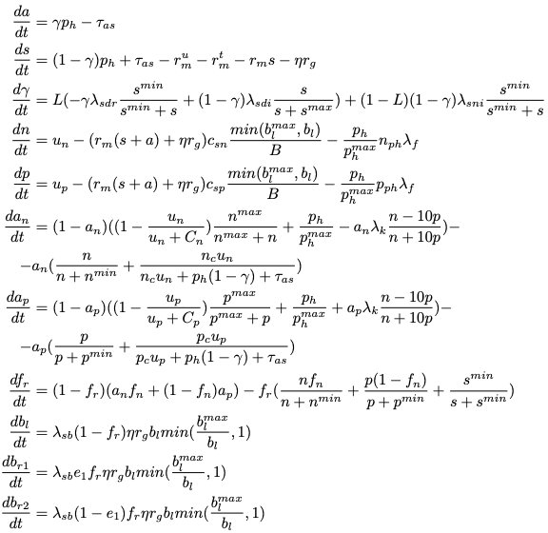

The model is composed by 11 non-linear equations: Credit: Tedone et al.

A team of researchers at the Gran Sasso Science Institute (GSSI) and Istituto Italiano di Technologia (IIT) have devised a mathematical approach for understanding intra-plant communication. In their paper, pre-published on bioRxiv, they propose a fully coupled system of non-linear, non- autonomous discontinuous and ordinary differential equations that can accurately describe the adapting behavior and growth of a single plant, by analyzing the main stimuli affecting plant behavior.

Recent studies have found that rather than being passive organisms, plants can actually exhibit complex behaviors in response to environmental stimuli, for instance, adapting their resource allocation, foraging strategies, and growth rates according to their surrounding environment. How plants process and manage this network of stimuli, however, is a complex biological question that remains unanswered.
Researchers have proposed several mathematical models to achieve a better understanding of plant behavior. Nonetheless, none of these models can effectively and clearly portray the complexity of the stimulus-signal-behavior chain in the context of a plant's internal communication network.

The team of researchers at GSSI and IIT who carried out the recent study had previously investigated the mechanisms behind intra-plant communication, with the aim to identify and exploit basic biological principles for the analysis of plant root behavior. Their previous work analyzed robotic roots in a simulated environment, translating a set of biological rules into algorithmic solutions.

Photo by Alex Loup on Unsplash.com.

Even though each root acted independently from the others, the researchers observed the emergence of some self-organizing behavior, aimed at optimizing the internal equilibrium of nutrients at the whole-plant level. While this past study yielded interesting results, it merely considered a small part of the complexity of intra- plant communication, completely disregarding the analysis of above-ground organs, as well as photosynthesis-related processes.

"In this paper, we do not aspire to gain a complete description of the plant complexity, yet we want to identify the main cues influencing the growth of a plant with the aim of investigating the processes playing a role in the intra-communication for plant
growth decisions," the researchers wrote in their recent paper. "We propose and explain here a system of ordinary differential equations (ODEs) that, differently from state of the art models, take into account the entire sequence of processes from nutrients uptake, photosynthesis and energy consumption and redistribution."

In the new study, therefore, the researchers set out to develop a mathematical model that describes the dynamics of intra-plant communication and analyses the possible cues that activate adaptive growth responses in a single plant. This model is based on formulations about biological evidence collected in laboratory experiments using state-of- the-art techniques.

Compared to existing models, their model covers a wider range of elements, including photosynthesis, starch degradation, multiple nutrients uptake and management, biomass allocation, and maintenance. These elements are analyzed in depth, considering their interactions and their effects on a plant's growth.

To validate their model and test its robustness, the researchers compared experimental observations of plant behavior with results obtained when applying their model in simulations, where they reproduced conditions of growth similar to those naturally occurring in plants. Their model attained high accuracy and minor errors, suggesting that it can effectively summarize the complex dynamics of intra-plant communication.

"The model is ultimately able to highlight the stimulus signal of the intra-communication in plants, and it can be expanded and adopted as a useful tool at the crossroads of disciplines such as mathematics, robotics and biology, for instance, for validation of biological hypotheses, translation of biological principles into control strategies or resolution of combinatorial problems," the researchers said in their paper.

More information: Fabio Tedone et al. Plant behavior: A mathematical approach for understanding intra-plant communication. DOI: 10.1101/493999. https://www.biorxiv.org/content/ea rly/2018/12/11/493999

© 2019 Science X Network
APA citation: A mathematical approach for understanding intra-plant communication (2019, January 4) retrieved 7 January 2019 from https://phys.org/news/2019-01-mathematical-approach-intra-plant.html

This document is subject to copyright. Apart from any fair dealing for the purpose of private study or research, no part may be reproduced without the written permission. The content is provided for information purposes only.

Acknowledgements & Credits

Funding for this publication was provided by NSF HSI Award number 1832348

- Some of the content in this manual was excerpted from the following:
  - Mathematics for the Life Sciences by Erin N. Bodine, Suzanne Lenhart & Louis J. Gross
  - The University of Arizona’s Biology Project website: http://www.biology.arizona.edu/

- Content was developed for Los Angeles Mission College College Algebra classes which use the Pearson textbook College Algebra Graphs and Models 6th Edition, by Bittinger/Beecher/Ellenbogen/Penna, and some of the content was derived from Pearson’s TestGen testbanks for this textbook.

- The Open Educational Resource Textbook from OpenStax Precalculus by Abramson is referenced for students as a resource for content review.

- Brainology and Mindset article is by Carol Dweck

- The remaining articles are from the website: https://phys.org/

