Trigonometry Supplemental Material for Biology Majors

This manual is the result of collaborative efforts between faculty from the Dept. of Mathematics and Life Sciences at Los Angeles Mission College and Mathematics faculty at University of California, Los Angeles

This manual is best used in conjunction with Academic Excellence Workshop manual.

Website: https://bit.ly/2QCe0ld

January 2020

Funding for this publication was provided by NSF HSI Award number 1832348

Trigonometry Supplemental Material for Biology Majors Table of Contents
Content Worksheets 1
Discovering Radians Activity 2
Applications of Trigonometric Functions 6
Introduction to Trigonometric Functions and the Unit Circle 7
Graphing Trigonometric Functions 11
Inverse Trigonometric Functions 16
Graphing Trigonometric Functions and Inverse Trigonometric Functions 19
Trigonometric Identities 23
Trigonometric Equations 25
Law of Sines and Law of Cosines 27
Vectors and Polar Coordinates 29
Polar Form of Complex Numbers 32
Test Reviews 34
Trigonometric Identities and Equations Review 35
Polar Forms and Vectors Review 38
Cumulative Review 42
Articles… 48
Angular Momentum in Human Walking… 49
Acknowledgments & Credits. 65

Content Worksheets

Supplies:

Discovering Radians Activity

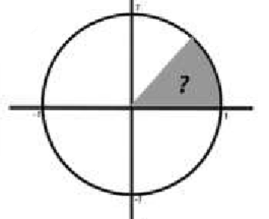
Pre-cut circle from construction paper, or a paper plate

String or heavy thread

Ruler and protractor

Scissors

Steps:

Using the string, measure the circumference of the circle (or paper plate). Record this length.

Circumference =

Fold the circle (or paper plate) in half. Crease the fold line so that it can be clearly seen.

Fold the circle again into quarters. Crease the fold lines.

Open the circle. Using the ruler, draw line segments along the fold lines forming four quadrants. Label the points on the edge of the circle that correspond to 0º, 90º, 180º and 270º.

The folding process has located the center of the circle. Use your string to measure the radius of the circle. Cut the string to this length. Record this length.

Radius =

Hold one end of the radius length string at the edge of the circle at 0º. Wrap the string around the edge of the circle and mark its ending location. Connect this point to the center of the circle.

Using your protractor, find the number of degrees in the central angle formed from 0º to the segment you drew in step 6. In terms of radians, this angle has a measure of one radian. Record this answer.

1 Radian = ˚

Using your radius length string, continue to wrap the string around the edge of the circle marking its ending locations. Record the number of radian angles that will fit in the circle.

How many radian angles are in your circle?

Ponder:

If the central angle has a radian measure of 2π, what is the number of degrees in the angle?

2π radians = ˚

Conversion between degrees and radian
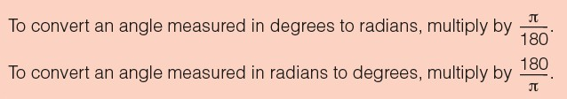

For example:

Ex 1) 225˚= (radians)

To convert to radians you should multiply by .

You should only focus on and write π after the fraction is reduced.

c. = .

d. The answer is .

Ex 2) = (degrees)

To covert to degrees you should multiply by .

Since the π’s cancel each other, we should only focus on the .

c. = .

d. The answer is .

Ex 3) An angle representing one complete revolution of the unit circle measures 2 π radians, formerly º.

Change the following radians to degrees if 2 π =360º,
a) π =

Change the following degrees to radians if 360º= 2 π ,

a) 270º =

b) π =

2

c) π =

4

b) 60º =

c) 150º =

d) 3π =

4

e) 11π =

6

d) 30º =

e) 240º =

Work with partners to find the angles in degrees and radians.

1.  Degree Radian |  | 2.  Degree Radian |  | 3.  Degree Radian
4.  Degree | Radian | 5.  Degree | Radian | 6.  Degree Radian
7.  Degree | Radian | 8.  Degree | Radian | 9.  Degree Radian
10.  Degree | Radian | 11.  Degree | Radian | 12.  Degree Radian
13.  Degree | Radian | 14.  Degree | Radian | 15.  Degree Radian

Applications of Trigonometric Functions

- The root system for some native Caribbean plants requires 5 m² of land area to collect the required amount of nutrients.
  - If this land area is circular, what is the area?
  - If this land is a 35º sector of a circle between two rocks, what is the radius?

- The equation P = 20 sin(2πt) + 100 models the blood pressure, P, where t represents time in seconds.
  - Find the blood pressure after 15 seconds.
  - What are the maximum and minimum blood pressures?

- The amount of nutrients in plants depends on the amount of sunlight they receive. The amount of
sunlight in a certain region can be modeled by the function h = 15cos ⎛ 1 d ⎞ , where h represents the
⎜ 600 ⎟
⎝ ⎠
hours of sunlight, and d is the day of the year. Use the equation to find how many hours of sunlight there are on February 10, the 42nd day of the year.

- At Mauna Loa, Hawaii, atmospheric Carbon Dioxide levels in parts per million (ppm) have been measured regularly since 1958. The function defined by L(x) = .022x2 + .55x + 316 + 3.5sin (2π x) can be used to model levels, where x is in years and x = 0 corresponds to 1960.
  - Calculate the Carbon Dioxide levels in 1970.
  - Calculate the Carbon Dioxide levels in 2017.

Introduction to Trigonometric Functions and the Unit Circle

- Find the angle of smallest possible positive measure coterminal with the given angle: -172°

- Find the angle of smallest possible positive measure coterminal with the given angle: 438°

- Suppose that θ is in standard position and the given point is on the terminal side of θ. Give the exact value of the indicated trig function for θ: (6, 8); Find csc θ.

- Convert 330° to radians. Leave answer as a multiple of π.

- Convert t 0.2521 to degrees. Give answer using decimal degrees to the nearest hundredth. Use 3.1416 for π.

- Find the exact value: sin(-180°)

- Find the exact value: sec 270°

- Find the exact value: cot 90° + 2 cos 180° + 6 sec2 360°

- Find the exact value: cos 30°

- Find the exact value: tan
-5π
6

- Find the exact value: csc 4π
3

- Find the length of an arc intercepted by a central angle θ = π radians in a circle of radius r = 38.81 ft; . Round
3
your answer to 1 decimal place.

- Assume that the cities lie on the same north-south line and that the radius of the earth is 6400 km. Find the latitude of Spokane, WA if Spokane and Jordan Valley, OR, 43.15° N, are 486 km apart.

- Find the area of a sector of a circle having radius r = 15.0 ft, and central angle θ = 2π radians. Express the
3
answer to the nearest tenth

- Each tire of an automobile has a radius of 2 feet. How many revolutions per minute (rpm) does a tire make when the automobile is traveling at a speed of 79 feet per sec? Round your answer to the nearest tenth.

- Find sec θ if cos θ = 1 and sin θ > 0.
4

- Find cot θ if csc θ = 37 and θ is in quadrant I. 6

- Find cot θ.
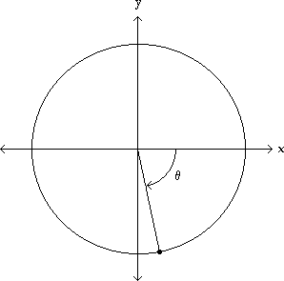
7 , - 24
25 25

- Find the exact value of x in the figure.
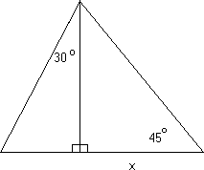
34

- Find the exact value of x in the figure.

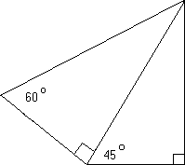38
x

- Find a formula for the area of the figure in terms of s.
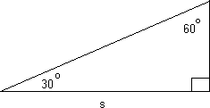

- Find h as indicated in the figure. Round your answer to the hundredths place.

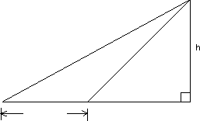
25.3°
58.4°
147 ft

- An airplane travels at 160 km/h for 4 hr in a direction of 306° from St. Louis. At the end of this time, how far west of St. Louis is the plane (to the nearest kilometer)?

- The angle of elevation from a point on the ground to the top of a tower is 37.87°. The angle of elevation from a point 106 feet farther back from the tower is 24.15°. Find the height of the tower. Round your answer to the hundredths place.

Answer Key

1) 188°
2) 78°
3) 5
4
4) 11π
6
5) 14.44°
6) 0
- Undefined 8) 4
9) 3
2
10) 3
3
11) -
2 3
3
12) 40.6 ft
13) 47.50 °N
14) 235.6 ft2
15) 377.2 rpm
16) 4
17) 1
6
18) - 7
24
19) 17 3
20) 76 6
3

21) 3 s2 6
22) 97.98 ft
23) 518 km 24) 112.26 ft

Graphing Trigonometric Functions

For textbook reference you can use the free opnestax Precalculus text: https://openstax.org/details/books/precalculus Sections 6.1 and 6.2

  - Match the function with its graph.

    - y = sin 3x 2) y = 3 cos x
3) y = 3 sin x 4) y = cos 3x

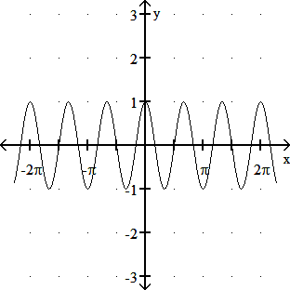
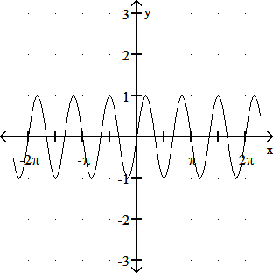
A) B)
C) D)
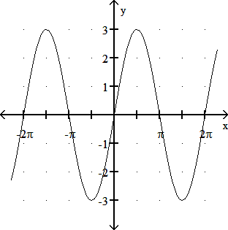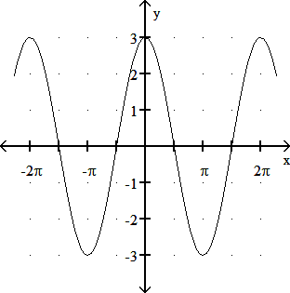
12) Give the amplitude: y = -2 cos x
3
3) Give the period: y = cos 5x

4)
Find the phase shift of the function. y = -3 + 2 sin 3x - π
6
5) Graph the function over a one-period interval: y = 4 + 1 sin (2x - π)
3

6)
Graph the function over a one-period interval. y = 1 + cos 2x - 2π
2
3

7) The population size of most insects is dependent on the temperature of their habitats. The temperature in Fairbanks is
2π 365

approximated by T(x) = 37 sin
(x - 101)
+ 25, where T(x) is the temperature on day x, with x = 1 corresponding to

Jan. 1 and x = 365 corresponding to Dec. 31. Estimate the temperature on day 10.

8)
Graph the function.: y = 4 tan
5 2 6
1 x - π

9)
Graph the function. y = - 4 cot 1 x - π
5 2 6

10)
Graph the function. y = csc x - π
3

11)
Graph the function. y = 2 + 4 sec x + π
5
- The average person’s blood pressure is modeled by the function f(t) = 20 sin(160πt) + 100, where f(t) represents the blood pressure at time t, measured in minutes.
  - Graph the function.
  - Find the highest and lowest values for the average blood pressure and the time at which they occur.

- Circadian rhythms are approximately 24-hour internally controlled biological changes that occur in the absence of environmental cues- although they can be altered by the environment. The first example that might pop in your mind when you hear circadian rhythms is the sleep-wake cycle. Other examples include daily fluctuations in fluctuations in body temperature, hormones, behavior, and heart rate. Individual neurons in the suprachiasmatic nucleus, a cluster of cells in the region of the brain called the hypothalamus, generates this "biological clock" in mammals. But you don't need to have a brain to have a biological clock. Circadian rhythms are found in a wide variety of organisms- from single-celled yeast to plants.

For this module, we will consider a hypothetical example. Suppose a particular species exhibits daily regular fluctuations in body temperature that can be approximated by the equation,

T(t) = 36.8 - 1.3sin ( π (t + 2))

12
where T represents temperature in°C, t represents time (in hours), and t = 0 corresponds to 12 o'clock midnight (12:00 am)

  - Find tte period of the function. Does the period make sense? Why?
  - What tiem of the day, does the body temperature reach the maximum? What is the temperature at that time?
  - Approximate the body temperature at 10 am.

Answer Key

Testname: GRAPHING TRIG FUNCTIONS

1) 1B, 2D, 3C, 4A
2) 2
- 2π
5

π units to the right 18
4)
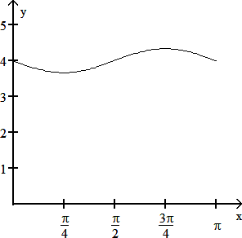
5)
6)
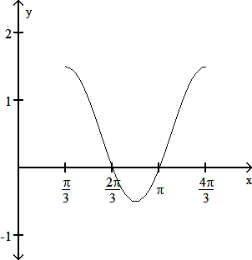
7) -12°
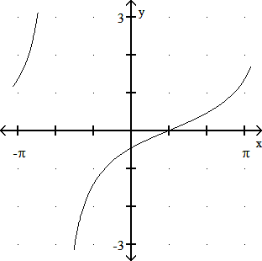
8)

Answer Key

Testname: GRAPHING TRIG FUNCTIONS

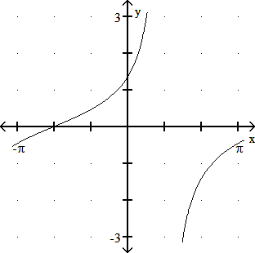
9)
10)
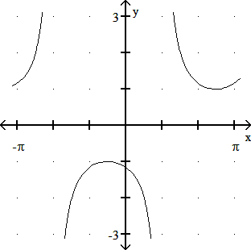
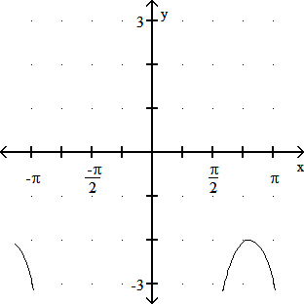
11)

Answer Key

Testname: GRAPHING TRIG FUNCTIONS

12)

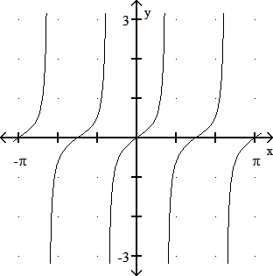13)

Inverse Trigonometric Functions

For textbook reference you can use the free opnestax Precalculus text: https://openstax.org/details/books/precalculus Section 6.3

  - 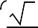Find the exact value of the real number y. y = cos- 1
2
2

2)
Find the exact value of the real number y. y = arctan 1
- Find the exact value of the real number y. y = sin- 1 (0.5)
- Graph: y = arccsc 1 x

Evaluate the expression.
- cos arcsin 1
3
4

6)
arccos cos l
2

- sin (arctan 2)
Write the following as an algebraic expression in u, u > 0.
- cos(arcsin u)

9)
tan cos- 1 u
3

10) cos(arctan u)

11)
sin arctan u
2

- True or false? The statement cos(cos- 1 x) = x for all real numbers in the interval 0 c x c l.

- True or false? The statement tan- 1(tan x) = x for all real numbers in the interval -∞∞c x c∞.
- A crystal is an array of atoms that forms atomic layers known as atomic planes. When an x-ray is passed through a crystal, the x-ray beam is diffracted according the crystal's atomic structure. Using a technique called x-ray crystallography, one can construct the three dimensional atomic structure based upon the diffraction pattern.
X-ray crystallography has been used to uncover the atomic structure of thousands of macromolecules ranging from vitamins
to protein complexes. X-ray crystallography was a critical technique in many discoveries that were honored with the Nobel Prize. Perhaps the most famous structure revealed by x-ray crystallography is the double helical structure of DNA.
The structure of a crystal can be experimentally determined by Bragg's equation, nλ =2d sinθ
where λ is the wavelength of x-rays, d is the distance between atomic planes, θ is the angle of reflection (in degrees), and n is a positive integer.

- Assume that for a given crystal n=1, find the angle of reflection, if the wavelength adn teh distance are equal.
- Assume that n=2, and the distance is three times the wavelength, use your calculator to approximate the angle.

- A 5.8- ft fence is 12.052 ft away from a plant in the direction of the sun. It is observed that the shadow of the fence extends exactly to the bottom of the plant. (See drawing) Find 0, the angle of elevation of the sun at that time. Round the measure of the angle to the nearest tenth of a degree.
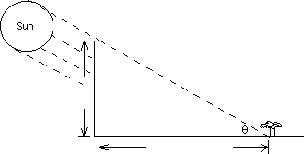
5.8 ft
12.052 ft

Answer Key

Test name: INVERSE TRIG FUNCTIONS

- l
4
- l
4
- l
6
4)

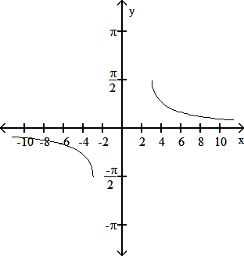5) 15
4
6) l
2
2 5
5

7)
8) 1 - u2
9) 9 - u2
u
10) u2 + 1
u2 + 1
11) u u2 + 2
u2 + 2
- True
- False
15) 0 = 25.7°

Graphing Trigonometric Functions and Inverse Trigonometric Functions

For textbook reference you can use the free opnestax Precalculus text: https://openstax.org/details/books/precalculus Chapter 6
Graph the function.
π
4
  - y = sin x +

2)
y = 2 sin x - π
4

3)
y = 2 cos x + π
3
3
4) y = 3 + sin(2x-π)

5)
y = 1 + cos 2x - 2π
2
3
16) y = tan 2x 3

7)
y = 2 tan
3 3 3
1 x - π

8)
y = 1 cot 1 x + π
2 2 5

9)
y = csc 2 x - π
5 2

10)
y = 2 + 4 sec x + π
5
- y = sin-1 x
- A generator produces an alternating current according to the equation I = 80 sin 106πt, where t is time in seconds and I is the current in amperes. What is the smallest time t such that I = 40?

3
Find the exact value of the real number y. y = arcsin 2

Find the exact value of the real number y. cos arcsin 1
4

- Write the following as an algebraic expression in u, u > 0. tan
u 3
cos-1

Answer Key

Testname: CHAPTER 6 REVIEW

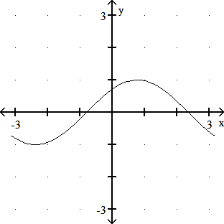
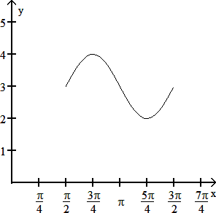
1) 4)
2) 5)
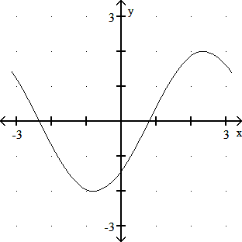
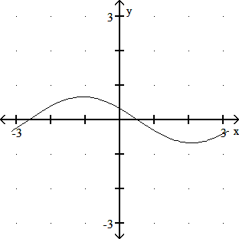
3) 6)

Answer Key

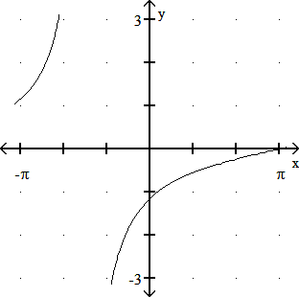
7) 10)
8) 11)
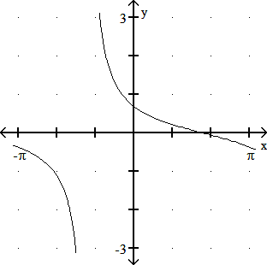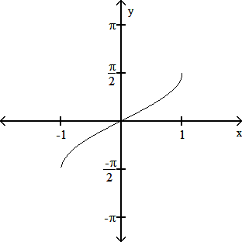
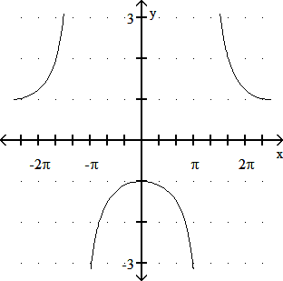
- 1 sec
12)
636
13) π
3
14) 15
4
9 - u2
15) u

Trigonometric Identities

For textbook reference you can use the free opnestax Precalculus text: https://openstax.org/details/books/precalculus Sections 7.1 and 7.2

Use the fundamental identities to simplify the expression.
1) 1 + sec 0 cos 0 1)
cot20
2) sin20 + tan20 + cos20 2)
  - cos x (csc x - sec x) - cot x 3)
Verify that each equation is an identity.
  - tan x(csc x - sin x) = cos x 4)

5) sec 0 - 1 = tan 0
5)

tan 0 sec 0 + 1

- (sec a - tan a)(sec a + tan a) = 1 6)
- csc s - sin s = cos s cot s 7)

- (sec a + tan a)2 = 1 + sin a
1 - sin a
8)

Use Identities to find the exact value.
9) cos 165° 9)

10) 10)
cos
l
12

Find the exact value of the expression using the provided information.
11) Find cos(s - t) given that cos s = - 1 , with s in quadrant III, and cos t = - 3 , with t in quadrant III.
2 5

11)

Find the exact value by using a sum or difference identity.
12) tan 75° 12)
13) sin 15° 13)

Use a sum or difference identity to find the exact value.
14) sin 7l cos l - cos 7l sin l

14)

24 8 24 8

Answer Key

Testname: TRIG IDENTITIES

- sec20
- sec20
3) - 1
4) tan x(csc x - sin x) = tan x · csc x - tan x · sin x = sin x · 1 - sin x · sin x = 1 - sin2 x = 1 - sin2 x = cos2 x =

cos x
cos x
sin x
cos x
cos x
cos x
cos x

cos x

5) sec 0 - 1 = sec 0 - 1 · sec 0 + 1 = sec2 0 - 1
= tan2 0
= tan 0

tan 0
tan 0
sec 0 + 1

tan 0(sec 0 + 1)

tan 0(sec 0 + 1)
sec 0 + 1

- (sec a - tan a)(sec a + tan a) = sec2a - tan2a = 1
- csc s - sin s = 1 - sin s = 1 - sin2s = cos2s = cos s · cos s = cos s cot s

sin s
sin s
sin s
sin s

- (sec a + tan a)2 = sec2a + 2 sec a tan a + tan2a = 1 + 2 sin a + sin2a
= 1 + 2 sin a + sin2a = (1 + sin a)2 =

(1 + sin a)2

(1 - sin a)(1 + sin a)
9) - 6 -
2
4
10) 6 +
2
4
11) 3 + 4 3
10
12) 3 +
2
2
13) 6 -
4

= 1 + sin a 1 - sin a
cos2a
cos2a

cos2a
cos2a

1 - sin2a

14) 1
2

Trigonometric Equations

For textbook reference and videos you can use section 7.5 of the free openstax Precalculus text:
https://openstax.org/details/books/precalculus

To access the section and videos,you can use use:
https://cnx.org/contents/_VPq4foj@11.14:aeVxcRIM@12/7-5-Solving-Trigonometric-Equations

Solve the equation for the interval [0, 2 π).
- cos2x + 2 cos x + 1 = 0

- 2 sin2x = sin x

- cos x = sin x

- sin2x - cos2x = 0

Determine the solution set of each equation in radians (for x) or degrees (for θ) to the nearest tenth as appropriate.
- 2 sin2 x + sin x = 1

- 4 tan θ = 1 5 - tan2 θ

Solve the equation for solutions in the interval [0, 2 π).
- sin 4x = 3
2

- sin x cos x = 1
2

- sin 2x + sin x = 0

Determine the solution set of each equation in radians (for x) or degrees (for θ) to the nearest tenth as appropriate.
- 3 cos2θ + 2 cos θ = 1

Answer Key:

1) {π}
2) 0, π, π , 5π
6 6
3) π , 5π
4 4
4) π , 3π , 5π ,
7π
4
4 4 4
5) π + 2nπ, 5π + 2nπ, 3π + 2nπ
6 6 2
6) {45° + 180°n, 101.3° + 180°n}
7) π , π , 2π , 7π , 7π , 13π , 5π ,
19π
12
12 6 3 12 6 12 3
8) π , 5π
4 4
9) 0, 2π , π, 4π
3 3
10) {70.5° + 360°n, 180° + 360°n, 289.5° + 360°n}

Law of Sines and Law of Cosines
For reference, you can use chapters 8.1 and 8.2 of the openstax Precalculus text: https://openstax.org/details/books/precalculus Solve the triangle.
1)
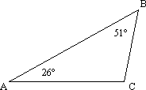
26 m

Solve the problem.
2) To find the distance AB across a river, a distance BC = 1053 m is laid off on one side of the river. It is found that B = 101.3° and C = 17.0°. Find AB rounded to the nearest meter.

Find the area of triangle ABC with the given parts. Round to the nearest whole number.
3) A = 26.4°
b = 12.3 in. c = 7.7 in.

Find the missing parts of the triangle.
4) C = 35°30'
a = 18.76
c = 16.15

5) A = 79°
a = 32 yd b = 65 yd

6) B = 63°30'
a = 12.20 ft c = 7.80 ft

Find the missing parts of the triangle. (Find angles to the nearest hundredth of a degree.)
7) a = 27 ft b = 32 ft c = 41 ft

Find the area of triangle ABC with the given parts. Round to the nearest whole number.
8) a = 17.4 cm b = 15.0 cm c = 13.4 cm

- Explain, in your own words, the situation called "the ambiguous case of the law of sines."

- What happens if C = 90° when the law of cosines is applied in the form C2 = A2 + B2 - 2ab cos C?

Answer Key

1) C = 103°, a = 11.7 m, b = 20.7 m
2) 350 m
3) 21.1 in.2
4) A1 = 42°25', B1 = 102°05', b1 = 27.20;
A2 = 137°35', B2 = 6°55', b2 = 3.35
5) no such triangle
6) b = 11.17 ft, A = 77°49', C = 38°41'
7) A = 41.14°, B = 51.24°, C = 87.62°
8) 97 cm2
- Answers will vary
- Answers will vary

Vectors and Polar Coordinates

For reference, you can use chapters 8.1 and 8.2 of the openstax Precalculus text:
https://openstax.org/details/books/precalculus

Find the component form of the indicated vector.
1) Let u = -9, -9 , v = -3, 3 . Find -u + 9v.

Find the magnitude and direction angle (to the nearest tenth) for each vector. Give the measure of the direction angle as an angle in [0,360°].
2) -3, -4

Vector v has the given magnitude and direction. Find the magnitude of the indicated component of v.
3) α = 38.3°, ∣v∣ = 281
Find the vertical component of v.

Write the vector in the form <a, b>.
4)
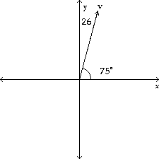

Two forces act at a point in the plane. The angle between the two forces is given. Find the magnitude of the resultant force.
5) forces of 25.0 and 31.8 lb, forming an angle of 162.8°

Find the dot product for the pair of vectors.
6) -16, 8 , 0, 15

Find the angle between the pair of vectors to the nearest tenth of a degree.
7) 5, 5 , -3, 8

- Starting at point A, a ship sails 57 km on a bearing of 188°, then turns and sails 37 km on a bearing of 330°. Find the distance of the ship from point A.

- Suppose you would like to cross a 209-foot wide river in a boat. Assume that the boat can travel 32 mph relative to the water and that the current is flowing west at the rate of 6 mph. If the bearing is chosen so that the boat will land at a point exactly across from its starting point, how long will it take for the boat to make the crossing? Give your answer to the nearest second.

The rectangular coordinates of a point are given. Express the point in polar coordinates with r ≥ 0 and 0° ≤ θ < 360°.
10) (2, -2)

Give the rectangular coordinates for the point.
11) (6, 225°)

For the given rectangular equation, give its equivalent polar equation.
12) 2x + 3y = 6

13) x2 + y2= 64

Plot the point.
9π 4
14) 4,
5
-5
5
-5

Graph the polar equation for θ in [0°, 360°).
15) r = 4 + 4 sin θ
r

Answer Key

1) -18, 36
2) 5; 233.1°
3) 174.2
4) ≈ 6.73, 25.11
5) 11 lb 6) 120 7) 65.6°
- 36 km
- 5 sec
10) (2 2, 315°)
11) (-3 2, -3 2)
6
- r = 2 cos θ + 3 sin θ
13) r = 8
14)
5
-5
5
-5
15)
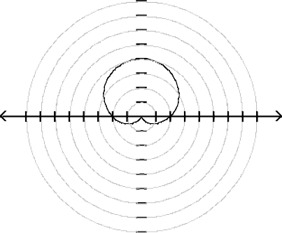
16
12
8
4
-16 -12 -8 -4
4 8 12 16 r
-4
-8
-12
-16

Polar Form of Complex Numbers

For reference, you can use chapters 8.5 of the openstax Precalculus text:

https://openstax.org/details/books/precalculus

  - Graph the complex number. -5 - 4i

Find the following quotient, and write the quotient in rectangular form, using exact values.
2) 12cis 158°
3cis 38°

- Graph the complex number. -4i

- Write the complex number in rectangular form. 8 cos π + i sin π
6 6

- Write the complex number in rectangular form. 9(cos 180° + i sin 180°)

Write the complex number in trigonometric form r(cos θ + i sin θ), with θ in the interval [0°, 360°).
3

6) 5
+ 5i

Find the product. Write the product in rectangular form, using exact values.
7) [8 cis 300°] [6 cis 330°]

- Find the given power. Write answer in rectangular form: (2 - 2i)5

- Find the given power. Write answer in rectangular form.: (- + i)6
3

- Find all cube roots of the complex number. Leave answers in trigonometric form: -125i

- Find all cube roots of the complex number. Leave answers in trigonometric form: 3 + 3i
3

- Find all solutions of the equation. Leave answers in trigonometric form.: x3 - 8 = 0

- Find all solutions of the equation. Leave answers in trigonometric form.: x5 - 32 = 0

Use a table of values to graph the plane curve defined by the following parametric equations. Find a rectangular equation for the curve.
14) x = 2t, y = t + 1, for t in [-2, 3]

- Find a rectangular equation for the plane curve defined by the parametric equations: x = sin t, y = 3 cos t

- Find a rectangular equation for the plane curve defined by the parametric equations.: x = sec t, y = tan t

Answer Key

1) 14)
y
10
-10
10 x
-10
2) y = 1 x + 1, for x in [-4, 6]
3) 2
6
y
4

2
-6 -4 -2
2 4 6 x
-2

-4

-6
- 2 + 2i 3
15) 9x2 + y2 = 9
6
y
4

2
-6 -4 -2
2 4 6 x
-2

-4

-6
4 3 + 4i
16) x2 - y2 = 1

4)
5) -9
6) 10(cos 30° + i sin 30°)
7) -48i
8) -128 + 128i
9) -64
10) 5 cis 90°, 5 cis °210, 5 cis 330°
3
6

3 3
11) 6 cis 20°, 6 cis 140°,
12) {2, 2 cis 120°, 2 cis 240°}
cis 260°

- 2 cis 0, 2 cis 2π , 2 cis 4π , 2 cis 6π , 2 cis
8π
5
5 5 5

Test Reviews

Trigonometric Identities and Equations Review

You can use chapter 7 in the free Precalculus text at openstax for reference: https://openstax.org/details/books/precalculus

Use the fundamental identities to simplify the expression.
cos2θ
  - sin2θ + csc θ sin θ

  - sin2θ + tan2θ + cos2θ

Verify that each equation is an identity.
  - cot2x = (csc x - 1)(csc x + 1)

  - sec β + tan β = cos β
1 - sin β

  - (sec α - tan α)(sec α + tan α) = 1

  - csc s - sin s = cos s cot s

Use Identities to find the exact value.
7) cos 255°

Find the exact value by using a sum or difference identity.
8) tan 105°

Find the exact value of the expression using the provided information.
- Find tan(s + t) given that sin s = 1 , with s in quadrant II, and sin t = - 1 , with t in quadrant IV.

4 2

Find the exact value by using a sum or difference identity.
- sin 15°

Use trigonometric identities to find the exact value.
11) sin 25° cos 35° + cos 25° sin 35°

Use identities to find the indicated value for each angle measure.
- cos 2θ = 2 and θ terminates in quadrant I Find sin θ. 3

- cos 2θ = 1 and θ terminates in quadrant III Find cos θ. 4

Express the function as a trigonometric function of x.
- cos 4x

Verify that each equation is an identity.
15) cos(4u) = 2 cos2(2u) - 1

Write the product as a sum or difference of trigonometric functions.
- 8 cos 14° cos 7°

Find the exact value by using a half-angle identity.
- sin 75°

Determine all solutions of the equation in radians.
- Find sin x , given that sin x = 1 and x terminates in 0 < x < π .
2 4 2

Solve the equation for the interval [0, 2π).
- cos2x + 2 cos x + 1 = 0

- 2 sin2x = sin x

- cos x = sin x

- sin2x - cos2x = 0

Determine the solution set of each equation in radians (for x) or degrees (for θ) to the nearest tenth as appropriate.
- 2 sin2 x + sin x = 1

Solve the equation for solutions in the interval [0, 2 π).
3
- sin 4x = 2

- sin x cos x = 1
2

- sin 2x + sin x = 0

Answer Key

- csc2θ
- sec2θ
- cot2 x = csc2 x - 1 = (csc x - 1)(csc x + 1).

1 sin β
1 + sin β
1 + sin β
1 - sin β
1 - sin2 β
cos2 β
cos β

- sec β + tan β = cos β + cos β =
cos β =
cos β ∙ 1 - sin β = cos β(1 - sin β) = cos β(1 - sin β) =

1 - sin β

- (sec α - tan α)(sec α + tan α) = sec2α - tan2α = 1

1 1 - sin2s
cos2s
cos s

- csc s - sin s = sin s - sin s =
2 - 6
sin s =
sin s = cos s ∙ sin s = cos s cot s

7) 4
8) -2 - 3
4 3 + 15

9)

10)

11)
-11
6 - 2
4
3
2
6

- sin θ = 6

- cos θ = -

101
4

14) cos4x - 6 sin2x cos2x + sin4x
15) cos(4u) = cos[2(2u)] = 2 cos2(2u) - 1
16) 4(cos 21° + cos 7°)
1
2 2 + 3
17)

18)
8 - 2 15
4

19) {π}
π 5π
20) 0, π, 6 , 6

21)

22)
π 5π
4 , 4
π , 3π , 4 4
π

5π , 4
5π 3π
7π 4
19π 12

23)
6 + 2nπ,
6 + 2nπ,
2 + 2nπ

24)

25)
π π
12 , 6 ,
π , 4
5π 4
2π , 3
7π , 12
7π , 6
13π 12 ,
5π , 3

26)
0, 2π , π,
3
4π 3

Polar Forms and Vectors Review

For reference, you can use chapters8 of the openstax Precalculus text: https://openstax.org/details/ books/precalculus

1) x = 5(t - sin t), y= 5(1 - cos t), 0 ≤ t ≤ 4π
Graph the cycloid for t in the indicated interval.
y

12

8

4

10 20 30 40 50 60 x

2) x = t - sin t, y = 1 - cos t, -4π ≤ t ≤ 4π
2.5
2
1.5
1
0.5
y
-16 -12 -8 -4
-0.5
-1
-1.5
-2
-2.5
4 8 12 16 x

Find the missing parts of the triangle.
3) A = 98°
b = 15.2 ft a = 43.4 ft

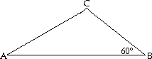4)
5 6
10

5) C = 35°30ʹ a = 18.76
c = 16.15

Find the missing parts of the triangle. (Find angles to the nearest hundredth of a degree.)
6) a = 27 ft b = 32 ft c = 41 ft

Find the missing parts of the triangle.
7) C = 112.5° a = 5.30 m b = 9.66 m

Solve the problem.
8) Two ships leave a harbor together traveling on courses that have an angle of 125° between them. If they each travel 501 miles, how far apart are they (to the nearest mile)?

9) If u = -5, 7 , v = -7, 6 , and w = -11, 2 , evaluate u ∙ (v - w).

Find the angle between the pair of vectors to the nearest tenth of a degree.
10) 5i - 3j, 5i - 6j

Find the magnitude and direction angle (to the nearest tenth) for each vector. Give the measure of the direction angle as an angle in [0,360°].
11) -3, -4

Two forces act at a point in the plane. The angle between the two forces is given. Find the magnitude of the resultant force.
- forces of 52 and 54 newtons, forming an angle of 90°

Solve the problem.
- A hot-air balloon is rising vertically 12 ft/sec while the wind is blowing horizontally at 5 ft/sec. Find the angle that the balloon makes with the horizontal.

- A pilot wants to fly on a bearing of 65.3°. By flying due east, he finds that a 50-mph wind, blowing from the south, puts him on course. Find the ground speed of the plane.

- A box weighing 80 lb is hanging from the end of a rope. The box is pulled sideways by a horizontal rope with a force of 24 lb. What angle, to the nearest degree, does the first rope make with the vertical?

Find the product. Write the answer in standard form.
16) 3i(3 + 6i)2

Simplify the power of i.
17) i79

Find the following quotient, and write the quotient in rectangular form, using exact values.
18) 12cis 158°
3cis 38°

Find the given power. Write answer in rectangular form.
19) (1 + i)20

Find all specified roots.
20) Fifth roots of 1.

Find all solutions of the equation. Leave answers in trigonometric form.
21) x5 - 32 = 0

For the given rectangular equation, give its equivalent polar equation.
22) x - y = 10

23) x2 + y2= 64

Find a rectangular equation for the plane curve defined by the parametric equations.
24) x = t + 4, y = t2

25) x = 5 tan t, y = 4 cot t

Answer Key

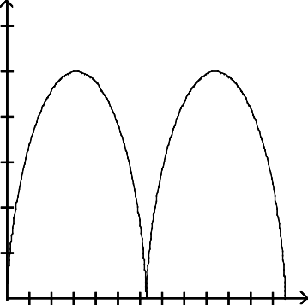1) 22) r = 10
y
cos θ - sin θ
12
23) r = 8
24) y = x2 - 8x + 16
8 25) y = 20
x

4

10 20 30 40 50 60 x

2)
2.5
2
1.5
1
0.5
y
-16 -12 -8 -4
-0.5
-1
-1.5
-2
-2.5
4 8 12 16 x
3) B = 20.3°, C = 61.7°, c = 38.6 ft
4) A = 45°, C = 75°, c = 5 3 + 5
5) A1 = 42°25ʹ, B1 = 102°05ʹ, b1 = 27.20; A2 = 137°35ʹ, B2 = 6°55ʹ, b2 = 3.35
6) A = 41.14°, B = 51.24°, C = 87.62°
7) c = 12.7 m, A = 22.7°, B = 44.8°
8) 889 mi
9) 8
10) 19.2°
11) 5; 233.1°
12) 75 newtons 13) 67.4°
14) 120 mph 15) 17°
16) -108 - 81i
17) -i
18) - 2 + 2i
3
19) -1024
- 1, cis 2π , cis 4π , cis 6π , cis 8π
5 5 5 5
- 2 cis 0, 2 cis 2π , 2 cis 4π , 2 cis 6π , 2 cis
8π
5
5 5 5

Final review
Cumulative Review of Trigonometry

  - Find the supplement of an angle whose measure is 37°45'2'' 2) 139°47' + 108°48'
Convert the angle to decimal degrees and round to the nearest hundredth of a degree.
3) 45°31'46''
Convert the angle to degrees, minutes, and seconds.
4) 28.34°
Find the angle of smallest possible positive measure coterminal with the given angle.
5) 840°
Suppose that 0 is in standard position and the given point is on the terminal side of 0.
6) (6, 8); Find cos 0.
The triangles are similar. Find the missing side, angle or value of the variable.
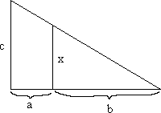
7) x

a = 30 b = 90 c = 52
Evaluate the expression.
8) sin(- 180°)
9) sec 270°
Identify the quadrant for the angle 0 satisfying the following conditions.
- sin 0 > 0 and cos 0 < 0
- sec 0 < 0 and tan 0 < 0
Use the fundamental identities to find the value of the trigonometric function.
- Find csc 0, given that sin 0 = - 2 and 0 is in quadrant IV.
3
Without using a calculator, give the exact trigonometric function value with rational denominator.
- cos 60°
- sec 45°

Suppose ABC is a right triangle with sides of lengths a, b, and c and right angle at C. Find the unknown side length .
- Find csc A when b = 8 and c = 17
Find a solution for the equation. Assume that all angles are acute angles.
16) sin(2p + 15°) = cos(3p - 25°)
17) A fire is sighted due west of lookout A. The bearing of the fire from lookout B, 5.1 miles due south of A, is N 48° 22'W. How far is the fire from B (to the nearest tenth of a mile)?
Convert the degree measure to radians. Leave answer as a multiple of l.
18) 330°
Convert the radian measure to degrees. Round to the nearest hundredth if necessary.
- - l
5
Find the exact value without using a calculator.
- sin 3l
4
- Find h as indicated in the figure. Round your answer to the hundredths place.
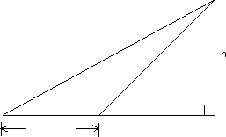
26° 55'
55° 53'
86 m

Solve the problem.
- Two wheels are rotating in such a way that the rotation of the smaller wheel causes the larger wheel to rotate. The radius of the smaller wheel is 6.5 centimeters and the radius of the larger wheel is 17.0 centimeters. Through how many degrees will the larger wheel rotate if the smaller one rotates 120°?
Graph the function over a one- period interval.
- y = 1 cos 4 x - l
2 3

24) y =sin(2x- 180)
Graph the function.
25)
y =tan 1 x - l
2 6

26) y = 2 csc 3x + 60
Solve the problem.
27) The temperature in Fairbanks is approximated by

T(x) = 37 sin 2l (x - 101) + 25, 365

where T(x) is the temperature on day x, with x = 1 corresponding to Jan. 1 and x = 365 corresponding to Dec. 31. Estimate the temperature on day 10.
The function graphed is of the form y = a sin bx or y = a cos bx, where b > 0. Determine the equation of the graph.
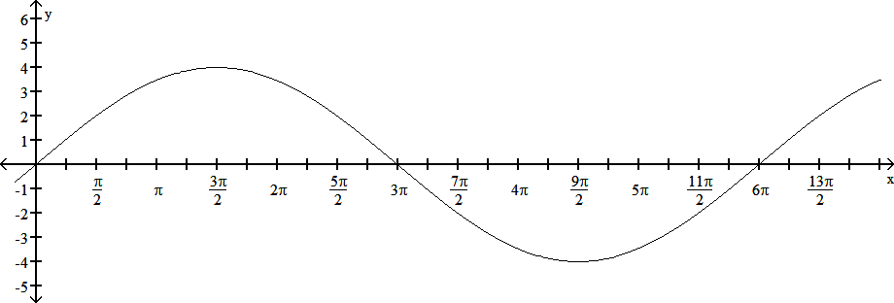
28)

29)
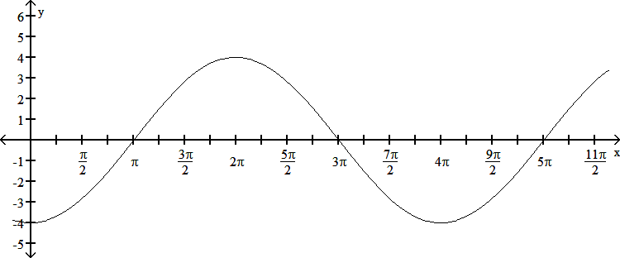
Verify that each equation is an identity.
- tan x(csc x - sin x) = cos x
- (sec a - tan a)(sec a + tan a) = 1
- sec p + tan p = cos p
1 - sin p

- A wheel is rotating at 3 radians/sec, and the wheel has a 54- inch diameter. To the nearest foot, what is the speed of a point on the rim in ft/min?
Identify the quadrant for the angle 0 satisfying the following conditions.
- sec 0 < 0 and tan 0 < 0
- Find cos(s + t) given that cos s = 1 , with s in quadrant I, and sin t = - 1 , with t in quadrant IV.
3 2

Use trigonometric identities to find the exact value.
36) sin 100° cos 40° - cos 100° sin 40°
Find the exact value by using a sum or difference identity.
- sin 15°

- Find tan(s - t) given that sin s = - 3 13 , with s in quadrant IV, and sin t = - 10 , with t in quadrant IV.
13 10
39) cos 0 = 12 , sin 0 < 0 Find sin(20). 13
- cos 20 = 2 and 0 terminates in quadrant III Find cos 0. 3

Determine all solutions of the equation in radians.
- Find cos 0 , given that cos 0 = - 3 and 0 terminates in 90° < 0 < 180°.
2 5

Find the exact value
cos arcsin 1
4
cos 2arcsin 3
5

Determine the solution set of each equation in radians (for x) or degrees (for 0) to the nearest tenth as appropriate.
- 2 sin2 x + sin x = 1
Solve the equation for the interval [0, 2π).
- sin2x - cos2x = 0
Determine the solution set of each equation in radians (for x) or degrees (for 0) to the nearest tenth as appropriate.
46) 3 cos20 + 2 cos 0 = 1
Solve the equation for solutions in the interval [0°, 360°). Round to the nearest degree.
47) sin 20 = cos 0

Solve the triangle.
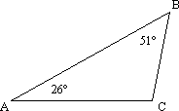48)
21 m

Find all th epossible values for the missing parts of the triangle.
49) A = 23° a = 35 km b = 55 km
Find the missing parts of the triangle. (Find angles to the nearest hundredth of a degree.)
- a = 22 ft b = 32 ft c = 43 ft
- wo airplanes leave an airport at the same time, one going northwest (bearing 135°) at 407 mph and the other going east at 345 mph. How far apart are the planes after 3 hours (to the nearest mile)?
Find the magnitude and direction angle (to the nearest tenth) for each vector. Give the measure of the direction angle as an angle in [0,360°].
52) - 5, 12
Vector v has the given magnitude and direction. Find the magnitude of the indicated component of v.
- a = 25.9°, IvI= 85.6 Find the horizontal component of v.
- Two forces, of 45.2 and 17.0 lb, forming an angle of 141.9°, act at a point in the plane. Find the magnitude of the resultant force.
Find the quotient. Write the answer in standard form.
55) 9 - 3i
5 - 7i
Write the complex number in trigonometric form r(cos 0 + i sin 0), with 0 in the interval [0°, 360°).
56) - 6 - 6i
3
Find the given power. Write answer in rectangular form.
57) (1 + i)20
Find all solutions of the equation. Leave answers in trigonometric form.
58) x5 - 243 = 0
59) Find an equivalent equation in rectangular coordinates. r = cos 0
Find a rectangular equation for the plane curve defined by the parametric equations.
60) x = t2 + 1, y = t2 - 1

Answers:

1) 142°14'58''
2) 248°35'
3) 45.53°
4) 28°20'24''
5) 120°
6) 3
5
7) x = 39
8) 0
- Undefined
- Quadrant II
- Quadrant II
12) - 3
2
13) 1
2
14) 2
15) 17
15
16) 20°
17) 7.7 mi
18) 11l
6
19) - 36°
20) 2
2
21) 66.55 m
22) 45.88°
23)
24)

25)

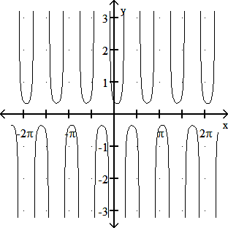
26)

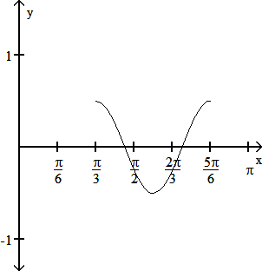
27) - 12°
  - y = 4 sin 1 x
3
  - y = - 4 cos 1 x
2

  - tan x(csc x - sin x) = tan x · csc x - tan x · sin x = sin x
cos x
53) 77.0
54) 33.5 lb

1 sin x
1 sin2 x
1 - sin2 x
55) 33 + 24 i

· sin x -
cos x · sin x = cos x -
cos x =
cos x =
37 37

cos2 x = cos x cos x
56) 12(cos 240° + i sin 240°)
57) - 1024
2 2 58) 3 cis 0, 3 cis 2l , 3 cis 4l , 3 cis 6l , 3 cis 8l

  - (sec a - tan a)(sec a + tan a) = sec
a - tan
a = 1
5 5 5 5

  - sec p + tan p = 1 + sin p = 1 + sin p = 1 + sin p ·
59) x2 + y2 = x

cos p
cos p
cos p
cos p
60) y = x - 2, x L 1

1 - sin p = 1 - sin2 p = cos2 p =

1 - sin p
cos p
1 - sin p
  - 405 ft/min

cos p(1 - sin p)

cos p(1 - sin p)

  - Quadrant II
2
35) 3 + 2
6
36) 3
2
37) 6 -
2
4
38) - 7
9
39) - 120
169
40) cos 0 = - 30
6
41) 5
5
42) 15
4
43) 4 3- 3
10
44) l + 2nl, 5l + 2nl, 3l + 2nl
6 6 2

45)
l , 3l , 5l , 7l

4 4 4 4
46) {70.5° + 360°n, 180° + 360°n, 289.5° + 360°n}
47) {30°, 90°, 150°, 270°}
48) C = 103°, a = 9.4 m, b = 16.7 m
49) B1 = 38°, C1 = 119°, c1 = 78 km B2 = 142°, C2 = 15°, c2 = 23 km
50) A = 29.76°, B = 46.22°, C = 104.02°
51) 2085 mi
52) 13; 112.6°

Articles

The Journal of Experimental Biology 211, 467-481 Published by The Company of Biologists 2008 doi:10.1242/jeb.008573

Angular momentum in human walking
Hugh Herr^{1,2,}* and Marko Popovic¹
¹The MIT Media Laboratory and ²The Harvard-MIT Division of Health Sciences and Technology, 20 Ames Street, Cambridge, MA 02139, USA
*Author for correspondence (e-mail: hherr@media.mit.edu)

Accepted 2 December 2007

SUMMARY
Angular momentum is a conserved physical quantity for isolated systems where no external moments act about a bodyʼs center of mass (CM). However, in the case of legged locomotion, where the body interacts with the environment (ground reaction forces), there is no a priori reason for this relationship to hold. A key hypothesis in this paper is that angular momentum is highly regulated throughout the walking cycle about all three spatial directions [|ĩ(t)|≈0], and therefore horizontal ground reaction forces and the center of pressure trajectory can be explained predominantly through an analysis that assumes zero net moment about the bodyʼs CM. Using a 16-segment human model and gait data for 10 study participants, we found that calculated zero-moment forces closely match experimental values (R_{x}²=0.91; R_{y}²=0.90). Additionally, the centroidal moment pivot (point where a line parallel to the ground reaction force, passing through the CM, intersects the ground) never leaves the ground support base, highlighting how closely the body regulates angular momentum. Principal component analysis was used to examine segmental contributions to whole-body angular momentum. We found that whole-body angular momentum is small, despite substantial segmental momenta, indicating large segment-to-segment cancellations (~95% medio-lateral, ~70% anterior–posterior and ~80% vertical). Specifically, we show that adjacent leg-segment momenta are balanced in the medio-lateral direction (left foot momentum cancels right foot momentum, etc.). Further, pelvis and abdomen momenta are balanced by leg, chest and head momenta in the anterior–posterior direction, and leg momentum is balanced by upper-body momentum in the vertical direction. Finally, we discuss the determinants of gait in the context of these segment-to-segment cancellations of angular momentum.
Key words: biomechanics, biped, locomotion, angular momentum, human.

INTRODUCTION
The advancement of a comprehensive model of human walking is a formidable task and a critical research objective in the fields of biomechanics, neural science and legged machine control. Although many walking studies have put forth experimental and theoretical descriptions of center of mass (CM) mechanics and energetics (Saunders et al., 1953; Bekker, 1956; Alexander, 1976; Cavagna et al., 1976; Margaria, 1976; Mochon and McMahon, 1980a; Mochon and McMahon, 1980b; McGeer, 1990; Lee and Farley, 1998; Croce et al., 2001; Kuo, 2002; Ortega and Farley, 2005; Geyer et al., 2006; Srinivasan and Ruina, 2006), surprisingly few investigations have specifically focused upon whole-body rotational behavior. Clearly, a comprehensive understanding of human walking would require descriptions of not only global body translations but also rotations. The objective of this investigation was to study the rotational behavior of human steady-state walking through the characterization of whole-body angular momentum, as well as body segment momenta, computed about the body’s CM.
The preponderance of research into human angular momentum behaviors has focused not on walking but on other movement tasks such as sit-to-stand maneuvers (Riley et al., 1997), running (Hinrichs et al., 1983; Hinrichs, 1982; Hinrichs, 1987; Hinrichs, 1992) and various sporting activities (Frohlich, 1979; Dapena and McDonald, 1989; Dapena, 1978; Dapena, 1993; LeBlanc and Dapena, 1996; King 1999). Specific to walking maneuvers, Elftman (Elftman, 1939) calculated the angular momenta of all body segments across one walking step, from heel strike to toe-off.
Based on pilot data from a single human participant, he argued that the arms reduced both angular momentum and rotation about both vertical and medio-lateral (left–right) axes.
Following Elftman’s findings in the late 1930s, it was not until the turn of the century that additional research was conducted in the area of human walking angular momentum behaviors. Xu and Wang (Xu and Wang, 1998) quantified angular momenta for lower- extremity segments for altering direction during walking, and Simoneau and Krebs (Simoneau and Krebs, 2000) studied whole- body angular momentum in elderly participants in an attempt to quantify balance deficiencies in the elderly population. More recently, a pilot study on a single study participant found that whole-body angular momentum is highly regulated about all three spatial directions in walking, not deviating substantially from zero throughout each phase of gait (Popovic et al., 2002; Gu, 2003; Popovic et al., 2004a).
Although angular momentum behaviors have been studied for human walking, the studies have been limited to a single study participant and often a single walking step. In this study we examined angular momentum behaviors of 10 study participants walking at self-selected speeds. Motivated by the findings of previous pilot investigations that showed a relatively small whole- body angular momentum, we hypothesized that horizontal ground reaction forces and the center of pressure (CP) trajectory in steady- state walking can be explained predominantly through an analysis that assumes zero net moment about the body’s CM. To test the hypothesis, we first derived what the horizontal ground reaction force, and CP location, would be if no moments were to act about

H. Herr and M. Popovic
the body’s CM. Using a 16-segment human model and gait data from the 10 study participants, we tested the hypothesis by comparing the calculated zero-moment forces and CP trajectory with measured values from a force platform.
We also examined segmental contributions to whole-body angular momentum. Motivated by Elftman (Elftman, 1939), we hypothesized that whole-body angular momentum is small throughout the walking gait cycle, despite substantial segmental momenta, indicating large segment-to-segment cancellations. Specifically, since the arms and legs alternately protract and retract within the sagittal plane, we anticipated that adjacent limb segment contributions are effectively balanced in the medio-lateral direction. Furthermore, due to pelvic obliquity, where the leg hip that is entering the swing phase drops lower than the adjacent leg hip (Saunders et al., 1953), we hypothesized that angular momenta contributions of the pelvis and abdomen are balanced by contributions from the rest of the body in the anterior–posterior (front–back) direction. Still further, due to pelvic rotation where the pelvis and upper body rotate about the vertical axis over the stance leg in walking (Saunders et al., 1953), we anticipated that leg angular momentum is balanced by upper-body momentum in the vertical direction. To test these hypotheses, we once again employed the 16-segment human model and gait data measured from the
10 study participants. Principal component (PC) analysis was performed on all 16 body segments’ angular momenta to produce PCs for each of three orthogonal directions. We then calculated their respective time-dependent weighting coefficients, or tuning coefficients. Finally, we obtained the amount and source of segmental momentum cancellation for all three spatial directions.
MATERIALS AND METHODS
Experimental procedures
Kinetic and kinematic walking data were collected at the Gait Laboratory of Spaulding Rehabilitation Hospital, Harvard Medical School, in a study approved by the Spaulding committee on the Use of Humans as Experimental Subjects. Ten healthy adult participants, five male and five female, with an age range from 20 to 38 years, volunteered for the study. The participants walked at a self-selected speed across a 10 m walkway in the Motion Analysis Laboratory. Participants were timed between two fixed points to ensure that the same walking speed was used between experimental trials. Walking speeds within a ±5% interval from the self-selected speed were accepted. For each study participant, a total of seven walking trials were collected.
The data collection procedures were based on standard techniques (Kadaba et al., 1989; Winter, 1990; Kadaba et al., 1990; Kerrigan et al., 2000; Kerrigan et al., 2001). An infrared camera system (eight cameras, VICON 512 motion analysis system, Oxford Metrics, Oxford, UK) was used to measure the three- dimensional locations of reflective markers at 120·frames s–1. A total of 33 markers were placed on various parts of a participant’s body: 16 lower-body markers, five trunk markers, eight upper-limb markers and four head markers. The markers were attached to the following bony landmarks: bilateral anterior superior iliac spines, posterior superior iliac spines, lateral femoral condyles, lateral malleoli, forefeet and heels. Additional markers were rigidly attached to wands over the mid-femur and mid-shaft of the tibia. The kinematics of the upper body were also collected with markers placed on the following locations: sternum, clavicle, C7 vertebra, T10 vertebra, head, and bilaterally on the shoulder, elbow and wrist. The VICON 512 system was able to detect marker position with a precision of ~1 mm.

During the walking trials, ground reaction forces were measured synchronously with the kinematic data at a sampling rate of 1080 Hz using two staggered force platforms (model no. 2222 or OR6-5-1, Advanced Mechanical Technology Inc., Watertown, MA, USA) embedded in the walkway. The platforms measured ground reaction force and CP location at a precision of ~0.1 N and
~2 mm, respectively.
Human model
A human model was constructed in order to calculate physical quantities such as CM position and angular momentum. The model and coordinate system used in the study are shown in Fig. 1. The model comprises 16 rigid body segments: feet, tibias, femurs, hands, forearms, arms, pelvis-abdomen, chest, neck and head. The feet and hands were modeled as rectangular boxes. The tibia segments, femur segments, forearm segments and arm segments were modeled as truncated cones. The pelvis-abdomen and chest segments were modeled as elliptical slabs [ellipses in the horizontal (x–y) plane and extruded in the vertical (z) direction]. The neck was modeled as a cylinder, and the head was modeled as a sphere. The following 28 anthropometric measurements were taken for each study participant to accurately construct a representative model: (1) body weight, height, and total leg length measured from the medial malleolus to the anterior superior iliac spine; (2) lengths, widths and thicknesses of foot and hand segments; (3) segment lengths and proximal/distal base radii of tibia, femur, forearm and arm; (4) heights, widths and thicknesses of chest and pelvis-abdomen segments; and (5) radius of the head. The neck radius was set equal to half the head radius. The human model had a total of 38 degrees of freedom, or 32 internal degrees of freedom (12 for the legs, 14 for the arms, and six for the head, neck and trunk) and six external degrees of freedom.
For acceptance of the human model, we required that each segment’s relative mass and density were in reasonable agreement with human morphological data from the literature (Winter, 1990). Relative mass was defined as segment mass divided by total body mass, and density as segment mass divided by segment volume. We accepted a segment design if both its relative mass and density fell within one standard deviation of the segment’s mean experimental values from the literature. When the relative mass of each model segment was set equal to each segment’s mean experimental value

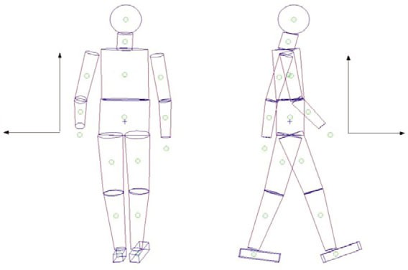
z
z
x
y
Fig. 1. Human model and coordinate frame. The human model has 16 segments with 32 internal degrees of freedom. Using human morphological data from the literature, mass is distributed throughout the model in a realistic manner. The coordinate frame is oriented by the right-hand rule with the z-axis directed vertically, the y-axis pointing in the direction of the walking motion (anterior–posterior direction), and the x-axis pointing to the right of the participant (medio-lateral direction).

from the literature, model segment density often became abnormal, falling beyond two standard deviations from the experimental mean. In distinction, when the density of each model segment was set equal to each segment’s mean experimental value from the literature, model relative mass then became abnormal. As a resolution to this difficulty, we performed an optimization where model relative mass was varied until the error between model and experimental density values were minimized. We then confirmed that each segment’s relative mass and density fell within one standard deviation of their experimental means reported in Winter (Winter, 1990).
Walking angular momentum
In detail, the relative mass distribution throughout the model, M_{R}, described by a 16-component vector corresponding to the 16 segments of the model, was modeled as a function of a single parameter α such that:
M_{R}(α) = (M_{R}^{Exp}+αV_{R}) / (1+α) . (1)
Here M_{R}^{Exp} is a 16-component vector of mean relative mass values obtained from the literature (Winter, 1990), and V_{R} is a 16- component vector of relative volumes computed directly from the human model. The relative volume of the i-th segment, V_{R}i , was defined as the ratio of the segment’s volume, Vi, over the total
The projection of the CM onto the horizontal ground surface, or x_{CM} and y_{CM} (see Fig. 1), was computed from the human model using Eqn 3, and then compared with the CP location measured directly from the force platform. The separation distance between the CM projection on the ground and the CP was ~3 mm. To determine whether the error changed appreciably for a different static pose, we repeated the experiment with one leg retracted rearward and the second leg protracted forward (comparable to the body’s posture during the double-support phase of walking). Using this second pose, the CM model error was still small (~3·mm). At a self-selected gait speed, the body’s CM oscillates with a peak-to- peak amplitude of between 4 and 5 cm in the medio-lateral (x) direction (Crowe et al., 1995). Thus, the estimated CM model error was less than 10% of these oscillations.
Whole-body angular momentum and moment
Whole-body angular momentum was estimated using the human model and kinematic gait data. Angular momentum, L, was calculated as the sum of individual segment angular momenta about the body’s CM, or:
16
—

body volume, V, or V_{R}i =Vi/V. By using Eqn 1, total body mass and
S = [(r ^{i} –r
) × m (vi–v
) + ω ] .
(4)

individual segment volumes computed from the model, model segment densities were computed and represented by a 16-

i=1
CM CM
i CM
Ii i

component vector D(α). Here the density of the i-th segment was defined as Di(α)=M_{subject}M_{R}i (α)/V i, where M_{subject} is total body mass and Vi is the volume of the i-th segment. The final relative mass distribution was obtained as M_{R}=M_{R}(α_{min}) where α_{min} minimized the absolute error between the distribution of segment densities, D(α), and the mean distribution of segment densities from the literature, D^{Exp}. This analysis procedure may be expressed as:
,
min|Ã(α) – ÃExp| = min [Di(α) – DExp,i]2

i
MExp + αminỸR
The first term within the square brackets is the angular momentum due to the i-th segment’s CM movement. Here r_{CM} is the CM position of the entire body defined in Eqn 3, and v_{CM} is the whole- body CM velocity in the lab frame. Further, r ^{i}_{CM} and v^{i} are the i-th segment’s CM position and velocity in the lab frame, respectively, and m_{i} is the i-th segment’s mass. The second term within the square brackets is the angular momentum of the i-th segment about its CM position. Here ↔I i and i are the i-th segment’s inertia tensor (3 × 3) and angular velocity (3 × 1) about the segment’s CM, respectively. In order to reduce data variance across study participants, angular momentum was represented in dimensionless form using a normalization constant N_{subject}, equal to the product of the

→ α_{min} → M_{R} =
R
1 + α_{min}
. (2)
participant’s mass M_{subject}, CM height H_{subject}, and the mean self- selected gait speed V_{subject} across seven gait trials, or:

Whole-body center of mass
The body’s CM location was estimated using the human model and joint position data from the motion capture measurements. The CM position, r_{CM}, of the entire 16-segment model was calculated as a sum of the products of the segments’ relative masses and CM locations, or:
16
Nsubject = MsubjectVsubjectHsubject . (5)
For each participant, the CM height was estimated during upright standing using the human model, the motion capture data, and Eqn
3. Angular momentum was computed using Eqn 4 for each gait cycle and then put into dimensionless form by dividing by the normalization constant N_{subject} defined in Eqn 5. Dimensionless angular momentum was then plotted versus percentage gait cycle

r_{CM} = M^{i} r ^{i} .
(3)
equal to gait time divided by total cycle time. At each percentage

R CM
i=1
cycle time, the mean and standard deviation of the dimensionless angular momentum were computed over a total of 70 walking trials

Here M_{R}i is the relative mass of the i-th body segment, and r_{C}^{i} _{M} is
(10 participants, 7 gait trials per participant).

the CM location of the i-th body segment relative to the lab frame.
CM error estimate
To estimate the error in the CM calculation, we first collected kinematic data from the aerial phase of running and then, using Eqn 3, estimated the body’s aerial phase CM trajectory. We found good agreement between this estimated CM trajectory and a ballistic trajectory (R2=0.99; see Eqn 11 for R2 definition). It was also noted that, during the aerial phase, the maximal distance error between these trajectories was less than 2 mm. As an additional check of CM error, we first collected kinetic and kinematic data while a participant stood on the force platform in a static standing pose.
An alternative method for computing angular momentum is by integration of the moment about the CM. We computed angular momentum in this manner and compared the result to the angular momentum estimate of Eqn 4. We found little difference between these two estimates (R2 values of 0.97, 0.96 and 0.98 for L_{x}, L_{y} and L_{z}, respectively). We preferred computing angular momentum directly from kinematics data because a single methodology could then be used when estimating both whole-body angular momentum and individual segment momenta in walking. The topic of individual segment angular momenta is addressed in the subsequent Materials and methods section entitled ‘Segmental contributions to whole-body angular momentum’.

H. Herr and M. Popovic

Angular momentum error estimate
To estimate the error in the angular momentum calculation, we first collected kinematic data from the aerial phase of running where angular momentum is a conserved quantity (assuming air drag exerts a negligible moment). From the flight phase kinematic data and Eqn 4, the angular momentum vector for the aerial phase was

where F_{z} is the measured vertical ground reaction force, and M_{x} and M_{y} are horizontal moments measured about that same lab reference point.
Eqn 6 can be solved for the horizontal ground reaction forces, or:

obtained, and one standard deviation about the mean value was
F = ⎧ Fz (x –x
⎫ ⎧ Ty ⎫ ,
(9)

assigned to be the model error for each spatial direction. To
x ⎨z
CM CP)⎬ + ⎨– z ⎬

quantify its relative size, model error was then compared with the
⎩ CM
⎭ ⎩ CM ⎭

maximum angular momentum value found during the walking

FZero-moment
⎧
⎨
⎩
⎧
⎨
⎩

FMoment

cycle about each spatial direction. Using walking data from the x x

same study participant that participated in the running experiments,
⎧ F ⎫ ⎧ T ⎫

we first calculated the mean angular momentum curve for each
Fy = ⎨ z (yCM–yCP)⎬ + ⎨ x ⎬ ,
(10)

spatial direction (n=7 walking trials). The maximum angular momentum values from the mean curves were then compared with the model errors for the three orthogonal directions. We found the
⎩zCM ⎭ ⎩zCM ⎭
FZero-moment FMoment
⎧
⎨
⎩
⎧
⎨
⎩

angular momentum errors were 1.7%, 4.2% and 10% of the maximum angular momentum values in the medio-lateral (x), anterior–posterior (y) and vertical (z) directions, respectively (see Fig. 1 for coordinate frame specifications).
In addition to angular momentum, CM moment T was estimated by taking the rate of change of angular momentum at each percentage cycle time. Moment was then put into dimensionless form using the scaling factor M_{subject}GH_{subject}, where G is the gravitational constant. Similar to the angular momentum data analysis procedure, dimensionless CM moment was plotted versus percentage gait cycle, and at each percentage cycle time the mean and standard deviation were computed over a total of 70 walking trials.
Horizontal ground reaction force predictions
A key hypothesis in this paper is that angular momentum is highly regulated in steady-state human walking about all three orthogonal directions [|L(t)|≈0], and therefore horizontal ground reaction forces can be explained predominantly through an analysis that assumes zero net moment about the body’s CM. To test this hypothesis, we first derived a relationship between horizontal ground reaction force, whole-body CM, and CP consistent with zero net moment. We then
y y

where T_{x} and T_{y} are the CM moments in the medio-lateral (x) and anterior–posterior (y) directions, respectively. Throughout this manuscript we refer to the first and second terms on the right-hand sides of Eqns 9 and 10 as the zero-moment and moment force contributions1 to the horizontal ground reaction forces, respectively (Popovic et al., 2005). To evaluate the hypothesis that horizontal ground reaction forces can be explained predominantly through a zero-moment analysis, zero-moment forces F_{x}Zero-moment and F_{y}Zero-moment were compared with the actual horizontal ground reaction forces measured from a force platform. As defined by Eqns
9 and 10, these zero-moment forces were obtained using the calculated position of body CM (Eqn 3), the experimentally measured CP, and the experimentally determined vertical ground reaction force.
To assess the amount of agreement between zero-moment model forces and experimentally measured horizontal forces, we used the coefficient of determination, R2, where R2=1 only if there is a perfect fit and R2=0 indicates that the model’s estimate is worse than using the mean experimental value as an estimate. More specifically, R2 was defined as:
NTrial NPercent

compared the predicted zero-moment forces with ground reaction
(F ij
–F ij )2

forces measured directly from a force platform.
Exp Mod

The horizontal component (hor) of the total moment about the CM [T |_{hor}=(T_{x},T_{y})=(T _{CM}·^{r}i ,T_{CM}·^{r}j )] may be expressed as:
1 – i=1 j=1 ,
NTrial NPercent
(F ij –F )2
(11)

T | = [(r –r

) × F]
= dS | ,

(6)

i=1

j=1
Exp
Exp

hor
CP CM
hor
hor
dt
where F _{E}ijxp and F_{M}ij od are the forces taken at the j-th percentage gait cycle of the i-th trial for the experimental data and model-predicted

where F is the ground reaction force, and r_{CP} is the CP location on the ground surface. The CP ground reference point is frequently used in the study of human gait and postural balance (Winter, 1990; Rose and Gamble, 1994). For a body in contact with the force platform, the position of the CP, measured relative to a lab frame reference point located on the force platform walking surface, is calculated as:
M
data, respectively. Before computing R2 values for each spatial direction and study participant, both experimental and zero- moment forces for the medio-lateral (x) and anterior–posterior (y) directions were plotted versus percentage gait cycle (equal to gait time divided by total cycle time). We then computed medio-lateral
(x) and anterior–posterior (y) R2 values for each participant by
summing over all walking trials (N_{Trial}=7) and gait percentage times analyzed (N_{Percent}=100).

x_{CP} = – ^{y}
F_{z}
(7)
In Eqn 11, experimental mean F_{Exp} is the grand mean over all walking trials and gait percentage times analyzed, or:
NTrial NPercent

and
F = 1
F ij .
(12)

y_{CP} = Mx ,
F

(8)
Exp
NTrialN

Percent

i=1

j=1
Exp

¹It is noted that moment as used here refers to horizontal moment and not
z vertical moment.

We used a non-parametric Wilcoxon matched-pairs test (Wilcoxon, 1945) for comparing the two R2 values corresponding to the medio- lateral (x) and anterior–posterior (y) directions. This statistical significance test was performed to look for differences in the capacity of the zero-moment force model to predict experimental force equally well in the two horizontal directions.
Walking angular momentum
Center of pressure predictions
An alternative strategy for quantifying the degree to which whole- body angular momentum is regulated in walking is to estimate a zero-moment CP position. This ground reference point, previously defined in the robotics literature, is called the centroidal moment pivot (CMP) (Herr et al., 2003; Hofmann, 2003; Popovic et al., 2004a; Popovic et al., 2005; Goswami and Kallem, 2004). The CMP location, r_{CMP}, is defined as the point where a line parallel to the ground reaction force, passing through the CM, intersects with the ground surface. As its name implies, when the CMP coincides with the CP, no horizontal moments act about the body’s CM. In distinction, when these ground reference points diverge, non-zero horizontal CM moments exist. To further quantify whole-body rotational dynamics, we compare a calculated CMP trajectory with an experimentally measured CP trajectory from the force platforms.
The CMP can be expressed mathematically by requiring that the cross-product of the CMP–CM position vector and the ground reaction force vector vanishes, or:
[(r_{CMP}–r_{CM}) × F]_{hor} = 0 . (13)
By expanding this cross-product, the CMP location can be written in terms of the CM location and the ground reaction force, or:
When the CMP departs from the CP, there exist non-zero horizontal CM moments, causing variations in whole-body angular momentum (see Fig. 2A). While by definition the CP cannot leave the ground support base2, the CMP can – but only when horizontal moments act about the CM. In this investigation, the CMP was calculated using Eqn 14 and 15, the calculated CM position from the human model, and the ground reaction force measured from the force platforms. We then computed the mean separation distance between the CMP and CP points, normalized by foot length, across the entire gait cycle. If angular momentum is highly regulated in walking and CM moments are small, we anticipate that the CMP location should coincide with the experimentally measured CP position (see Fig. 2B).
Segmental contributions to whole-body angular momentum Motivated by Elftman (Elftman, 1939), in this paper we tested the hypothesis that whole-body angular momentum is small throughout the walking cycle, despite substantial segmental momenta, indicating large segment-to-segment cancellations. To investigate the segmental movement correlations in connection with angular momentum, we used principal component (PC) analysis. We first obtained the segmental angular momentum PCs together with the amount of data explained by each PC. We then calculated their respective weighting coefficients, or tuning coefficients. Finally, we obtained the level of momentum cancellation between body segments for all three spatial directions, and the strategy employed by the body to achieve that level of cancellation.
Principal component analysis
PC analysis (e.g. Jackson, 1991) was performed on all segmental angular momenta, for each of the three spatial components, to

and
xCMP
= x_{CM}
– Fx z_{CM} F_{z}
(14)
produce PCs. Each PC was a 16-component unit vector, P_{j}^{i}, corresponding to the 16 body segments of the human model. Here P_{j}^{i} represents the i-th PC in the j-th direction. Vector components P_{j}^{iq} denoted the relative contributions of the q-th body segment to P_{j}^{i}. As is customary, each PC was assigned a value for the percentage

yCMP = yCM – Fy zCM .
F_{z}
(15)
of data explained, DEij, where j=1…3 denotes the number of spatial components, and i=1…N corresponds to the total number of PCs (equal to the number of human model segments, i.e. N=16).
The PC vectors and the corresponding percentages of data explained were obtained using the MATLAB statistical toolbox (MathsWorks Inc., Natick, MA, USA). The 16-component angular momentum vector was compactly represented as:
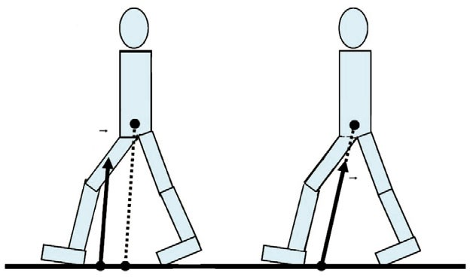N
A
B
CM
CM
F
F

Λ^{r} (t) = C^{i}(t) · Ã^{i} ,
(16)

j j j
i=1
where C_{j}i(t), te(0%, 100%) are time-dependent tuning coefficients. The components of the momentum vector defined in Eqn 16 correspond to the 16 segments of the human model.

CP CMP

CP=CMP
Normalized tuning coefficients
In order to extract directional dependence, we introduced the normalized tuning coefficients c_{j}i(t), such that:

Fig. 2. Centroidal moment pivot (CMP). The CMP is the point where the ground reaction force would have to act to keep the horizontal component
r ⎧ N ⎫ N
Λ_{j}(t) = ⎨ [C^{i}(t)]2 ⎬ c^{i}(t) · Ã ^{i} ,

(17)

of the whole-body angular momentum constant. When the moment about the center of mass (CM) is zero (B), the CMP coincides with the center of
j
⎩ i=1
j j
⎭ i=1

pressure (CP). However, when the CM moment is non-zero (A), the extent of separation between the CMP and CP is equal to the magnitude of the horizontal component of moment about the CM, divided by the normal component of the ground reaction force.
²When in single support, the support base is the outline of the part of the stance foot that is actually in contact with the ground. When in double support, where both feet are on the ground, the support base is the smallest convex shape that includes all points where both feet are in contact with the ground.

H. Herr and M. Popovic
where the expression in the brackets represents the magnitude of the angular momentum vector in the N-dimensional space. It is noted here that the time-dependent normalized tuning coefficients satisfy:
N

To provide the reader with a better understanding of the relative size of these measured human values, we computed the angular momentum about the CM of single-segment, rigid-body models. In the vertical (z) direction, we computed the angular momentum

|c^{i}(t)|2 = 1 , j = 1...3 , t e (0%,100%) . (18)
j
i=1
about the CM of a rigid body rotating about a stationary vertical axis passing through the stance foot with an angular velocity equal to V_{subject}/W, where W is half the foot separation distance in the

Analysis was performed to find the smallest number of angular momentum PCs necessary to explain greater than 90% of the segmental angular momentum data. To determine the minimum number of PCs to capture both inter- and intrasubject variability, both participant-dependent and participant-independent analysis methods were performed. For the participant-dependent method, PC analysis was performed for each participant across seven walking trials, whereas for the participant-independent method, PC analysis was conducted across all participants and walking trials (70 trials).
Segmental angular momentum cancellation
The participant-dependent PCs were used to estimate the amount of segmental momentum cancellation for each participant and j-th spatial direction, or:
N_{E}

DE
i j
⎡
16
i=1
⎢
⎢

P
iq j
q=1
⎣ q=1 ⎦
16

|P |
iq
j
⎥
⎥
⎤2
medio-lateral (x) direction during quiet standing. The angular momentum, scaled by M_{subject}V_{subject}H_{subject}, for this simple comparison case is then equal to I_{zz}/(M_{subject}H_{subject}W). Using the human model and kinematic data from the 10 study participants, we computed the average I_{zz} value during the single-support phase for all 10 participants. Using this value, the normalized angular momentum for the rotating rigid body was equal to ~0.05, 5-fold larger than our measured human angular momentum value of 0.01 in the vertical (z) direction.
In the medio-lateral (x) direction, the normalized angular momentum about the CM of a physical inverted pendulum falling forward while rotating about a stationary rotational axis at the ground surface is I_{xx}/(M_{subject}H_{s}2ubject), assuming an angular velocity equal to V_{subject}/H_{subject} and a moment of inertia about the CM equal to I_{xx}. Once again, using the human model and kinematic data from the 10 study participants, we computed the average I_{xx} value during the single-support phase for all 10 participants. Using this value,

S_{j} = 1 –
, (19)
the normalized angular momentum for the physical inverted pendulum falling forward was equal to ~0.2, 4-fold larger than our measured human angular momentum value of 0.05 in the medio- lateral (x) direction.
The authors cannot think of a simple comparison case for the

where q=1…N and where N_{E}=4 sufficed for the level of precision in our study. The net cancellation was therefore expressed as a sum of squares (i.e. treated as independent variables or orthogonal directions) of cancellations, across the largest PCs, weighted by their respective data explained.
To test whether the amount of angular momentum cancellation for all 10 participants across the three spatial directions was sampled from the same distribution, we used a non-parametric Friedman ANOVA test (Friedman, 1937; Friedman, 1940). This statistical significance test was performed to look for differences in the amount of angular momentum cancellation across the three orthogonal directions, or vertical (z), anterior–posterior (y) and medio-lateral (x). Two types of non-parametric post hoc tests were independently performed to compare cancellation for pairs of spatial directions. These tests were the Dunn procedure with Wilcoxon test (Wilcoxon, 1945; Dunn, 1964) and the minimum significant difference (Portney and Watkins, 2000).
RESULTS
Whole-body angular momentum and moment
Angular momentum estimations
To quantify whole-body rotational behavior during steady-state walking, angular momentum was computed from kinematic gait data, as defined in Eqn 4. Angular momentum curves, scaled by M_{subject}V_{subject}H_{subject}, are shown in Fig. 3A versus percentage gait cycle. Throughout the gait cycle, the absolute value of the normalized angular momentum mean, plus one standard deviation, remains smaller than 0.05, 0.03 and 0.01 in the medio-lateral (x), anterior–posterior (y) and vertical (z) directions, respectively3.
³The angular momentum curves shown in Fig. 3A agree well with the measurements of Elftman (Elftman, 1939), in terms of overall curve shape, as well as peak momentum values in the medio-lateral (x), anterior–posterior (y) and vertical (z) directions.
peak angular momentum in the anterior–posterior (y) direction. Thus, the normalized peak human value of 0.03 in the anterior–posterior (y) direction can be compared with both the medio-lateral (x) and the vertical (z) single-segment, rigid-body values; the vertical (z) rigid body value of 0.05 is 1.7-fold larger, and the medio-lateral (x) value of 0.2 is over 6-fold larger, than the human value of 0.03.
CM moment estimations
Moment curves, scaled by M_{subject}GH_{subject}, are shown in Fig. 3B versus percentage gait cycle. Throughout the gait cycle, the absolute value of the normalized CM moment mean, plus one standard deviation, remains smaller than 0.07, 0.03 and 0.014 dimensionless units in the medio-lateral (x), anterior–posterior (y) and vertical (z) directions, respectively.
Horizontal ground reaction force and CP predictions
In Fig. 4A,B, zero-moment and experimental forces are plotted versus percentage gait cycle for the medio-lateral (x) and anterior–posterior (y) directions, respectively. Plotted data are for one representative participant (participant no. 1 in Table 1) and experimental trial. Mean R2 values for each participant, and across all participants, are listed in Table 1. Across all study participants, the mean R2 value is 0.91±0.06 in the medio-lateral (x) direction and 0.90±0.03 in the anterior–posterior (y) direction. The high R2 values indicate good agreement between zero-moment force predictions and experimental force values. No significant difference was observed between the distributions of R2 values for these two spatial directions (P=0.267), indicating that the zero- moment model has an equal capacity to predict horizontal ground reaction forces independent of horizontal direction.
Additionally we calculated the CMP using Eqn 14 and 15, and then compared the values with the experimentally measured CP

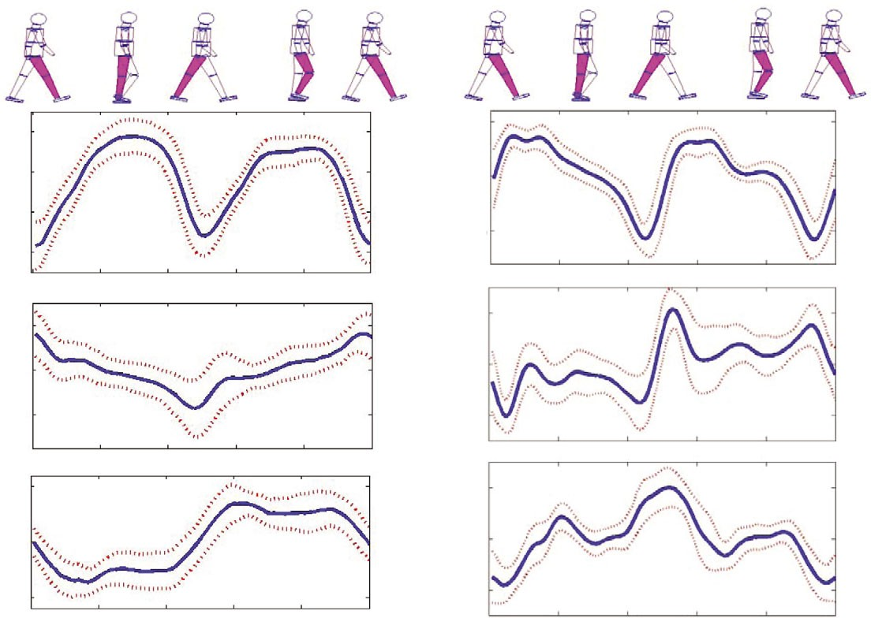
A B
Walking angular momentum

0.02

0
L_{x}/(MVH)

–0.02

–0.04
0.05

0
T_{x}/(MGH)

–0.05

0.02
L_{y}/(MVH)

0
0.02

0
T_{y}/(MGH)

–0.02 –0.02

0.01 0.01

0 0
L_{z}/(MVH)
T_{z}/(MGH)

–0.01
0 20 40 60
Gait cycle (%)

80 100
–0.01
0 20 40 60
Gait cycle (%)

80 100

Fig. 3. Whole-body angular momentum and moment. (A) A normalized angular momentum for walking is plotted about three orthogonal directions versus percentage gait cycle. The angular momentum is normalized by the product of each participantʼs mass, CM height and self-selected gait speed (MVH; see Table 1 for values). (B) Normalized CM moment is plotted about three orthogonal directions versus percentage gait cycle. Moment is normalized by the product of each participantʼs weight and CM height (MGH). For both A and B, the solid line is the mean normalized value, and the dashed lines are one standard deviation about the mean (10 participants and seven walking trials per participant). In addition, 0% and 100% gait cycles correspond to consecutive heel strikes of the same foot.

from a force platform. In Fig. 4C, the CP, CMP and CM ground projection locations are plotted. Again, plotted data are for one representative participant (participant no. 1 in Table 1) and experimental trial. Table 1 includes the mean distance between the

Table 1. Body mass M_{subject}, CM height H_{subject} and self-selected walking speed V_{subject} for each study participant

 | Msubject | Hsubject | Vsubject
Participant | (kg) | (m) | (m s^{–1}) R² R² β%  x y
1 | 50.1 | 0.88 | 1.30 0.97 0.94 16
2 | 62.7 | 0.94 | 1.38 0.97 0.90 13
3 | 81.9 | 1.08 | 1.32 0.96 0.92 12
4 | 73.9 | 1.01 | 1.18 0.95 0.85 16
5 | 49.9 | 0.88 | 1.06 0.95 0.90 15
6 | 57.2 | 0.92 | 1.40 0.95 0.87 10
7 | 82.6 | 1.08 | 1.24 0.91 0.88 12
8 | 64.6 | 1.03 | 1.41 0.82 0.84 12
9 | 65.3 | 0.99 | 1.40 0.83 0.95 15
10 | 76.8 | 1.06 | 1.33 0.81 0.91 15
Mean ± s.d. | 66±12 | 1.0±0.1 | 1.3±0.1 0.91±0.06 0.90±0.03 14±2
Also listed are the mean coefficients of determination R ² between the zero- moment force curve and the experimentally measured horizontal ground reaction force for medio-lateral (R²) and anterior-posterior (R²) directions (see Eqn 11), and the mean distance between the CMP and CP points across the entire gait cycle normalized by foot length for each study participant (β%) is given.
x
y

CMP and CP points, normalized by foot length, across the entire gait cycle, or β%. The mean normalized distance across participants is small (β=14±2%), indicating good agreement between the CMP and CP points in steady-state walking. Finally, for all participants and walking trials, the CMP remains within the ground support base throughout the walking cycle, indicating how closely the human body regulates angular momentum in walking.
Segmental contributions to whole-body angular momentum For the participant-dependent analysis approach, the data explained by the first PC, as well as the first three PCs combined, are shown in Table 2. On average across all study participants, the first three PCs accounted for 98±1%, 92±2% and 95±1% in the medio-lateral (x), anterior–posterior (y) and vertical (z) directions, respectively. Thus, the participant-dependent PC analysis performed on each participant’s trial data reveals that only three PCs are necessary to explain greater than 90% of segmental momentum data. In Fig. 5, the average participant-dependent first PC is shown for all three spatial directions. Standard deviation error bars are included to quantify the level of variability in the first PC across study participants. The greatest variability in the segmental momentum distribution was found to occur in the coronal plane (x–z plane in Fig. 1).
The results of participant-independent PC analysis performed simultaneously on all participants and trials (total of 70 trials) are shown in Figs·6 and 7. In Fig. 6, the angular momentum PCs, that

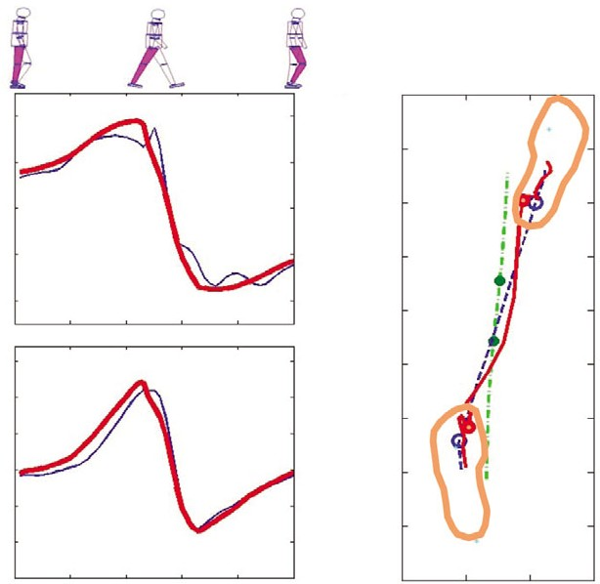
A
40
20
F_{x} (N)
0
–20

–40
B150
100
50
F_{y} (N)
0
–50
H. Herr and M. Popovic

C –100
–200

–300
Anterior–posterior direction (mm)

–400

–500

–600

–700

–800

–900

found that whole-body angular momentum is small, despite substantial segmental momenta, indicating large segment-to- segment cancellations: 95% medio-lateral (x) cancellation, 69% anterior–posterior (y) cancellation and 77% vertical (z) cancellation. We found no significant difference between the amount of momentum cancellation in the anterior–posterior (y) and vertical (z) directions (P=0.19). However, we did find a significant difference between the amount of momentum cancellation in the medio-lateral (x) direction compared with the anterior–posterior (y) direction (P=0.001) and the vertical (z) direction (P=0.002).
In Fig. 7, the mean normalized tuning coefficients, as defined in Eqn 17, are shown for three spatial directions. The tuning coefficients correspond to the PCs plotted in Fig. 6, and define the relative dominance of each PC as a function of gait cycle. In the subsequent sections, we use the PCs, and their respective tuning coefficients, to describe segment-to-segment momentum cancellations.
Segmental cancellation in the medio-lateral direction

–100
–1500 10 20 30
Gait cycle (%)

40 50

–10000 100 200 300
Medio-lateral direction (mm)
The most dominant first PC in the medio-lateral (x) direction shows that adjacent leg-segment momenta oppose one another (the left foot momentum cancels the right foot momentum, etc.; see Fig. 6). Further, the first PC shows that arm, abdomen, pelvis, chest, neck

Fig. 4. Horizontal ground reaction force and CP predictions. (A,B) The horizontal ground reaction forces in walking are plotted versus percentage gait cycle in the medio-lateral (x) and anterior–posterior (y) directions, respectively. The thick red line is the calculated zero-moment force (see Eqns 9 and 10), and the thin blue line is the force measured experimentally using force platforms. (C) Plotted are the CP (blue dashed line), CMP (red solid line) and CM ground projection (green dash-dotted line) trajectories and corresponding footprints. The two circles on each line denote the transition from single to double support, and vice versa. In all plots, only half the gait cycle is shown. Data span from the middle of a single-support phase (0% gait cycle) to the middle of the next single-support phase of the opposite limb (50% gait cycle). Data shown are for one representative participant and trial (participant no. 1 in Table 1).

when combined account for more than 90% of the experimental data, are shown for three spatial directions. While only three PCs are needed to explain more than 90% of the data in sagittal (y–z) and transverse (x–y) planes, four PCs are needed in the coronal (x–z) plane.
The percentage of segmental momentum cancellation (see Eqn 19) per participant and spatial direction is listed in Table 2. We
and head momenta are negligible. However, as the first tuning coefficient in the medio-lateral (x) direction shows in Fig. 7, the first PC becomes less dominant during the powered plantar flexion phase, from 43% to 62% gait cycle, and the second PC increases in dominance.
For the second PC, cancellation occurs within each leg, in contrast to the first PC where cancellation occurs from leg segment to adjacent leg segment. For the trailing limb, foot and calf momenta oppose thigh momentum during ankle-powered plantar flexion, pre-swing knee flexion, and pre-swing hip flexion. For the forward limb, foot and calf momenta oppose thigh momentum during ankle-controlled plantar flexion, early stance knee flexion and early stance hip flexion.
Segmental cancellation in the anterior–posterior direction
The most dominant first PC in the anterior–posterior (y) direction shows that foot, calf, chest and head momenta oppose the abdomen and pelvis momenta, and further that arm, thigh and neck momenta are negligible (see Fig. 6). However, as the first tuning coefficient in the anterior–posterior (y) direction shows in Fig. 7, the first PC is most dominant during the double-support phase of walking, from
0% to 12% gait cycle and from 50% to

Table 2. The data explained (DE) by the first principal component (PC), as well as the first three PCs combined, listed for each participant and spatial direction
62% gait cycle. During single support, the first PC is not as dominant, and the second,

Participant DE¹ DE¹ DE¹ DE ^{III} DE ^{III} DE ^{III} S S
S third and fourth PCs increase in

x y z x
y z x y
z dominance. It is noted here that for the

1 87 73 86 99 93 94 96 92 73
2 89 75 82 98 92 94 96 92 74
3 86 49 85 98 91 95 93 64 63
4 86 66 89 99 94 95 93 52 80
5 87 67 89 99 90 95 93 89 81
6 90 65 90 99 94 95 97 74 79
7 86 57 87 98 93 95 95 71 79
8 83 78 85 97 92 93 93 84 94
9 88 65 89 99 90 97 96 44 69
10 87 85 88 98 95 97 95 21 78
Mean ± s.d. 87±2 68±10 87±2 98±1 92±2 95±1 95±2 69±23 77±8
x
y

DE¹ (%) denotes the percentage of data explained by the first PC in the x-direction, and DE^{III} (%) denotes the data explained by the first three PCs combined in the x-direction. Also listed is the percentage of angular momentum cancellation, S (%) defined in Eqn 19, for each participant and spatial direction.

second PC, explaining 29% of the data, no dominant segmental cancellation occurs.
Segmental cancellation in the vertical direction
The first PC in the vertical (z) direction shows that leg angular momenta oppose the remaining body segment momenta of the arms, pelvis, abdomen, chest, neck and head. However, the first PC becomes less dominant during the powered plantar flexion phase, from 43% to 62% gait cycle, and the second and third PCs increase in dominance (see Fig. 7). However, the

Walking angular momentum
PC₁ (y)
PC₁ (x)
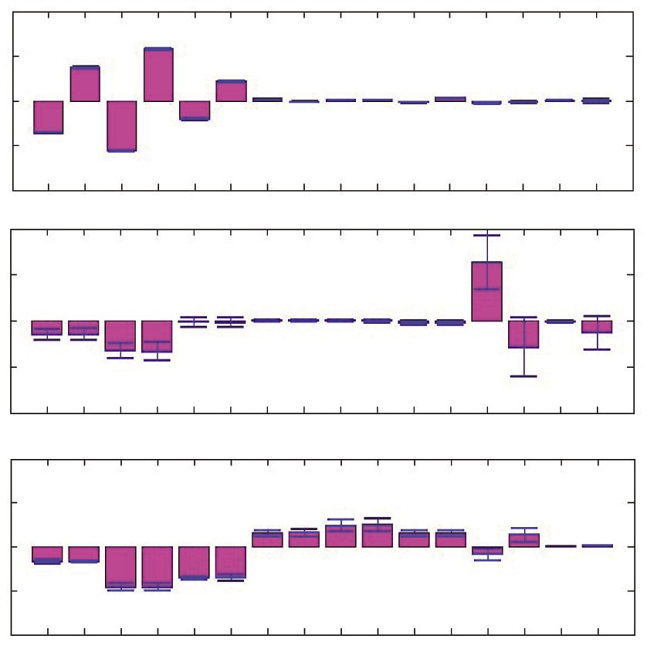second and third PCs only explain ~4% of the data, and thus the rotational dynamics that they explain are not discussed here.
1
0.5
0
Left foot (1)
–0.5
–1

1
0.5
0
–0.5
–1

1
0.5
0
–0.5
–1
2
4
6
8
10 12 14
16
Right foot (2)
Left calf (3)
Right calf (4)
Left thigh (5)
Right thigh (6)
Left hand (7)
Right hand (8)
Left forearm (9)
Right forearm (10) Left upper arm (11) Right upper arm (12)
Pelvis and abdomen (13) Chest (14)
Neck (15)
Head (16)
Fig. 5. The mean participant- dependent first PC about three spatial directions. Here the participant- dependent first PCs were averaged across the 10 study participants. Error bars are one standard deviation about the mean. The abscissa numbers and human model segments are paired to the right of the figure. In the anterior–posterior (y) direction, large variations in the relative contribution of angular momentum are observed for the pelvis and abdomen (segment 13), chest (segment 14) and head (segment 16) [see large standard deviations in Fig. 5 for PC₁ (y)].
Link number
PC₁ (z)
DISCUSSION
Would simple inverted pendulum mechanics also predict the observed horizontal ground reaction forces?
The inverted pendulum model has been used by researchers to describe sagittal-plane CM dynamics during the single support phase of walking (Bekker, 1956; Cavagna et al., 1976; Alexander, 1976; Margaria, 1976; Cavagna et al., 1977). The model comprises a point mass attached to a mass-less rigid leg that intersects with the ground surface at a single point. The model makes three critical assumptions. First, that the body moves as if all its mass is located at the CM, requiring that the resultant ground reaction force vector always points at the CM (zero-moment condition). Second, that the CP is a stationary, time-invariant point. And finally, that the leg during single support behaves as a rigid strut.
This study directly addresses the first two assumptions of the inverted pendulum model. Since the entire mass of the body is represented as a point mass, the model will, by definition, always move with a constant angular momentum and with no moments acting about its CM. The data presented in this study support the point mass representation, assumed by many recent walking models (Kuo, 2002; Geyer et al., 2006; Srinivasan and Ruina, 2006). In fact, we further generalize the point mass representation to include single- and double-support phases. We found that zero-moment forces agree remarkably well with experimental values for single support (R_{x}2=0.97±0.02; R_{y}2=0.94±0.02), and agree reasonably well for double support (R_{x}2=0.72±0.14; R_{y}2=0.78±0.06). Still further, whereas the inverted pendulum model is a 2-D sagittal plane model, the results of this study further generalize the point mass representation to include the medio-lateral (x) direction. Across all study participants and including the entire gait cycle, the mean R2 parameter was 0.91±0.06 in the medio-lateral (x) direction and 0.90±0.03 in the anterior–posterior (y) direction. No significant difference was observed between the distributions of R2 values for

these two spatial directions (P=0.267), indicating that zero-moment forces are equally dominant in the two horizontal directions.
Not all assumptions of the inverted pendulum model are supported by this investigation. The fact that the model assumes that the CP acts as a fixed point limits its capacity to predict horizontal ground reaction force and CM dynamics. For the zero- moment force predictions shown in Fig. 4A,B, the CP was not represented as a fixed point, but rather experimental CP trajectories were used as inputs, as dictated by Eqns 9 and 10. As noted earlier, zero-moment forces closely match horizontal ground reaction forces during single support (R_{x}2=0.97±0.02; R_{y}2=0.94±0.02). In contrast, using a fixed CP point as required by the inverted pendulum model4, the calculated horizontal forces agree well in the medio-lateral (x) direction (R_{x}2=0.88±0.08) but the agreement is very poor in the anterior–posterior (y) direction (R_{y}2=–0.33±0.44). Not surprisingly, for double support a fixed CP analysis results in extremely poor agreement between zero-moment and experimental forces (R_{x}2=–0.28±0.22; R_{y}2=–0.11±0.53). In summary, for the advancement of bipedal walking models that accurately predict steady-state CM dynamics, we feel a point mass representation can be assumed, but the mechanical behavior of the model’s legs and their interaction with the ground surface must be sufficiently human-like so as to achieve realistic CP dynamics.
Is angular momentum always regulated during human movement tasks?
Whole-body angular momentum regulation is not a general feature across all human movement tasks. For some movement patterns, humans purposefully generate angular momentum to enhance stability and maneuverability (Popovic et al., 2004b; Hofmann et al., 2007). By actively rotating body segments (arms, torso, legs), CM moments can be generated that cause horizontal moment forces
⁴For the stationary CP analysis, the zero-moment force components of Eqns 9 and 10 were used where the CP position was assumed to be at a fixed, lab frame location, corresponding to a point at the foot center for single support and halfway between both feet for double support.

H. Herr and M. Popovic

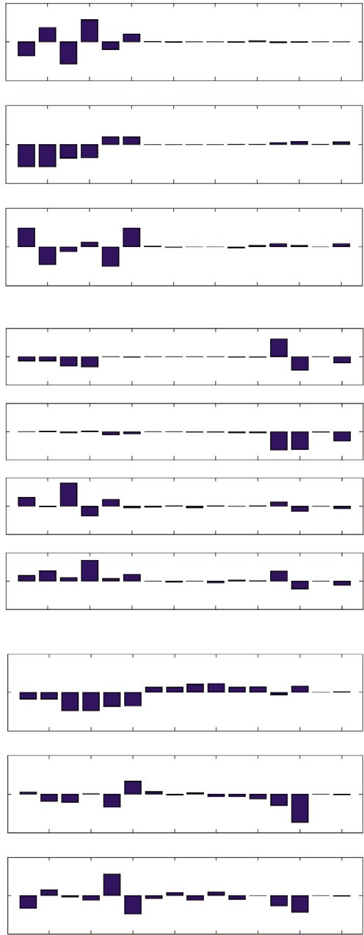
1
86.25%
PC₁ (x)
0

–1
1
PC₂ (x)

1

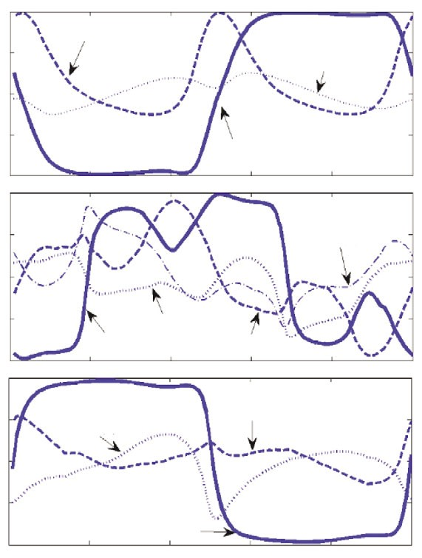
0.5

0

B₂ (x)=0.26

B₃ (x)=0.32

0

–1
1
PC₃ (x)

0

–10
9.33%

2.20%

2 4 6 8 10

12 14 16
–0.5

–1
Normalized tuning coefficients
1

0.5

0

–0.5

B₃ (y)=1.20

B₁ (x)=0.14

B₄ (y)=1.03

1
PC₁ (y)
51.83%
0
–1
1
PC₂ (y)
29.21%
0
–1
1
PC₃ (y)

–1
1

0.5

0
B₁ (y)=0.52

B₃ (z)=0.64
B₂ (y)=1.45

B₂ (z)=1.00

7.62%
0
–1
1
PC₄ (y)
7.20%
0
–0.5

–1

B₁ (z)=0.19
0 20 40 60 80 100
Gait cycle (%)

–10
1
PC₁ (z)

0

–1
1
PC₂ (z)

0

–1
1
PC₃ (z)

0

–1

2 4 6 8 10

83.45%

3.92%

3.85%

12 14 16
Fig. 7. Tuning coefficients. The mean values, over all participants and trials, of the normalized tuning coefficients are plotted for three spatial directions. The tuning coefficients correspond to the PCs shown in Fig. 6. Here the normalized tuning coefficients were computed using Eqn 17, and were obtained as gait percentage averages over all participants and walking trials. To provide information on the variability of each normalized tuning coefficient, a variability number B_{i}(j) is assigned to each curve, where j=1…3 (spatial directions) and i=1…N (model segments or PCs). Each number was computed by first estimating the area between plus and minus one standard deviation about the tuning coefficient mean, and then dividing by the total area beneath the tuning coefficient mean – from 0% to 100% gait cycle.

2007). Such a stability feature cannot be achieved using a bipedal control scheme that simply applies a zero-moment, constant

0 2 4 6 8 10 12 14 16
Link number

Fig. 6. The participant-independent PCs about three spatial directions. Plotted are the PCs that when combined account for more than 90% of experimental data. The abscissa numbers correspond to the same human model segments as defined in Fig. 5. While only three PCs are needed to explain 90% of the data in the sagittal and transverse planes, four PCs are required in the coronal (x–z) plane.

to act on the CM, as defined by Eqns 9 and 10. This strategy allows humans to perform movement tasks that would not otherwise be possible. For example, while balancing on one leg, humans are capable of repositioning the CM just above the stance foot from an initial body state where CM velocity is zero, and the ground CM projection is outside the foot support envelope5 (Hofmann et al.,

⁵The support envelope is the support base when the foot is flat on the ground during single support, or when both feet are flat on the ground during double support. See Materials and methods for a definition of support base.
angular momentum control. Clearly, if the ground CM projection falls outside the support envelope and the CM velocity is zero, the zero-moment force does not act to restore CM position, but rather continually accelerates the CM away from the stance foot. This fact can be easily verified by reviewing the zero-moment force component from Eqn 9, or F_{x}Zero–moment=F_{z}(x_{CM}–x_{CP})/z_{CM}. Imagine the case where a person is trying to balance on his right leg, and a laterally directed force disturbance causes x_{CM} to move beyond the foot envelope in a lateral, positive direction (positive x-direction as defined in Fig. 1). Since x_{CP} cannot extend beyond the foot’s lateral edge, x_{CM}–x_{CP} is positive, making the CM zero-moment force positive, and causing the CM to move farther from the stance foot. The only way a person can successfully balance on one leg from these initial conditions is to actively generate angular momentum. By rotating arms, trunk, head and swing leg, a CM moment in the positive y-direction can be generated, causing a negative moment force, F_{x}Moment=–T_{y}/z_{CM}, that can restore the CM back to a position directly over the stance foot (Hofmann et al., 2007). This behavior can be observed in tightrope walking. Here body segments are accelerated to generate angular momentum about the CM and to

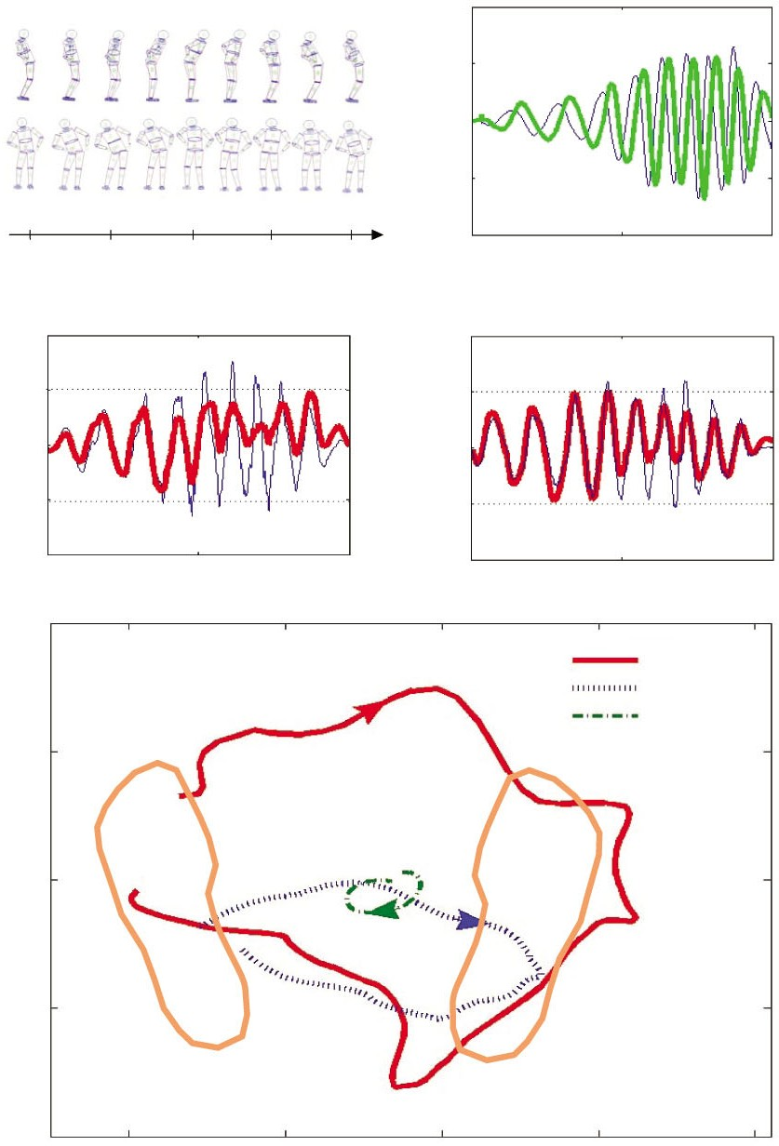
A B 0.2
Walking angular momentum
0.1
L_{x,y}/(MVH)

0

–0.1
–0.2
Fig. 8. Hula-hoop body motions. Angular momentum, horizontal ground reaction force and ground references points are plotted in the medio-lateral (x) and anterior–posterior (y) directions. In this experiment a participant rotated his hips while standing in double support, similar to how one twirls a hula hoop, at an increasing and then decreasing rotational speed for approximately 10 s (see A for one representative cycle). (B) The horizontal components of normalized angular momentum are plotted versus time. For ease of comparison with walking values shown in Fig. 3A, the angular

7.2 7.4

C
2
Anterior–posterior
Fy/kylimit
1

0
7.6 7.8 8.0
Time (s)
0 5
Time (s)

D
2
1
Medio-lateral
Fx/kxlimit

0
10 momentum is normalized by the product of the participantʼs mass,
CM height and self-selected gait speed (MVH; see participant no. 1 in Table 1). (C,D) The horizontal ground reaction forces measured experimentally (thin blue line) are plotted along with the calculated zero-moment forces (thick red line) versus time for the same participant and trial as in B. Both experimental and calculated zero- moment forces are normalized by the stiffness term, F_{z}/z_{CM}, and the radius of the ground support base in the appropriate direction

–1
–2

E 400

300
Anterior–posterior direction (mm)

0 5 10
Time (s)
–1
–2
0 5 10
Time (s)

CMP CP CM
(see Eqns 9 and 10). In the medio-lateral (x) direction, the radius was measured while standing in double support, and was equal to one-half the distance from the lateral edge of the right foot to the lateral edge of the left foot. In the anterior–posterior (y) direction, the radius was equal to one-half the participantʼs foot length.
(E) Plotted are the CP (blue dashed line), CMP (red solid line) and CM ground projection (green dash-dotted line) trajectories and corresponding footprints. As in A, only one hula-hoop cycle is shown from 7.2 to 8 s. The ground CM projection remains within the support envelope while the CMP often falls outside the region.

200

100

0
400 500 600 700 800
Medio-lateral direction (mm)

create a moment force that restores the CM position over the stance foot.
To further investigate movement tasks where the moment force is dominant, we conducted two pilot investigations. We first analyzed a particular movement task while standing in double support. Here a study participant rotated his hips, similar to how one twirls a hula-hoop, at an increasing and then decreasing speed for approximately 10·s (see Fig. 8A). Kinetic and kinematic data were collected using the same experimental setup employed in the walking study, and the same human model was then used for physical modeling.
In Fig. 8B, the horizontal components of normalized angular momentum are plotted versus time, showing angular momentum values that are approximately an order of magnitude larger than the steady-state walking values shown in Fig. 3A. Further, in Fig. 8C,D, we show zero-moment forces, as well as experimental forces measured from a force platform, for the hula-hoop twirling motion. Here the difference between the two curves is equal to the moment force component of the horizontal ground reaction forces, as defined by Eqns 9 and 10. Beyond t=5 s, there is no longer good agreement between zero-moment forces and experimental values as CM moment, or the rate of change of angular momentum, becomes dominant. During this same time period, as is shown in

Fig. 8E, the CMP ground reference point often moves beyond the ground support envelope, diverging from the CP and the ground CM projection. This dynamical behavior is distinct from that of steady-state normal walking where the CMP never leaves the ground support base, as indicated in Fig. 4C.
For the hula-hoop motion, angular momentum becomes sufficiently large that moment forces become dominant over zero- moment forces, and the CMP moves beyond the support envelope. Between t=6 s and t=8 s in Fig. 8C,D, the moment force is often as large as, or larger than, the zero-moment force. Even with the existence of large CM moments, the participant still remains upright and stable. The regulation of angular momentum [|L(t)|≈0] is therefore not a necessary condition for human stability. This finding is in direct disagreement with the arguments of Morasso and Schieppati (Morasso and Schieppati, 1999) and Morasso et al. (Morasso et al., 1999), who stated that the ‘CP–CM phase-lock’, a relation similar to the zero-moment force component of Eqns 9 and 10, is a pure physics consequence of stability. In fact, the generation of angular momentum and CM moments is a key strategy for the enhancement of bipedal maneuverability and stability (Popovic et al., 2004b; Hofmann et al., 2007). Clearly, the CM motions found in the hula-hoop task could not be achieved using only a constant angular moment, zero-moment control approach.

H. Herr and M. Popovic

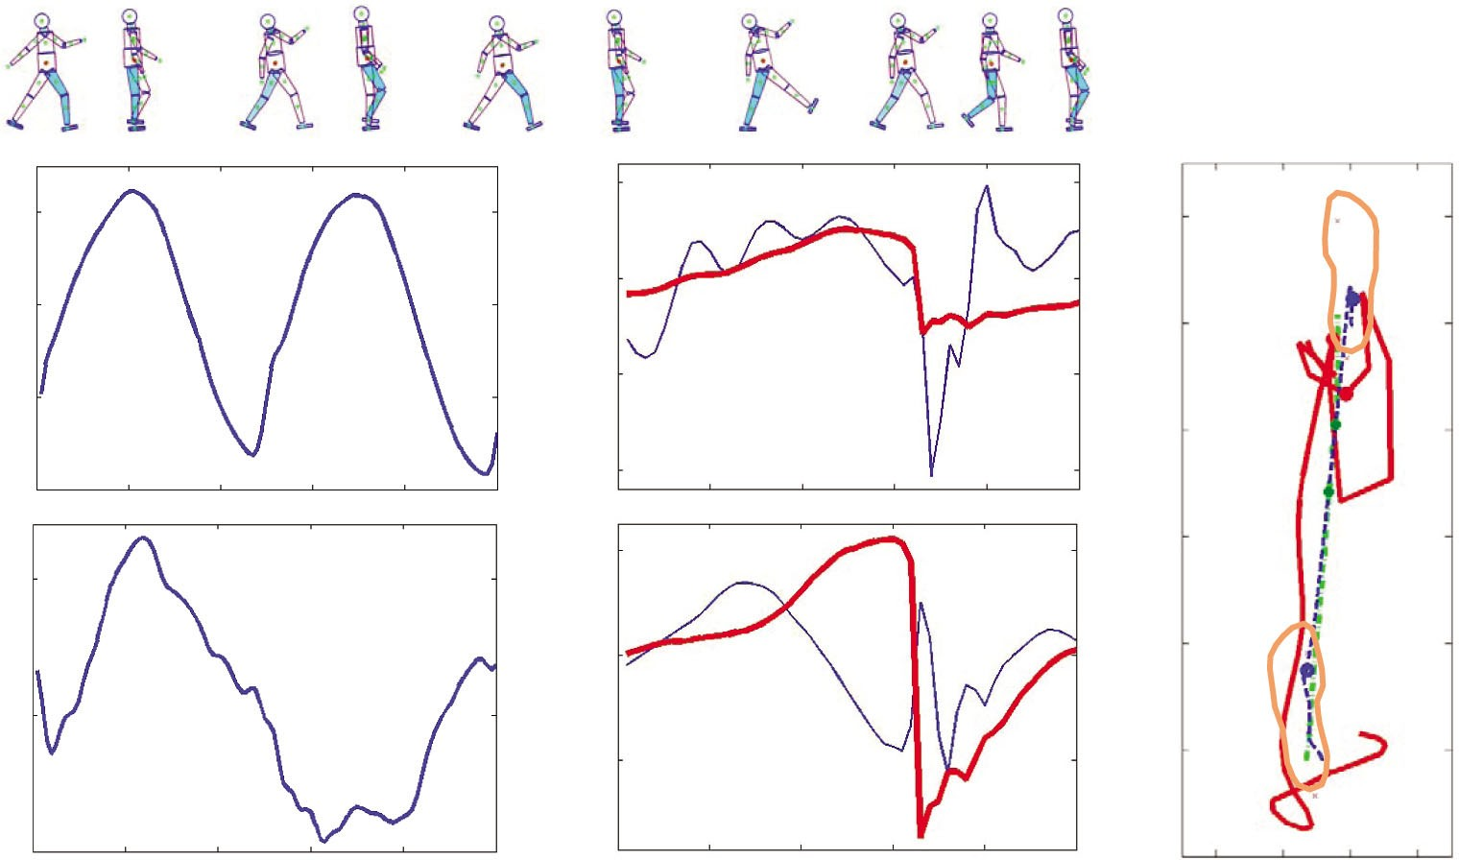
0.2 A
50 C
800 E

0
L_{x}/(MVH)

–0.2

–0.4

B
0.05

0

–50
F_{x} (N)

–100

200 D

0
F_{y} (N)

600

400
Anterior–posterior direction (mm)

200

0

0
L_{y}/(MVH)
–200

–200

–0.05
0

20 40

60 80

100

0 10 20

30 40
–400
50 –200 –100 0 100

Gait cycle (%)
Gait cycle (%)
Medio-lateral direction (mm)

Fig. 9. Exaggerated walking gait. Angular momentum, horizontal ground reaction force and ground reference points are plotted in the medio-lateral (x) and anterior–posterior (y) directions. In this experiment a participant walked with exaggerated leg protraction and retraction movements, similar to a military marching gait, at a forward speed of 1.3 m s^{–1} (see whole-body sketches above plots). (A,B) The horizontal components of normalized angular momentum are plotted versus percentage gait cycle. For ease of comparison with walking values shown in Fig. 3A, the angular momentum is normalized by the product of the participantʼs mass, CM height, and self-selected gait speed (MVH; see participant no. 1 in Table 1). Here 0% and 100% gait cycles correspond to consecutive heel strikes of the same foot. (C,D) The horizontal ground reaction forces measured experimentally (thin blue line) are plotted along with the calculated zero-moment forces (thick red line) versus percentage gait cycle for the same participant and trial as in A and B. Here 0% to 50% gait cycle spans from the middle of a single-support phase to the middle of the next single-support phase of the opposite limb. (E) Plotted are the CP (blue dashed line), CMP (red solid line) and CM ground projection (green dash-dotted line) trajectories and corresponding footprints. As in C and D, only 50% of the gait cycle is shown. The two circles on each line denote the transition from single to double support, and vice versa. For this exaggerated gait, the CMP often falls outside the ground support envelope.

What would be the benefits of a generalized strategy of angular momentum regulation in normal walking?
As highlighted in the last section, active generation of angular momentum is a key strategy for bipedal maneuverability and stability. Why then is momentum highly regulated during normal steady-state walking? To address this question, we conducted a second pilot study where a participant walked with exaggerated leg protraction and retraction movements, similar to a military marching gait, at a forward speed of 1.3 m s–1 (see whole-body sketches above plots in Fig. 9). Kinetic and kinematic data were collected using the same experimental setup employed in the normal walking study, and the same human model was used for physical modeling. In Fig. 9, the angular momentum (Fig. 9A,B), horizontal ground reaction forces (Fig. 9C,D) and ground references points (Fig. 9E) are plotted in the medio-lateral (x) and anterior–posterior (y) directions. As with the hula-hoop motion, angular momentum is an order of magnitude larger than in normal walking (see Fig. 3A). Further, zero-moment forces do not agree well with experimental values (R_{x}2=0.01±0.12; R_{y}2=–1.6±0.3; mean±s.d. across seven gait trials), and the CMP diverges from the CP, often moving outside the ground support envelope (β=50±6%).
The exaggerated walking plots of Fig. 9 clearly show that it is possible to walk with large CM moments. The dominant source of CM moment in this particular walking pattern is due to rapid body movements within the sagittal plane, as indicated by the large angular momentum values in the medio-lateral (x) direction (Fig. 9A) compared with the anterior–posterior (y) direction (Fig. 9B). Throughout much of the single-support phase, the swing leg protracts rapidly forward, often generating a positive CM moment in the medio-lateral (x) direction. As described by Eqn 9, this moment causes a positive moment force to act in the anterior–posterior (y) direction, accelerating the CM forward during early to mid-swing phase (see Fig. 9D). During terminal swing (18% to 30% gait cycle in Fig. 9D), the swing leg retracts towards the walking surface, generating a negative CM moment in the medio-lateral (x) direction and causing a negative moment force to act in the anterior–posterior (y) direction. This exaggerated retraction motion tends to decelerate the CM in the anterior–posterior (y) direction just prior to heel strike. Thus, throughout the single-support phase, the moment force tends to accelerate the CM forward as the result of swing-leg protraction, and then rapidly decelerate the CM as the swing leg retracts just prior to the double-support phase.

Walking in this manner, although possible from a stability standpoint, is nonetheless energetically expensive. Generating substantial CM moments by driving the swing leg in rapid protraction and retraction movements is likely to increase muscle work. The total kinetic energy increment resulting from body movements relative to the CM6 (Willems et al., 1995) is 123±16·J (mean±s.d. across seven gait trials) for the exaggerated walk, a value that is 5-fold larger than the normal walking value from the same participant (22±2 J). Further, using the individual limbs method (Donelan et al., 2002), the positive and negative external work performed by the legs on the CM is 53±3 J and –40±6 J for the exaggerated walk, respectively. For normal walking from the same participant, the positive and negative external work is 28±2 J and –25±1 J, respectively. These preliminary results suggest that perhaps CM moments are kept small in normal steady-state walking in order to lower the body’s work requirements, allowing for less muscle work and a more economical walking pattern.
Walking angular momentum
The determinants of gait and segmental angular momentum cancellations
The gait determinants of pelvic rotation, controlled plantar flexion and powered plantar flexion are thought to be important mechanisms for making the CM trajectory flatter and smoother in walking (Saunders et al., 1953; Kerrigan et al., 2000; Kerrigan et al., 2001). Although pelvic obliquity and early stance knee flexion were also believed to produce flatter CM motions (Saunders et al., 1953), recent evidence suggests otherwise (Gard and Childress, 1997; Gard and Childress, 1999). We now discuss these particular determinants of gait in the context of segment-to-segment momentum cancellations. We found that feet and calf momenta are balanced by thigh momenta as a result of controlled plantar flexion, powered plantar flexion and early stance knee flexion, resulting in the relatively small medio-lateral (x) component of whole-body angular momentum. Further, we found that pelvis and abdomen momenta are balanced by segmental momenta from the rest of the body through the action of pelvic obliquity, resulting in the relatively small anterior–posterior (y) component of whole-body momentum. Finally, we show that leg angular momenta are balanced by segmental momenta from the rest of the body during pelvic rotation, producing the relatively small vertical (z) component of whole-body momentum.
Coronal plane rotational variability in normal human walking Since steady-state walking comprises a series of coupled and alternating movement patterns, a reduced-order PC representation naturally exists for the high dimensional space of segmental angular momenta. For participant-independent PC analyses (using data from all participants and gait trials), we found that only three PCs
required for a participant-dependent analysis, highlights a more dominant rotational variability in the coronal (x–z) plane, across study participants, compared with sagittal and transverse planes. This result suggests that body dynamics that may be used to distinguish individual gait patterns in an angular momentum representation are mainly present in the coronal (x–z) plane. The specific source of the observed variability is predominantly due to large variations in the relative contribution of angular momentum in the abdomen and pelvis (segment 13), chest (segment 14) and head (segment 16) [see large standard deviations in Fig. 5 for PC₁ (y)].
In an analysis of passive dynamic walking stability, Kuo (Kuo, 1999) argued that bipedal walking is inherently unstable in the medio-lateral direction, and thus body movements within the coronal (x–z) plane would need to be actively controlled in order for the body to remain upright and stable. One interpretation of why there is a more dominant rotational variability in the coronal (x–z) plane is that distinct participant-dependent strategies are being expressed to achieve stable bipedal gait due to perhaps morphological variations between study participants. Although beyond the scope of the present study, the precise reason for the more dominant rotational variability in the coronal (x–z) plane is an interesting area for future research.
Future work
An understanding of angular momentum behaviors in human walking and other movement tasks may have important implications for several fields of study. In clinical gait research, the moment and zero-moment force components, as well as the CMP ground reference point, may potentially serve as valuable identification metrics for the diagnosis of pathological walking patterns such as was shown in Fig. 9. Further, in legged robotics research, an understanding of human angular momentum behaviors is likely to motivate improvements in humanoid controllers that effectively exploit both moment and zero-moment CM force components to improve robotic stability and maneuverability (Hofmann et al., 2004; Popovic et al., 2004b; Hofmann et al., 2007). It is our hope that this work will motivate further studies related to the biomechanics and control of human rotational behavior.
LIST OF SYMBOLS AND ABBREVIATIONS
B_{i}(j) PC variability number: ratio between the area of the one sigma confidence interval of the normalized tuning coefficient c_{j}i(t) to the total area beneath the mean value curve
c_{j}i(t) Normalized tuning coefficients
C_{j}i(t) Time-dependent tuning coefficients
D(α) A 16-component vector of segmental model densities
D^{Exp} A 16-component vector of mean segmental densities obtained

are required to explain greater than 90% of angular momentum data
DE i
from the literature
i

in the medio-lateral (x) and vertical (z) directions, whereas four PCs are necessary in the anterior–posterior (y) direction. Furthermore, for participant-dependent analyses (using only individual participant data), we found that only three PCs are needed to
_{j} Percentage of data (variance) explained with PC vector P_{j}
Di(α) Density of the i-th segment
- Ground reaction force vector
F_{Exp} Grand mean, over all trials and gait percentages, of measured

explain greater than 90% of data about all three spatial directions
F ij
ground reaction force (x or y)
j

Exp
-th gait percentage of the i-th trial measured ground reaction

(see Table 2).
F ij
force (x or y component)
j

In the anterior–posterior (y) direction, the fact that four PCs are
required for a participant-independent analysis, and only three are
Mod

FxM,yoment
-th gait percentage of the i-th trial model-predicted ground
reaction force (x or y)
Horizontal components of ground reaction force corresponding to CM moment

⁶This kinetic energy quantity was computed by taking the sum of the increments in the segment kinetic energy versus time curves of all the body segments relative to the CM. Willems et al. (Willems et al., 1995) argues that this kinetic energy quantity relates to the upper limit of internal mechanical work necessary to accelerate the limbs relative to the CM.
F_{x}Z,yero–moment Horizontal components of ground reaction force corresponding to zero CM moment
- Gravitational constant
H_{subject} CM height

H. Herr and M. Popovic

—I i Segment i moment of inertia tensor about segment’s CM
L Angular momentum vector about the whole-body CM
m_{i} Mass of the i-th segment
M_{R} A 16-component vector of relative mass distribution throughout the model
Exp

Friedman, M. (1937). The use of ranks to avoid the assumption of normality implicit in the analysis of variance. J. Am. Stat. Assoc. 32, 675-701.
Friedman, M. (1940). A comparison of alternative tests of significance for the problem of m rankings. Ann. Math. Stat. 11, 86-92.
Frohlich, C. (1979). Do spring board divers violate angular momentum conservation?
Am. J. Phys. 47, 583-592.

M_{R} A 16-component vector of mean relative mass values obtained
from the literature
Gard, S. A. and Childress, D. S. (1997). The effect of pelvic list on the vertical
displacement of the trunk during normal walking. Gait Posture 5, 233-238.

M_{i}R(α) Relative mass of the i-th segment
M_{subject} Total body mass
M_{x,y} Horizontal moments measured relative to a fixed reference point on the force platform
N Number of segments of human model, N=16
N_{E} Number of PCs used for angular momentum cancellation estimate
N_{Percent} Number of gait percentage times analyzed
N_{subject} Angular momentum normalization constant
N_{Trial} Number of trials
Gard, S. A. and Childress, D. S. (1999). The influence of stance-phase knee flexion on the vertical displacement of the trunk during normal walking. Arch. Phys. Med. Rehabil. 80, 26-32.
Geyer, H., Seyfarth, A. and Blickhan, R. (2006). Compliant leg behaviour explains basic dynamics of walking and running. Proc. R. Soc. Lond. B: Biol. Sci. 273, 2861- 2867.
Goswami, A. and Kallem, V. (2004). Rate of change of angular momentum and balance maintenance of biped robots. Proceedings of the IEEE International Conference on Robotics and Automation, New Orleans, LA, USA, pp. 3785-3790. doi: 10.1109/ROBOT.2004.1308858, www.ieee.org.
Gu, W. (2003). The regulation of angular momentum during human walking. Undergraduate thesis, Physics Department, MIT, USA.

Pji
Pjiq
Principal component (PC) basis vectors, with j=1…3 (spatial directions) and i=1…N (model segments or PCs)
The angular momentum contribution of the q-th body segment to P_{j}^{i}
Herr, H., Hofmann, A. and Popovic, M. (2003). New horizons for orthotic and prosthetic technology: merging body and machine. Presented at the ZIF International Conference on Walking Machines, Bielefeld, Germany, http://biomech.media.mit.edu/publications/ArtificialMuscle_O&P.pdf.
Hinrichs, R. (1982). Upper extremity function in running. PhD thesis, The
Pennsylvania State University, University Park, USA.

r_{CM} Whole-body CM position relative to lab frame r ^{i}_{CM} Segment i CM position relative to lab frame r_{CMP} Centroidal moment pivot (CMP) receptor
r_{CP} Center of pressure location
R2 Coefficient of determination
S_{j} Segmental angular momentum cancellation in the j-th spatial direction
T Moment vector about the whole-body CM
v_{CM} Whole-body CM velocity relative to lab frame
v^{i} The i-th segment’s CM velocity relative to lab frame
V Total body volume
Vi Volume of segment i
Hinrichs, R. (1987). Upper extremity function in running. II. Angular momentum considerations. Int. J. Sport Biomech. 3, 242-263.
Hinrichs, R. (1992). Case studies of asymmetrical arm action in running. Int. J. Sport Biomech. 8, 111-128.
Hinrichs, R., Cavanagh, P. and Williams, K. (1983). Upper extremity contributions to angular momentum in running. Biomechanics VIII-B. Champaign, IL, 641-647.
Hofmann, A. (2003). Control rules for biomimetic human bipedal locomotion based on biomechanical principles. PhD Thesis Proposal, Submitted to the Computer Science and Electrical Engineering Department, Massachusetts Institute of Technology.
Hofmann, A., Massaquoi, S., Popovic, M. and Herr, H. (2004). A sliding controller for bipedal balancing using integrated movement of non-contact limbs. IEEE/RSJ International Conference on Intelligent Robots and Systems, October, Sendai, Japan, pp. 1952-1959. doi: 10.1109/IROS.2004.1389683, www.ieee.org.

VRi
Relative volume of the i-th segment
Hofmann, A., Popovic, M. and Herr, H. (2007). Exploiting angular momentum to
enhance bipedal center-of-mass control. IEEE Trans. Rob. Autom. In press.

V_{R} A 16-component vector of relative volumes computed directly from the human model
V_{subject} Walking speed
α Parameter used in optimization of segment mass properties
α_{min} Value of parameter α minimizing the absolute error
|D(α)–D^{Exp}|
β% Mean CP–CMP separation distance normalized by foot length
_{j} A 16-component vector of segmental angular momenta in j-th spatial direction
i Segment i angular velocity vector about segment’s CM
We thank the Michael and Helen Schaffer Foundation of Boston, Massachusetts for their generous support of this research. We also thank Paolo Bonato, Tod Farrell, Hartmut Geyer and Jennifer Johansson for their helpful suggestions and support.

REFERENCES
Alexander, R. (1976). Mechanics of bipedal locomotion. In Perspectives in Experimental Biology (ed. P. S. Davies), pp. 493-504. Oxford, UK: Pergamon Press.
Bekker M. G. (1956). Theory of Land Locomotion. Ann Arbor: University of Michigan Press.
Cavagna, G. A., Thys, H. and Zamboni, A. (1976). The sources of external work in level walking and running. J. Physiol. Lond. 262, 639-657.
Cavagna, G. A., Heglund, N. C. and Taylor, C. R. (1977). Mechanical work in terrestrial locomotion: two basic mechanisms for minimizing energy expenditure. Am. J. Physiol. 233, R243-R261.
Croce, U. D., Riley, P. O., Lelas, J. L., and Kerrigan, D. C. (2001). A refined view of the determinants of gait. Gait Post 14, 79-84.
Crowe, A., Schiereck, P., Boer, R. W. and Keessen, W. (1995). Characterization of human gait by means of body center of mass oscillations derived from ground reaction forces. IEEE Trans. Biomed. Eng. 42, 293-303.
Dapena, J. (1978). A method to determine the angular momentum of a human body about three orthogonal axes passing through its center of gravity. J. Biomech. 11, 251-256.
Dapena, J. (1993). An analysis of angular momentum in the discus throw. Paper presented at 14th International Congress of Biomechanics, Paris, France.
Dapena, J. and McDonald, C. (1989). A three-dimensional analysis of angular momentum in the hammer throw. Med. Sci. Sports Exerc. 21, 206-220.
Donelan, M., Kram, R. and Kuo, A. (2002). Simultaneous positive and negative external mechanical work in human walking. J. Biomech. 35, 117-124.
Dunn, O. J. (1964). Multiple comparisons using rank sums. Technometrics 6, 241- 252.
Elftman, H. (1939). The function of the arms in walking. Hum. Biol. 11, 529-535.
Jackson, J. (1991). A User’s Guide to Principal Components. New York: John Wiley & Sons.
Kadaba, M. P., Ramakrishnan, H. K., Wootten, M. E., Gainey, J., Gorton, G. and Cochran, G. V. (1989). Repeatability of kinematic, kinetic, and electromyographic data in normal adult gait. J. Orthop. Res. 7, 849-860.
Kadaba, M. P., Ramakrishnan, H. K. and Wootten, M. E. (1990). Measurement of lower extremity kinematics during level walking. J. Orthop. Res. 8, 383-392.
Kerrigan, D. C., Croce, U. D., Marciello, M. and Riley, P. O. (2000). A refined view of the determinants of gait: significance of heel rise. Arch. Phys. Med. Rehab. 81, 1077-1080.
Kerrigan, D. C., Riley, P. O., Lelas, J. L. and Della Croce, U. (2001). Quantification of pelvic rotation as a determinant of gait. Arch. Phys. Med. Rehab. 82, 217-220.
King, D. (1999). Generating vertical velocity and angular momentum during skating jumps. Paper presented at 23rd annual meeting of the American Society of Biomechanics, University of Pittsburgh, October, 21-23, http://asbweb.org/ conferences/1990s/1999/ACROBAT/086.PDF.
Kuo, A. (1999). Stabilization of lateral motion in passive dynamic walking. Int. J. Robot. Res. 18, 917-930.
Kuo, A. D. (2002). Energetics of actively powered locomotion using the simplest walking model. J. Biomech. Eng. 124, 113–120.
LeBlanc, M. and Dapena, J. (1996). Generation and transfer of angular momentum in the javelin throw. Proceedings of the 20th annual meeting of the American Society of Biomechanics. Atlanta, Georgia, USA, October 17-19, http://www.elitetrack.com/ asbjavelin.pdf.
Lee, C. R. and Farley, C. T. (1998). Determinants of the center of mass trajectory in human walking and running. J. Exp. Biol. 201, 2935-2944.
Margaria, R. (1976). Biomechanics and Energetics of Muscular Exercise. Oxford, UK: Clarendon Press.
McGeer, T. (1990). Passive dynamic walking. Int. J. Robot. Res. 9, 62- 82.
Mochon, S. and McMahon, T. A. (1980a). Ballistic walking. J. Biomech. 13, 49-57.
Mochon, S. and McMahon, T. A. (1980b). Ballistic walking: an improved model. Math. Biosci. 52, 241-260.
Morasso, P. and Schieppati, M. (1999). Can muscle stiffness alone stabilize upright standing? J. Neurophysiol. 82, 1622-1626.
Morasso, P., Baratto, L., Capra, R. and Spada, G. (1999). Internal models in the control of posture. Neural Netw. 12, 1173-1180.
Ortega, J. D. and Farley, C. T. (2005). Minimizing center of mass vertical movement increases metabolic cost in walking. J. Appl. Physiol. 99, 2099-2107.
Popovic, M., Gu, W. and Herr, H. (2002). Conservation of angular momentum during human locomotion. MIT, Artificial Intelligence Laboratory, Research Abstracts.
September, 231-232, http://biomech.media.mit.edu/research/Popovic_Gu_Herr.pdf.
Popovic, M., Hofmann, A. and Herr, H. (2004a). Angular momentum regulation during human walking: biomechanics and control. Proceedings of the IEEE International Conference on Robotics and Automation. New Orleans, LA, USA, April, pp. 2405-2411. doi: 10.1109/ROBOT.2004.1307421, www.ieee.org.

Popovic, M., Hofmann, A. and Herr, H. (2004b). Zero spin angular momentum control: definition and applicability. IEEE-RAS/RSJ International Conference on Humanoid Robots. Santa Monica, CA, USA, November, www.ieee.org.
Walking angular momentum
Popovic, M., Goswami, A. and Herr, H. (2005). Ground reference points in legged locomotion: definitions, biological trajectories and control implications. Int. J. Robot. Res. 24, 1013-1032.
Portney, L. G. and Watkins, M. P. (2000). Foundations of Clinical Research: Applications to Practice (2nd edn). Upper Saddle River: Prentice Hall.
Riley, P., Krebs, D. and Popat, R. (1997). Biomechanical analysis of failed sit-to- stand. IEEE Trans. Rehabil. Eng. 5, 353-359.
Rose, J. and Gamble, J. G. (1994). Human Walking (2nd edn). Baltimore, MD: Williams and Wilkins.
Saunders, J. B., Inman, V. T. and Eberhart, H. D. (1953). The major determinants in normal and pathological gait. J. Bone Joint Surg. Am. 35, 543-558.
Simoneau, G. and Krebs, D. (2000). Whole-body angular momentum during gait: a preliminary study of non-fallers and frequent fallers. J. Appl. Biomech. 16, 1-13.
Srinivasan, M. and Ruina, A. (2006). Computer optimization of a minimal biped model discovers walking and running. Nature 439, 72-75.
Wilcoxon, F. (1945). Individual comparisons by ranking methods. Biometrics 1, 80- 83.
Willems, A., Cavagna, A. and Heglund, N. C. (1995). External, internal and total work in human locomotion. J. Exp. Biol. 198, 379-393.
Winter, D. A. (1990). Biomechanics and Motor Control of Human Movement. New York: John Wiley & Sons.
Xu, D. and Wang, T. (1998). Lower extremity contributions to altering direction during walking: analysis of angular momentum. Proceedings of the North American Congress on Biomechanics. University of Waterloo, Waterloo, Ontario, Canada, August. http://asbweb.org/conferences/1990s/1998/160/index.html.

Acknowledgements & Credits

Funding for this publication was provided by NSF HSI Award number 1832348

Some of the content in this manual was excerpted from the following:
  - Mathematics for the Life Sciences by Erin N. Bodine, Suzanne Lenhart & Louis J. Gross

The University of Arizona’s Biology Project website: http://www.biology.arizona.edu/

The Discovering Radians Activity comes from: http://mrsnicoleburns.weebly.com/uploads/8/6/7/0/8670276/_1 discovering_radians_acti vity page_1_.pdf

Content was developed for Los Angeles Mission College Trigonometry classes which use the Pearson textbook Trigonometry 11th Edition, by Lial/Hornsby/Schneider/Daniels, and some of the content was derived from Pearson’s TestGen testbanks for this textbook.

The Open Educational Resource Textbook from OpenStax Precalculus by Abramson is referenced for students as a resource for content review.

The article is from the Journal of Experimental Biology

