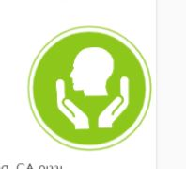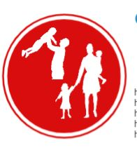

**LAMC Students Health Center Will Remain Open**

Hours of operation:

Tuesdays 8am-4:30pm

Wednesdays 8am-12pm

Thursdays 8am-4:30pm.

Phone Session are offered: 818-362-6182

<https://www.lamission.edu/Health-Center/Home.aspxoffice>

**Transportation and statistics**

<https://edd.ca.gov/about_edd/coronavirus-2019.htm>

<https://www.prb.org/racialinequalitiesinmanagerialandprofessionaljobs/>

**Employment and Statistics**

<https://edd.ca.gov/about_edd/coronavirus-2019.htm>

<https://www.prb.org/racialinequalitiesinmanagerialandprofessionaljobs/>

Children and Families

**El Nido Family Services**

11243 Glenoaks Blvd #2, Pacoima, CA 91331

(818) 896-7776

**North Valley Caring Services**

15453 Rayen St, North Hills, CA 91343

(818) 891-0481

**Food Banks:**

**MEND**

10641 San Fernando Rd, Pacoima, CA 91331

(818) 896-0246

**San Fernando High School**

11133 O'Melveny Ave, San Fernando, CA 91340

**Sylmar Charter H.S**

13050 Borden Ave, Sylmar, CA 91342

Maclay Middle School

12540 Pierce St, Pacoima, CA 91331

Housing

<https://hcidla.lacity.org/covid-19-eviction-moratorium>

<https://member.everbridge.net/453003085619167/login>

<https://www.elawc.org/saam_20>

Domestic Violence:

<https://www.thehotline.org>

<https://www.womenslaw.org/find-help/ca/advocates-and-shelters>

<https://www.womenslaw.org/laws/general/restraining-orders>

<https://www.ncsc.org/>

<https://www.elawc.org/saam_20>