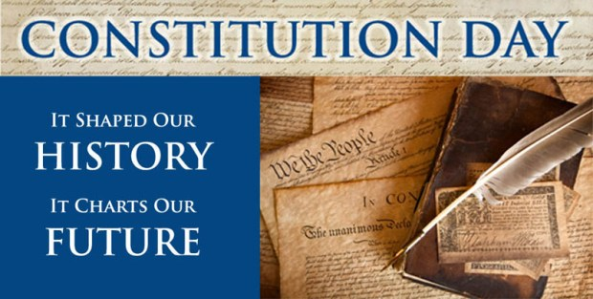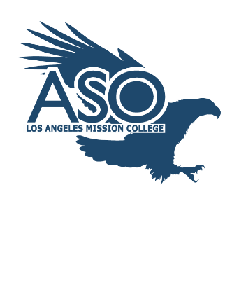

**Monday, September 18, 2017**

Constitution Day

Come learn about the Constitution of America

**Quad Area**

**9am –1pm**

Receive a free mini copy of the US Constitution

Ask Questions

Get informed

Know your rights